
They’re not all that new, but they are big and clever. Are they the ultimate teaching tool or just a luxury that impresses Ofsted and the governors? We have a look at a variety of boards and discuss their pros and cons.
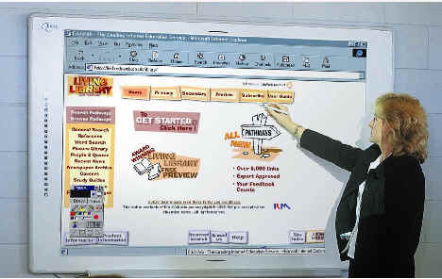
Introduction
There is quite a debate about whiteboards at the moment. On the one hand thrifty ICT co-ordinators consider them an expensive luxury. On the other, those who have used them never want them to be taken away!
We catalogued the debate in a previous article, but for the moment, some feedback from association members who have trailled the boards themselves. Not just in a comfy office, or a demonstration hall we might add, but in a class with children on a day to day basis.
The Promethean ACTIV Board
The Promethean board is a hard melamine board with a copper metal grid sandwiched inside it. Through use of a special inductive pen the board can detect where it is touched based on the metal grid. This is aligned with the projected picture on the board and the pen in effect becomes the mouse. Its size is misleading as the board is larger than the actual grid area that you can use. So it looks impressive but in reality it is similar in size to the others for practical use.
Now we’ve used a Promethean with a variety of classes and we have to say that they are reliable and hard wearing. The software too scores highly, and offers more features than the others. The inclusion of clip art and spotlights and reveals are at first sight welcome additions, but once you get down to using the board in real life, these features that so wowed us at the demonstration stand actually get used little.
Clip art is like McDonalds, (allegedly) no matter how much you get, it never seems to fill you up. As useful as the idea of incorporating some pre-sorted clip art is, you soon find it’s never enough or what you really want. But to increase the amount of images would just make handling or finding what you want harder. In practice I ended up building a folder of my own favourite clips and using them instead. However that is not to say these features are not helpful. They point you in the direction of what is possible and for most teachers who are not ICT friendly, providing some initial structure is very welcome.
Another factor that the Promethean boasts is the speed of update, which was the fastest of all the boards tested, the electronic image keeping up well with speedy notes and handwriting. The accuracy is claimed to be higher than that of the Smartboard at about 200 dpi and it certainly is better for fine work. However once the screen is magnified in projection it seems to make little difference between most of the boards on test and in our experience they all suffer from going slightly out of alignment at times.
We found the constant click of the pen on the board mildly irritating and the method of changing from pen mode to mouse mode all the time awkward compared to the Smartboard. The one thing in the design that lets it down is the necessary special pen that costs about £35 to replace. Promethean have now improved their design and the pen is now cordless, battery-free and cheaper than before with one extra provided in the pack. Even though the pupils have not yet stolen it, it proved really inconvenient at times to have to hunt around for it and remember where it was hidden. Traditionally you have a box of pens to write on your board with, if you can’t find one, use another. Here, if you can’t find your pen, it’s time to get the flip chart out.
One feature that the full size board boasts is the infa red port near the top. This is used in conjunction with an infa red slate or a voting system. It’s a touch sensitive tablet that you can pass around the class for pupils to interact with the board. (Bought separately) On the other hand it can free you up to wander from the front and retain control.
This has two minor problems. One, you must remember to keep the slate pointing at the board for it to work and students’ heads can get in the way unless you ask the users to stand up. Two, it is a direct translation of the board, which means that where you touch on the tablet corresponds to the equivalent of the board. This sounds sensible but the natural tendency is to treat it as a mouse pad and expect it to be able to cope with lifting the pen up, moving to the top and expecting the mouse to continue moving from where you left it. It doesn’t. It jumps to the top where you have just started. Although this is a minor niggle, it means having to unlearn one technique and develop the knack of pointing at the board while remembering to not use the pen as a true mouse while constantly adjusting your sense of scale. It’s not a huge problem but it’s certainly a design that could be improved. Our colleagues in Barking and Dagenham inform us that there is a version of the slate being developed in Germany that is based on wireless, so maybe that will eliminate the hit and miss of the infa red.
Activboard 60 (bottom of their range) £1,650.
Activboard plus with serial, infra red and radio. £2,495. (slates not included)
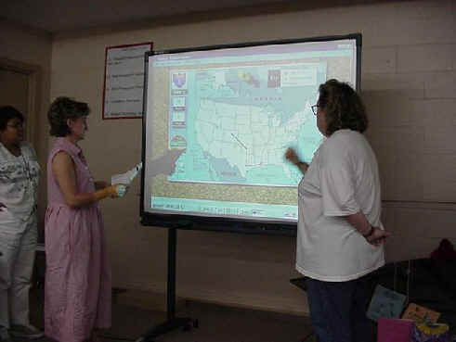
The Smartboard
The Smartboard works on a touch screen method. The board has a durable membrane stretched over it which they claim can be used with normal whiteboard pens, though it takes a LOT of scrubbing to get clean. (Why would you want to though?) This membrane detects where pressure is on the board and aligns it to the image with a 9, 40 or 80 point configuration routine. In practice the 9 point routine seems to be as accurate as the 80 so we never bother with the higher ones now.
The beauty of the Smartboard is in its design. 4 pens are at the bottom and a board rubber. These are nothing special, just moulded plastic, but pick up a pen and you are switched to the pen mode in that colour. The trays are weight sensitive and when something is picked up it triggers the appropriate mode. Whoever designed this needs a medal. (or at least a pay bonus) In practice you can start using the board with no training at all. Pick up a pen and write, pick up the rubber and rub out. We can’t emphasize how important this is. It builds upon the natural inclination of the way teachers currently use a board making its use all but intuitive. Stunning.
You then touch the screen with your finger for any mouse mode operations, as long as you remember to put the pen down in the tray, and it makes the switch between modes all but invisible. (although there is a menu command to override the trays if you want to draw with your finger) We loved it. Our members loved it. Really simple, the result of a well thought out design.
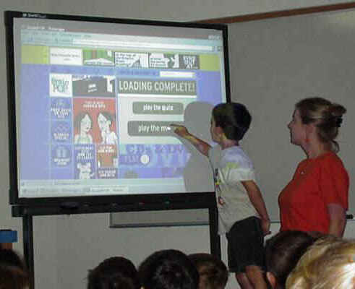
The handwriting recognition has been improved so that you can write anywhere on the board at any time and tap the top right corner of the resulting box and it translates into text. It was the most accurate of all the boards in this respect, leaving the others behind. It manages to recognize my signature at high speed which is no mean feat. (Just don’t write diagonally and expect any of them to cope)
Speed is a slight drawback on the Smartboard. The update is quicker with the solid boards but it’s not irritating. As to writing large amounts of text on the board, you would never do that with a normal board in front of a class. You would prepare it beforehand and in practice you do this with a keyboard or on your laptop at home for any of the boards.
Another problem is the tendency to rest the wrist on the board whilst writing with the pen. This results in errors as the touch sensitive board jumps between the two contacts. Not insurmountable but a common early error.
The Software has less features than the Promethean though more than the others - notably the absence of clipart and reveals some of which Smartboard have rectified but are now selling as an add on. Shame on you, a selection at least should come with the board.
The tactile aspect of the board makes it the most user friendly and some have argued that using this with the children has a profound effect on them, in Primary at least. Personally I’d love to see some simple SEN software that talks when you touch it. Image a large letter “a” that lights up and speaks when you trace it with your finger in the correct way. Multi sensory overload!
Touching with a finger or a pen seems a trivial point but in trials, the Smartboard engendered a feeling of affection that the other boards didn’t. It also was by far the board of choice by the teachers themselves which we feel is due to its user interface rather than its software features.
In terms of durability the Smartboard is the most vulnerable. If you took a Stanley knife to it, it would have to be sent away to be re-skinned. (To Canada I believe) Not so the melamine boards. Mind you, if you work in such a school you have our admiration and sympathy! Also, we have found the position of the serial port on the board already a trouble spot for bent pins. It is upside down, on the bottom edge of the board so unless you lie on the floor to connect it, you have to do it unsighted which can cause some port bashing. (a pair of tweezers fixed it but it took a long while to work out what the problem was) In a permanent set up it doesn’t matter of course but if Smartboard are listening, perhaps put it on the side facing outwards and strengthen the board rubber holder which is prone to unclipping.
SMART Board 580 72” education price £1495

Numonics - Diamond 10

This board is really an older design of the Promethean. Its method is essentially the same and although it is solid you can't use normal white board pens as it will stain. The board uses an electronic pen, which although it doesn't need a permanent lead, provides one, so you can use the pen and simultaneously charge it. There is a red button for the right mouse click on the pen.
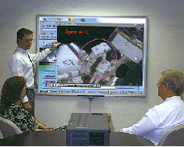

The size of the pro boards are 40, 62, and 77 inch, slightly larger than smartboard and there is no area inside like the promethean. Where this board differs is that keys are physically printed on both the board sides and form the menu, which can be programmable through macros. Although this is supposed to be a helpful feature, in practice it’s very easy to forget what they are for as they are without icons. They are just numbers, and although a mouse reminder comes up when you hover over each one, if you forget where the button you want is it takes some searching to find it.
There is a rubber stamp for instant clip art, a reveal and spotlight tool and the zoom is a good addition. All the boards have an onscreen keyboard, but this one has no manual, the help is all in software. The handwriting recognition was notably poor and under-developed.
The whiteboard software generally has less to offer over the Smartboard and Promethean. The constant changing of the pen mode for eraser or pen or mouse by clicking the numbered buttons is irritating. There is no line tool or lock to grid feature despite providing a variety of graph paper as clip art. (They could all do with handwriting and music paper clips actually.)
It has the same resolution as the Promethean and the 4 point calibration setup is quick and painless. But it doesn't retain your notes outside of the whiteboard software on the screen. A refresh window command will erase it. You can save your notes as a screen grab, but it is too awkward, it loses your annotations between minimizing. This is a fault with the Smartboard as well and the Promethean wins here, the software having been programmed correctly.
There is no shape tool for objects, or resizing possibilities in the current whiteboard software. Like the Promethean it also requires a separate power point unlike the Smartboard which draws its power from the serial port.
Numonics Diamond 10
62 “ diagonal = £1450
pen = £40
trolley = extra £400
Mimio

The Mimio has two strengths that the others don’t have - portability and price.
It attaches to any existing whiteboard you already have (very portable) and connects to PC and Apple Mac computers. It can be used on its own as a data capture device or in conjunction with any Projection Unit connected to the host computer, therefore turning any standard whiteboard into an interactive one. It costs around £350 + cost of projection unit. Our testers weren’t too impressed with the Mimio though, a bit too fiddly to set up and not as responsive as the others. In practice we found that the sucker cups are not always as long lasting as they should be which adds to the fiddling.
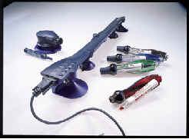

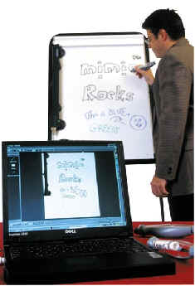
As far as benefits go, the Mimio will do what it claims and at a much reduced cost to the other alternatives. In practice though, the appeal of the whiteboard is partly the luxury of having a large integrated board in a permanent set up. If you are prepared to ‘rough it’ as money is your prime consideration, then you might as well just go for a data projector. Our testers were not thrilled about the amount of wires and setting up required for this design.

Of more interest might be a new board coming out called the “Sahara”. This is said to be based on the same ultra sound technology as Mimio used to locate the position of the pen holders relevant to the screen . However the board is a permanent set up with the sensors built in rather than the portable design of the Mimio. It is expected to considerably undercut the price of the other boards and maybe cause them to re-think their pricing strategy.
General Points
Some things were found to be common with nearly all the boards, such as learning to avoid the shadow of your hand in much the same way as you would with an OHP.
Back projection is an option but in truth just too impractical in classrooms unless space is no object, which is very rare.
Plasma screens are the only other way around this at present but they are too expensive and not large enough to be a viable alternative.

Mounting the projector from the ceiling helps lessen the shadow effect and not leave wires trailing all over the floor or require such a distance from the board to avoid children’s heads and hands making shadow pictures to entertain the class with.
This was in fact another common factor - a permanent set up was soon discovered to be the optimal way of using the boards. Even the Mimio, whose main feature is portability, was preferred to be left in a permanent arrangement, negating its benefits of design. The hassle involved in setting up and orientating any board and projector just led to them either not being used or only used in one room and not altered. Although many would argue that this is a waste of a projector which could be used anywhere, in practice we found with permanent set ups the boards were used to death. Without it, they failed to make much impact.
With regards to text input most have an onscreen keyboard that can be called up and tapped or some form of handwriting recognition. Plus the computer that the board is connected to has a keyboard you can use. It’s handy to have this near the screen so you can type at the side if you need to as in practice, all the onscreen keyboards are too slow and fiddly. The handwriting recognition is great for notes but for more text input the computer keyboard remains more efficient.
Ideally, teachers took a laptop with the board software home, knocked up their screens for the next lessons, came in the next day, plugged in by the side of the board and off they went.
The joy of having unlimited display space for notes and photos that can be saved and manipulated was universally acclaimed by one and all. The whiteboards are one of those rare inventions that actually make the teacher’s life easier, and help make more effective lessons. That’s quite something in these overstressed and overworked days.
Pricey yes, but no-one in the tests wanted to go back to their old board.
Interestingly when considering where to put the board, we wouldn’t recommend the ICT suite as necessarily the first choice - there the children all have access to monitors anyway. Choose a room where lots of teaching takes place all the time, then you will get the maximum benefit out of them.
Although we know of quite a few schools where one or two boards are used, few have one in every classroom, but as prices fall and word spreads, they are beginning to grow. The Millennium Primary School in Greenwich is one such school where the teachers who were certainly not ICT specialists before, now use them for every lesson and along with the pupils just take them for granted. The novelty has gone and what remains is a teaching aid that all the teachers love and would recommend.
Conclusions
Q: I can’t be bothered to read all this, which one would you buy?
A: The Smartboard.
Let’s be honest, there isn’t much in it. The Promethean is very good indeed and certainly reliable, however, if you want your teachers to use the board on a daily basis the Smartboard is the least intimidating of all the designs we tried. The tools have been really thought about for simplicity and ease of use rather than trying to score by offering a multitude of gimmicks. It isn’t perfect but it is the one that 80% of our testers preferred.
Compare the use of the Sony Mavica to the use of other digital cameras. Why is it so popular in schools? Answer: Teachers hate having to fiddle with leads round the back of the computer. Honestly, that’s all it is! The Mavica uses floppies and everyone is pretty happy with that concept. Fiddling and faffing gadgets end up collecting dust in the storeroom in today's high pressured job. Other cameras may offer docking stations or higher resolutions but the Mavica walks away with it for ease of use.
As ICT teachers, we are not adverse to coping with such things, but our colleagues are. The Smartboard wins in our opinion because the software can always be improved. The physical method of interacting with the board can’t.
Rocky Horror said it best I feel.
“Touch-a-touch-a-touch-a-touch me….”

