Scoil Raifteirí
23.09.08

A Thuismitheoirí,
Táimid ag obair chun an Bratach Glas a fháil don bhliain 2009. This year’s theme concerns transport, with special reference to our over-dependence on cars. Táimid ag iarraidh gearradh siar ar thrácht, agus na páistí a chur ag siúl agus ag rothaíocht ar bhealaí atá sochair. We believe that schoolchildren will benefit from walking and cycling safely.

Beidh lá speisialta ag Scoil Raifteirí ar an Aoine seo, 26ú Meán Fómhair. Parents are invited to come along and join in the walks which will be conducted by 2nd to 6th Classes next Friday, our day of Action. Beimid ag féachaint ar bhealaí deasa siúl ar scoil. The purpose of these walks is to investigate safe routes to school from four different drop-off points, all located within 500 metres of the school. You might find it convenient to drop off your child at one of these locations, thus avoiding the traffic and congestion in the immediate vicinity of the school.
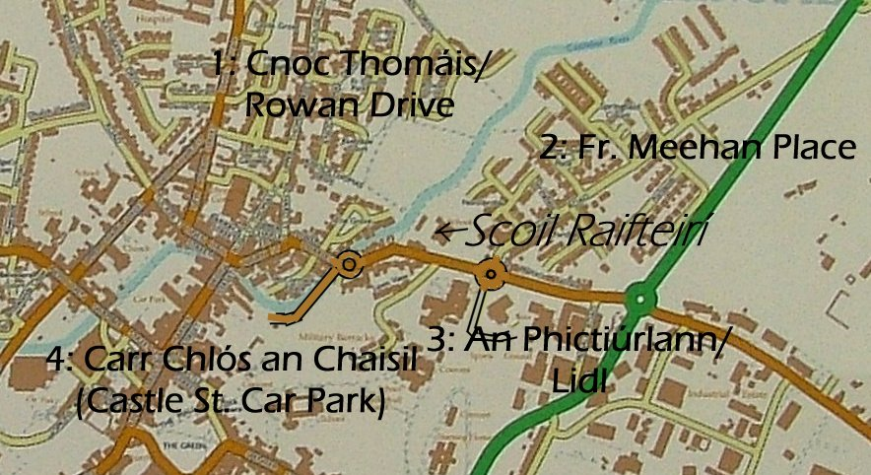

Tá dhá cheann de na bealaí seo go hálainn, le cosáin gan trácht. Routes 1 and 2 are particularly safe and attractive. We recommend any children on Routes 3 and 4 to use the pedestrian crossing outside the school, and to be very careful in the vicinity of the roundabout at Lidl.

Tá súil againn go mbeidh sibh in ann triail a bhaint as an mbealach seo chun seans a thabhairt do do pháiste siúlóidí rialta a fháil. We hope this Park and Stride idea will work.

