Suffragettes

Hello my name is Millicent Fawcent and I am the of the National Union of Women’s Suffragettes. I believe in a peaceful protest. Even though I don’t believe in fighting, my best friend Emmeline Pankhurst believes that all of the woman out there should go out there and fight.

Emmeline Pankhurst was the founder of “Women’s Social and Political Union (WSPU).” Emmeline was so annoyed at the men that she even went to St Stephen’s Hall in the House of Commons and painted the extract from the bill of rights on the wall. I told her millions of times not to get angry and mess up, but she never listened to me.

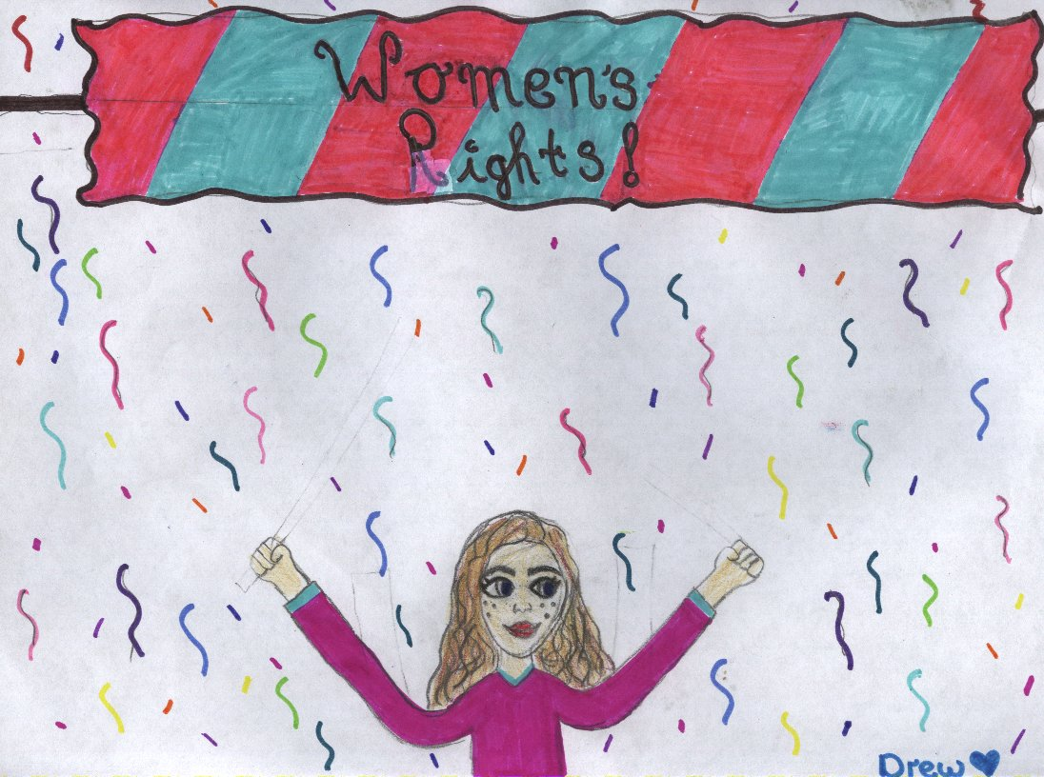

Some times I get angry and when I get angry, I get VERY ANGRY. But I never take it out on anyone. The way I think about it is that , if I say something to someone that they mightn’t like , they’re not going to set my house on fire, because I won’t let that happen. The men don’t do that. The men let the women do what ever they like because they have the police of their side.

The women in the jails started a new thing called “hunger strike”. A hunger strike is when women in jails don’t eat anything. It didn’t work out because the police forced them to eat blended food by, putting a tube down their necks. Some women won the “hunger strike”, because they wouldn’t even open their mouths so, because of that, they had to be let out of jail.

We Suffragettes still have a lot to go though to win our battle! Wish us luck!

Millicent Fawcent (Drew)

As I woke up, I quietly reached over for my trousers, t-shirt and socks. I quietly tip-toed through my bedroom, looking for my sign. I couldn’t find it anywhere, so I quickly ran downstairs. The door was smashed. There was a brick which had been through the window and a note sellotaped on it saying “Let women vote”. It was probably for my husband Herbert Henry Asquith, the prime minister of the government.

Back to the sign. I couldn’t find it anywhere, or else someone had hidden or taken it. I hate my husband. He’s always gone and he’s always on the computer. I eventually found my sign. It says ‘Let Women Vote’.

Off with me to the courthouse, along with hundreds of women along with me. There were over 500 police standing ready for war. We shouted as loudly as we could: “Let women vote!” As we charged, the rain started to pour down on us. I looked up at the window, and there he was: my disgusting freaky old husband. I quickly glided past a guard, dropped a shoulder and shimmied past. I ran up the steps. My buddies and I opened the door, screaming and roaring. We spread out into groups, 100 upstairs, and 250 downstairs. Through walls, doors and windows, we still couldn’t find him anywhere.

Hopefully, he’s gone to a different country.

*Gavin*

From the mid 19th century, women in Ireland campaigned for women’s rights to vote, the rights to married women’s property rights and access to third level education and an improvement in the conditions for working women.

Belfast- based Isabella Todd an educator and reformer, together with Anna Haslann, were active in the Ladies National Association, founded in 1969 to campaign for women’s rights. Todd became convinced of the need for female participation in the public arena and went on to set up the first Irish suffrage group in Northern Ireland. Anna Haslann founded the Dublin Women’s suffrage movement society.

These groups used soft campaign techniques of letters writing, meetings, gathering signature on petitioned handing out pamphlets. One of their greatest successes was when the Local Government of Ireland Act allowed certain women to vote in and sit on rural and district councils and on town commission. However by the early years of the 20th century activists had lost patience with the soft campaign tactics of the older suffrage organisations similar to the British movement they became more militant and determined to push their idea of suffrage first before all else.

Female suffrage The movement launched a determined campaign chaining themselves to railings and breaking windows in public building like Dublin Castles and the GPO several found themselves arrested and imprisoned several others went on hunger strike but were realised shortly after.

By 1913 the suffrage movement became involved with the labour rights and shared a stage with the great James Larkin at the launch of the female Trade Union. During the lock out of 1913 many of the working women, together with the suffrage campaigners worked together in Liberty Hall.

Influenced by the support and thinking of James Connelly, some later joined the Irish Citizen Army. Despite their difference and argument of suffrage first or nation first the Irish Citizen Army co-operated on many issues. Once war broke out in 1914, the influence and ideas of these women could be best seen in the proclamation of 1916.

Ethan☺

Back in the nineteenth and twentieth century, women were not allowed to vote. However a rebel called Millicent Fawcett believed in peaceful protest. She felt that any violence or trouble would persuade the men that women could not be trusted with the right to vote. Her goal was to put up good arguments against the men’s decision and, to improve women’s opportunities for higher education. But her plan would soon fail. She died aged (eighty-two) on the fifth of August 1929. She was born in 1847 on the eleventh of June.

After Millicent failed in1903, the women’s social and political union was founded by Emmeline Pankhurst and, her daughters Cristobel and Sylvia. They wanted women to have the right to vote and, they were not prepared to wait. The union became better known as the Suffragettes. Members of the Suffragettes were prepared to use violence to get what they wanted.

In 1905 Cristobel Pankhurst and Annie Kenny interrupted a political meeting in Manchester to ask to liberal politicians (Winston Churchill and Sir Edward Grey) if they believed that women should have the right to vote. Neither man replied. As a result the two women got out a banner which said on it women for votes and they shouted at the two men to answer their questions. Such actions were all but unheard of then when public speakers were usually heard in silence and listened to courteously even if you did not agree with them. Pankhurst and Kenney were thrown out of the meeting and arrested for causing an obstruction and a technical assault on a police officer.

But in 1918 women in Britain over the age of thirty were allowed to vote and, in 1928 the level was lowered to age twenty-one.

Donal

My Life as a Suffragette

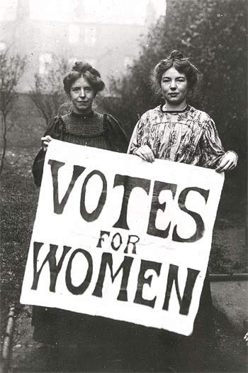

It was a typical stormy night. I heard snoring coming from my bedroom. It was my husband, it wasn’t easy for me and him as I was a suffragette and he was a politic but he didn’t know that I was a suffragette. I find it hard talking to him as he is always complaining about us suffragettes. I usually lie to him when I’m going to my friend’s house but today, I just sneaked out when he was fast asleep. I was off to my friend’s house Annie; she was a nice woman who also was a suffragette.

When I got there, I realised something was going on, as there was police car outside her house. Suddenly I heard a loud scream. I ran into her house as I assumed it was her it was Annie.

“Annie, are you ok?” I shouted

“Hello Catharine.” He thought he was really cool because he was a police officer.

“By any chance have you Annie”?

“Yes, but there was a bit of a problem. She’s been arrested” He said.

“What for”? I asked.

“She was a suffragette” He said.

“I’d better be going” as I walked out the door.

“I’d better tell the others” I said in my head. When I arrived at Patricia’s house, I noticed all my friends were there outside her house getting ready for a walk I presumed.

“Did you hear the news?” I said.

“We know Annie is gone” said Jean.

“So where are we off to?” I asked.

“The pub,” Mary replied.

By the time we arrived at the pub it was empty apart from the people who were too drunk to go home. When we sat down at our table, I noticed that the bar tenders were Chief Patrick and were Sargent Ronan.

“It’s a trap!” I shouted. But what I didn’t know was we were trapped. “So you figured but how?”

“Well you know you’re so called friend Annie well she was one of us” Sergeant Ronan said.

I punched Ronan in the face because I knew that I was going to jail. We started fighting five minutes until chief Patrick shot a bullet.

Mary fell to the floor. Everybody stopped and then we heard Mary scream in agony.

We were sentenced to jail for ten years for assaulting a police officer and being a suffragette. Unfortunately we died because we basically starved to death.

*Ríoghan*



I woke up at about half six in the morning. I had huge black bags under my eyes. I grabbed two slices of bread and my sign. But the only thing I could not find was my keys. I looked into the bedroom with my husband inside it. I didn’t want my husband to know I was a suffragette because he hated them and if he knew he would turn me into the police. So I crept past my husband I swiped my keys of the bedside locker. I walked slowly out of the room but, my husband popped up and said “What are you doing?” he asked suspiciously “Nothing”, I said swiftly” I’m just going to umm... Mary’s house, bye!” I grabbed my sign and ran to the door. I forgot to open the door and I ran into it. I cursed so loud the neighbours started knocking on the wall. I got up, opened the door and sprinted out

When I reached the door of Mary’s house, I nearly tripped over the door “Let’s go”, I said. There were about five other women at the door ready to protest. We walked down the street; it was quite quiet down St Mary’s Street, and O’Connell Street was empty. Then we went down Shop Street. It was packed. People started booing us and they were throwing food at us. About half way down the street, we all heard sirens and the police came and arrested us. They threw us into the back of a police van.

When we reached the prison, we were taken to our cell. At about seven o’clock we were given dinner. I think it was the worst dinner I’ve have ever had in my life. After about two weeks, I got very slim and I felt really sick.

But I found a loose brick in the ground. It led to the sewers. Normally I would not go down, but in this case I’d do anything to get out of this rotten place. I could barely fit through the tiny hole but I did. When I fell down, it was a dark, smelly disgusting place. I heard loads of mice and rats. I saw daylight at the other side of the sewer. I sprinted out of the sewer.

When I got out, I was on a beach. I saw a town in the distance so I started walking over that direction. When I reached the town I barely had any energy left. I walked into a cafe and I had a scone and tea.

Pádraig

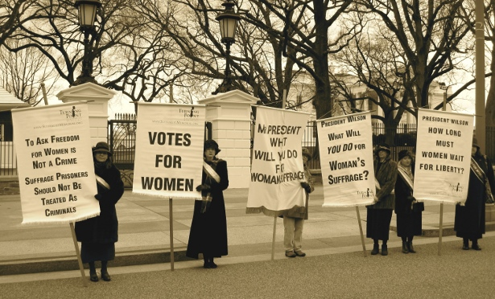

“Where are you Betty?” I said. I ran down the stairs but, on the last step, I heard a squeak. It was the door. “Betty never leaves like that,” I said. After a while, I got a call from my boss. He said “there’s a march by the suffragettes. Keep an eye on it. You’ll be fine there. They’re just women.”

I got my uniform on and headed out the door. When I got there, there was broken glass on the floor. Out of the corner of my eye, I saw suffragettes. They said “we want the vote” and smashed a window. We arrested them. I had to find their names, the last one was Betty Mc Ginty.

I said “so that’s where you were going this morning.”A police officer should never have to arrest his wife. When she got out of jail, we had a discussion about prison. She got elected and now we’re rich and super happy. Yay!

Diary of a Suffragette 1920

February First, 1920

I‘ve finally manged to join the great woman’s movement of our time: the suffragettes. It’s amazing. I’ll start by going to my first rally in Baker Street and, if all goes well, we’ll get our right to vote, but it will be hard to persuade those stubborn men into giving us that great life change for generations in our future

5th of February

This is so unfair, especially for my first rally. If I had known it was this hard to be a suffragette I would have never have started. Who am I kidding? I’d still be a suffragette even it was twice as hard. I’ll never give up for something so big☹

15th of February

Why do I bother? Some of the suffragettes have started vandalising paintings and builedings. All that does is give the rest of us civilised suffragette woman bad names which is not what we want at all.

18th of August 1920 (the last day of the suffragettes’ fight for the right to vote)

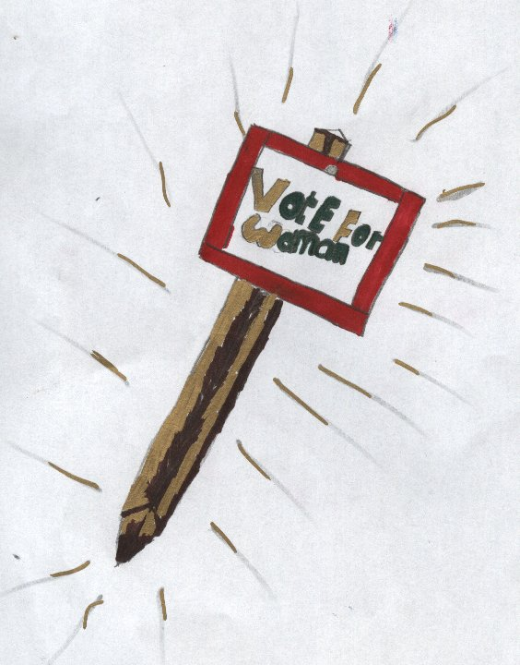

Sorry I havn’t been writing much lately because I’ve been so busy with suffragette work but it all finally paid of. We (the suffragents) have manedged to pull of the impossible and change the lifes of so many by persuading those self-centered men who continued to neglect our wish to be granted a right to vote …until today, a day to be remembered as one of greated fights for women.

INFO: In 1920 18th of August, women over the age of thirty were granted the right to vote. Ten years later, women over the age of twenty-one were then granted the right to vote☺

Tadhg

My Life as a Suffragette



My name is Maisie and iI’m’ over ninety years of age. I have lived a long and eventful life and I have seen many changes during my lifetime. The most relevant to me are the changes that have occurred in the rights of women.

When I was born in a London slum in 1893, women had few options open to them. A life of domestic service or marriage were the routes open to most of us women and this involved a life of drudgery. Women had no expectation of education or position in society and no right to vote

I was employed as a parlour maid in a large house when I was sixteen. It was very hard work and involved long hours. I became friends with the other maids, especially Alice. She took me to my first suffragette meeting in 1909.

There, we heard of the long oppression suffered by women, and dreamed of a better future where women could vote. I once heard Emmeline Pankhurst speak. She was a very powerful speaker and persuaded us to campaign more vigorously.

We agreed to a campaign involving more drastic measures against the British government. I am not ashamed to say I became involved in some violent acts including window breaking and burning of post boxes! Of course I was eventually arrested and given a twelve-month prison sentence.

Prison life was very tough and I, like my fellow suffragette prisoners, went on hunger strike. After days of no food, I was subjected to the barbaric act of force feeding. This involved being held down by several wardens and a tube being passed down my throat to my stomach. It was so painful and traumatic that I still have nightmares to this day. Within a few weeks of this treatment, I was released. The government had introduced the new cat and mouse scheme which allowed weak prisoners to be released. Only to be rearrested on their recovery.

In the meantime, world events took over and World War One broke out in 1914. As the men left for the front, women took over their jobs and all suffragette activity ceased. In 1918, because of their role in the war effort, married women over thirty were allowed to vote. It was a step in the right direction.

Now I live in a world where women have mostly the same rights and expectations as men. I am very proud to be able to say I took part in the early years of the struggle for franchise for women.

Rónán

* Suffragettes began their protests in the late nineteenth century to the early twentieth century.
* The term suffragette was first used in the London Daily Mail.
* The suffragists believed in peaceful campaigning.
* The suffragettes believed in violence and military.
* New Zealand was the first country to give all women the right to vote in 1893.
* The first hunger strike was ninety-one hours!
* Until the First World War, around one thousand suffragettes were imprisoned.
* They used the colour scheme violet, white and green. Green stood for dignity; white, purity; and green, hope.
* A lot of the suffragettes burned wealthy men’s houses and destroyed a load of cricket fields and horse racing tracks.
* Saudi Arabia was the last country to give voting rights to women in 2011.

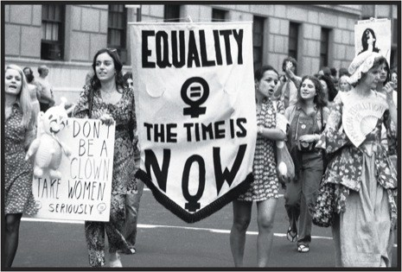

Fianach

The Savage Suffragettes!

The day was supposed to be a normal day, a peaceful protest, a quick march from and to Liberty Hall, and another day lying to my husband.

It was supposed to be a peaceful protest, our usual ‘Votes for Women!’ rally. I woke at the crack of dawn, when I saw the sunlight piercing through the curtains in the bedroom. I quickly rose and dressed into my uniform. I packed a bag with the usual equipment: the sign I had made and hidden in the broom closet, my jacket with its long hood, and my shouting voice.

I crept around my husband, who was still sleeping, with long, drawn-out snores creaking through his open mouth and nose. I opened the door and dodged the creaky floorboard. I escaped past my two children’s bedroom. I put a note on the windowsill, saying ‘I’ve gone to visit Anna’ I dipped my fingers in the holy water, praying for luck, before opening the door and running out.

The reason I was so cautious not to wake my husband is that he **strongly** disapproves of all the suffragette activities. He believes that women would only vote for the man ‘that they fancy’. I know he is wrong, that’s why I joined the group. Another reason that I don’t want him to know about my loyalties to the group is that he is the editor of the Telegraph Bulletin!, the biggest paper in Dublin! If people were to find out that he was married to a suffragette, nobody would buy his paper! We would turn poorer than the ‘shawlies in Sackville Street. He could file for a divorce, and I would be arrested.

I arrived in Liberty Hall half an hour later. We all chatted and socialised until it was time to leave. I stood beside my friend Anna, as Mary Lee marched us out of Liberty Hall.

We walked down Baker Street, past Grafton Street, through Shrewsbury Road and over Sackville Bridge. Eventually, we ended up outside the GPO. It’s tall: the half-rebuilt pillars cast a long shadow down on top of us. In my mind, I saluted the heroes of 1916. At the time, the public hated them. But now people are beginning to realise the good they had done. Maybe, in time, the people of Ireland will realise the good we were doing, but I can’t see that happening anytime in the future. But my thought trail was Mary Lee began to make her speech. “People of Dublin...” she began.

After Mary Lee’s tremendous speech, we all let out a few shouts of ‘Votes for Woman!’ I held my sign up as high as I could. My face was as serious as anybody could imagine, and my eyes as steely as iron. But inside, I was beaming. This was the proudest moment of my entire life! I was fighting for what I believed in, I felt nothing could stop women from getting their votes! No violence was necessary in this battle! Well that was what I thought at the time. But my opinion was about to change extremely rapidly...

The group began to turn around and quickly marched back in the direction of Liberty Hall, but then I heard a shout. “COME ERE, YE DIRTY LITTLE GIRLS!” a man shouted from behind. I turned around. The man was obviously drunk, I could tell from the way he lurched from side to side, taking up the entire two sides of the road. “I SAID COME ‘ERE!” he slurred again. We all turned around. “Pay no heed of him; he’s just a poor drunk man!” Mary Lee persuaded us, and we all turned our attention to our March back to Liberty Hall.

But that comment only seemed to further enrage the drunken man. He picked a stone of the road and threw it with all his might. Fortunately, as he was drunk, his aim was completely off. We all sniggered a little, at the sheer thickness of the man.

But the man’s nostrils flared, and his face began to turn a purplish-red colour. He picked up another rock. There was something about the man’s posture that made it look like he was... focused. And with one swift move, he through the heavy stone in our direction like a champion rounder’s pitcher.

The stone flew through the air. For a brief moment, I thought I was going to be hit. Out of pure instinct, I leaned right. The stone went whizzing past my ear. I screamed, knowing I was a millimetre away from certain death.

Put then time seemed to slow down, I turned around. I felt a small splatter of something wet on my left ear. I turned around to see what it was. What I found was beyond my wildest... **Nightmares**

Anna’s temple was bleeding, that’s why the blood was splattered o my ear. Her eyes were open; she had a look of pure terror etched across her face. Her eyes were unmoving and she lay motionless on the ground of the dirty Sackville St. Anna, my closest friend and neighbour had just been killed.

**MURDERED.**

The man began to snigger at us now. Blood rushed to my head and I felt an urge to wipe that smile of his face forever. I wanted to kill him. I had a quick look at Anna’s recently deceased body. I wanted revenge.

I rushed at the man, sign in hand, my eyes glistening with tears. For a brief moment I made eye contact with...with the Monster who had killed Anna. He was expecting me to try and kick him; I surprised him when I brought the hard, metal sign on top of his head, knocking him out.

I worked myself into frenzy, kicking the man with all my might repeatedly. I kicked him until his breathing ceased and his blood splattered on to my shoe.

# TWO HOURS LATER

I opened the door and stepped back into my house, knowing I would never be the same again. I saw my husband at the table beside his typewriter. He was typing an article titled: THE SAVAGE SUFFRAGETTES!

“How was your visit to Anna, Darling?” he asked. “It was lovely, Arthur. Anna baked the most delightful scones I’ve ever tasted!” I lied.

“Those suffragettes, they murdered a man you know.” My husband started. “They’re complete savages, don’t you agree?” “Yes, they’re all complete savages” I replied.

**Was the right to vote worth all of this??????????**

***Muiris***

**Hanna Sheehy-Skeffington**

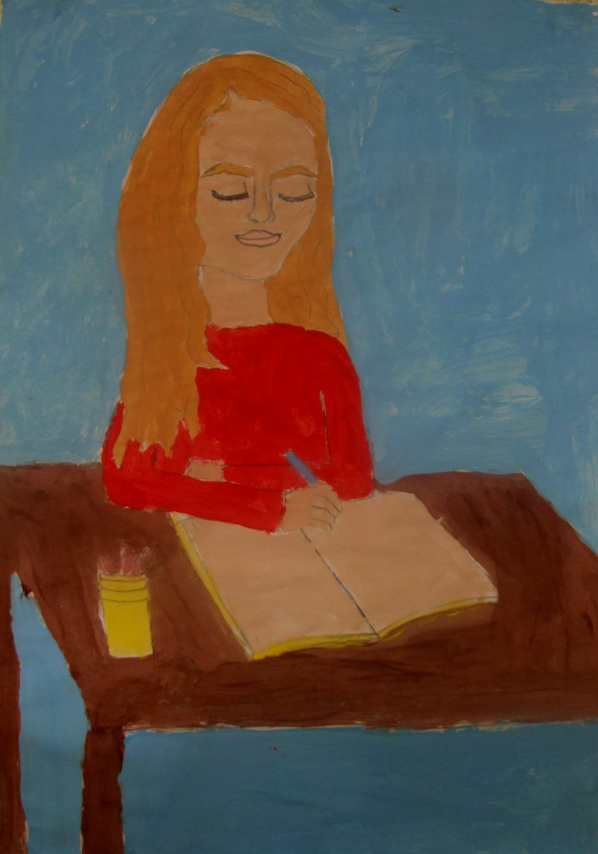

22nd November 1908

Today, my husband, Francis Sheehy Skeffington, Margaret Cousins, her husband , James Cousins, myself and eight others set up the Irish Women’s Franchise League, (IWFL). You may ask how this suffrage society will be different to any other; it will be taking action and getting results. No other suffrage society has. It will represent the new s. generation, (like me!) who has lost patience with the tactics of the old suffrage societies. We have seen the militancy of the British Women’s Social and Political Union (WSPU), and we believe this radical way is the only way we will get the results we desire!

29th December 1908

Although the IWfL started with just twelve members, it has grown immensely! People just like me have been joining and it’s great to see the group growing. We now have an official motto, ‘Suffrage First, before all else!’ This is a perfect motto, as many suffrage women hide being a suffrage woman from the people around them, but they should not hide what they believe in and should take risks to help us get the results we desire.

18th December 1911

I am aware it has been quite a while since I last wrote in my diary, but the IWFL is going well. We have been having weekly meetings in Phoenix Park. Home Rule has been coming up many times in these meetings and we are all in agreement that we should be aiming to achieve female suffrage within the campaign for Home Rule. Although some individuals in John Redmond’s Irish Parliamentary are in favour for female suffrage, but in general it isn’t in favour.

15th April 1912

The third Home Rule Bill has been introduced, and it does not include a provision for IWFL. The last meeting was chaotic, with people shouting and screaming, it nearly turned into a full blown fight. We will have to go to extreme measures and step up our militancy. It’s infuriating that see that women should have the same rights as men. The founders of the IWFL have been on the front cover of many newspapers, so now some of the people I know are ashamed of me, but I have realised these are the sacrifices that we IWFL women have to make to improve women’s conditions.

25th May 1912

Margaret Cousins and I have created a feminist newspaper. It is called the ‘I rish Citizen’ and has just been published today! It has been edited by our husbands. We believe this will be a perfect way to spread our message. Our motto is ‘For Men and Women Equally The Rights and Duties of Citizenship.

23rd August 1912

A lot has happened! I was imprisoned after an incident relating the IWFL. When I was in prison, two members of the WSPU, Mary Leigh and Gladys Evans, were arrested because they supposedly threw a hatchet at Prime Minister Asquith, which missed him and grazed John Redmond. The two women went on a hunger strike and a although many Irish women don’t appreciate WSPU women getting involved in Irish politics; I admire them for their determination, and I think we should work together as we want the same thing. Since I agreed with them, I went on hunger strike too. The WSPU women were force-fed, but the other IWFL women and I were not, and we were released without charge but, because of my actions, I lost my job as a German teacher. Since I’ve lost my job, this might be my last diary entry for a while. Wish me luck in my journey to improve women’s rights and conditions, I don’t know where it will take me, but I know it won’t be easy!

**Alexandra**

My Time as a Suffragette

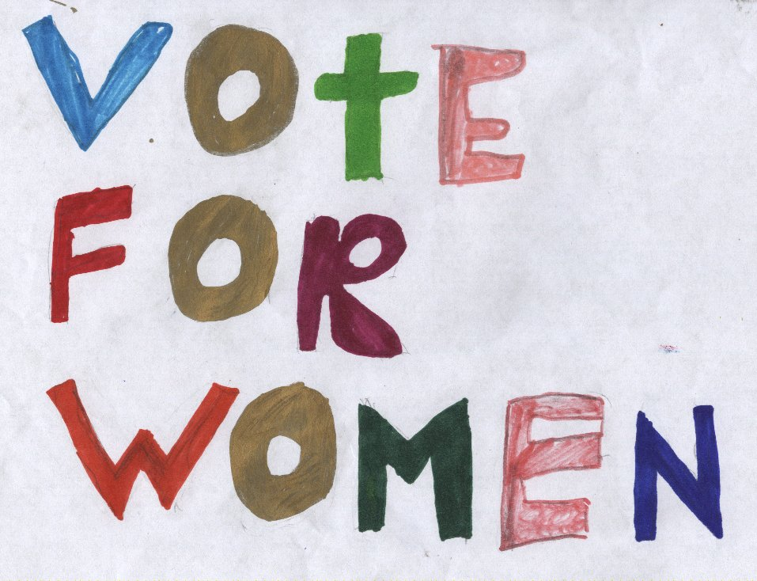

My father would come home from the courts at around 2:00p.m. But, since the suffragettes became a thing, he would come home at random times to make sure we weren’t protesting. He was totally against women being able to vote. He isn’t a nice man. He comes home and orders me to redo my chores. I don’t do them. Instead, I storm out of the room. By the time that I have slammed the door, he is asleep. My mother wants to leave, but then we wouldn’t have any money. It was like living in the middle of a verbal war.

New Start Without Father

On the day of my birthday, he came home and gave me bread. I was so happy. But then he took it from me and he ate it. That was the final straw for mother. She grabbed money out of his pocket, and then she pulled me out the back door. We ran to Aunt Bridget’s house. It was a measly, but it was better than one with father in it. She was also a suffragette. She decided to go to a protest instead of worrying about what was going on at home. It was one of the protests that I was ever at. It was in the ‘Royal Albert Hall’. For the first time, we saw men getting ready to protest for women to able to vote. Then as soon as the protest started the police started, the police came rushing in. They went for men first which gave us a chance to escape. Bridget fell. She had a big cut on her knee, but she carried on running. We headed to the overcrowded hospital. To get Bridget’s knee checked out. It turned out a bone had snapped. We left without her, to Kensington Palace Protest. There we could meet Bridget’s friend Clare. She would help us in getting somewhere to stay for the night. Bridget described how she looked before we left the hospital.

Kensington Palace

On our way, we met a man with a carriage. We told him where we were going. He said he would bring us to Kensington Palace for one shilling it was a lot of money, but it gave us time to rest. When we arrived at the Palace, we saw the most beautiful lady. She was in a long dress. Her makeup was pristine. She was exactly as Bridget described. We went up to and asked her to help us. She rejected us straight away until we mentioned Bridget’s name. She wanted us to wait until after the protest until she’d help us. It was tiring, but it was worth it. We headed to the hotel. Clare was going to pay for us until we found a permanent place to stay. The hotel wasn’t nice. The walls had grime all over them and it stunk. It was also very small. It felt like mother and I never get a break from each other. After three days of staying of staying in the hotel, mother found a place for us to stay. It was a one-roomed apartment above a pub. It was small and it stunk of alcohol. But it was better than nothing, that’s what I kept telling myself. After a while of decorating the apartment, we headed back to Kensington Palace protest. It was very violent. People were throwing stones over the Palace walls. The police were arresting people everywhere you looked. But they were doing it in a violent manner. We decided to go back to our apartment because mother was afraid we might get arrested. We had to go through the pub to get to our apartment. On the radio in the pub it was announced that eleven people died during the protest. We were so that we left early. When we got back to our apartment, we said a prayer for our fellow suffragettes.

Four Months After Moving Into The Apartment

After a long four months, the protesting had stopped. The suffragettes were granted permission to vote. We decided to go back to father because we knew we could be open about our beliefs. We were just saying hi. When we arrived, he was like a different man. We decided to move back home. But until this day I don’t forgive him about my birthday bread

*Lee*

Suffragettes

I walked in the door, I saw a few dozen women dressed in fur coats and feathered hats. I wondered if my sister Olivia had made them as she worked in a hat store. Miss Roberts invited me to this suffragettes meeting. She was the owner of the factory I worked in. I respected her and was honoured that she invited me to this meeting. I sat down in one of the empty seats and looked expectantly at the stage.

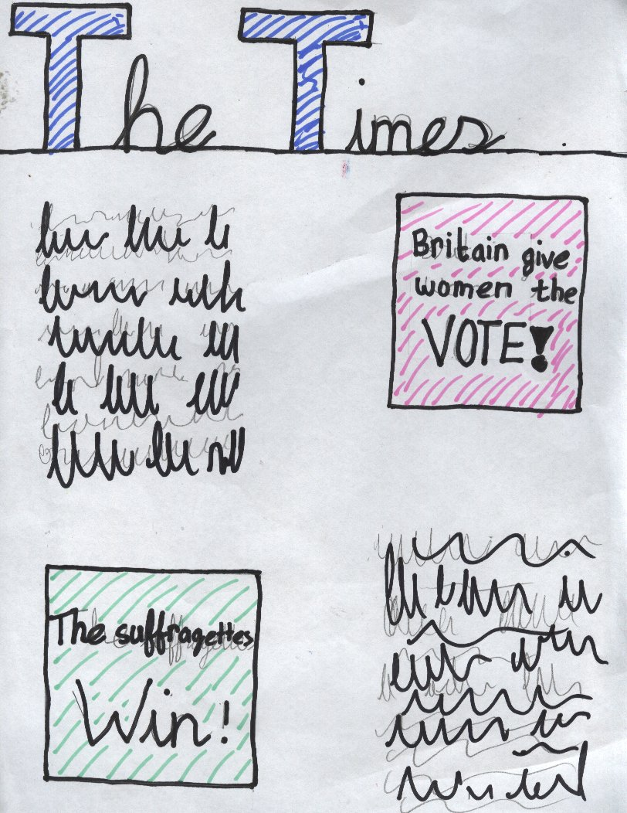

After a couple of minutes a tall dark curly-haired woman stepped up on the stage. She began to speak about women’s education, what we could be if we were given the chance. She spoke clearly and loudly. She made me sit up a little straighter in my seat. “I have rambled on long enough; remember our slogan, Deeds not words”! She said. My eyes followed her off the stage. I aspired to be like her one day.

Many other women made a speech but everything seemed like a let-down compared to the first lady. At the end I asked the lady beside me who the first lady was. She looked at me as if I was simple. “Why that is Miss Pankhurst herself, wasn’t she splendid”? “Yes she was particularly excellent”, I replied but she was no longer listening to me.

I continued going to the meetings for about five weeks. Then Miss Pankhurst died. Everyone was hysterical. She was our leader. Of course I was very sad.

Britain declared war so my father enlisted. I stopped going to the suffragette meetings after an axe was thrown at the Prime Minister. In addition my mother wouldn’t let me.

Many years later, when I was married with a nine year old son, Britain gave women the vote. I cried with happiness for Miss Pankhurst, and all the other brave women who finally had got everything they had worked for. I was very proud of them all.

Freya

Suffragettes

24th of October 1997

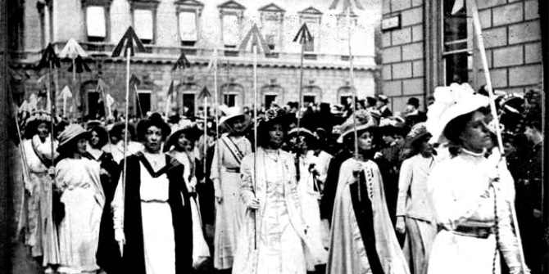

Today was one of the eventful days. We protested at the town hall. We got up at dawn to meet. The leaders got us in groups. I was the leader of group three.

We headed for the town hall behind everyone else. We got to the town hall and began protesting. Everything was going smoothly until someone shouted ‘Women don’t have the same logic as men!’ All hell broke loose then. Many women took the comment personally and charged the man. It was at that moment I knew there would be no more peaceful non-violent protests from that day on. I was right! Women grew a hatred for political leaders who disapproved of the Suffragettes.

There were guards outside waiting for us but we got them by surprise (sort of). Groups one and two raced towards the guards. That left my group and group four an open path into the town hall. We dashed inside and stormed the office. The secretary told us we had lost and the police were on their way. We knew that almost all of us would go to jail but we would awaken a new age of Suffragettes. Some people think our wrath is over but the Suffragettes Age has just begun!

Caolán

Mary Feerick

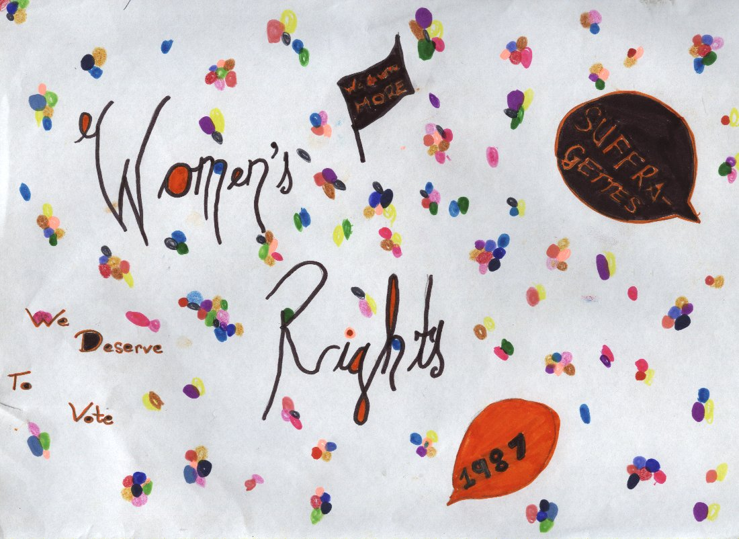

There once was a woman named Mary Feerick. She was a strong, independent woman and was very interested in women’s rights. She became very involved in the suffragette movement that was founded in 1897. This movement’s main aim was to secure the right of women to vote in elections. Mary was very different to a lot of other women back then. She didn’t have a husband or children. She was known to have a lot of idiosyncrasies too, such as walking whilst looking up at the sky, eating whilst on the move etc.

There were many meeting of like-minded people that were held locally and nationally. Various powerful women spoke at these meetings. She too became a campaigner. She was able to outline her reasons for wanting this right for women. She argued that women should be treated equally to men. Women played a very important role in the home raising children. Sometimes their lives were very difficult, with hard work and very few facilities in the home such as washing machines and other labour-saving devices, so she argued strongly on behalf of all women to have their voices heard, and enable them to have their say in elections.

She continued to work tirelessly with and for the movement. It faced strong opposition from strong and powerful men, and she continued to push their case forward. Were they not as entitled to vote as men did?

Slowly but surely they felt that they were having an impact. Large crowds of women supported them so they felt that they would achieve their aim. She, as a member of this movement, felt strengthened and confident about their future. Women having the right to vote would be a major achievement and it would make her proud to be part of such a movement.

Since Ireland was under English rule in the late nineteenth century, the English were slow to change the law whereby women could vote but she and the movement were determined to make them change this law. Only men could vote at the beginning of the twentieth century. Things were beginning to change. The right to vote for women was on its way. How proud she felt.

*Niamh.*

Méabh O’Donnell

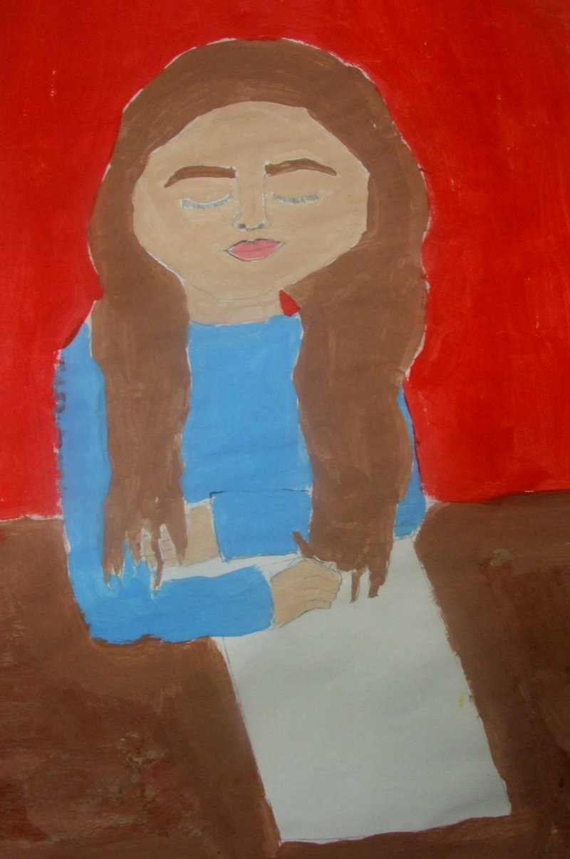

January 18th 1897

Dear Diary,

Hello, my name is Méabh O’Donnell. I am sixteen years old. I am the eldest in my family. I finished school at fourteen because Mother and Father wanted me to find a job. I have three sisters and four brothers. We all live in a simple two-storey house in Castlebar, Mayo. My uncle Séamus knew a man who was in need of a maid, so Séamus suggested me for the role. Today is the day in which I will be travelling up to Dublin to start my new job. Mother gave me this diary as a going away present, to keep account of my everyday life. My coach will be arriving soon so I’d better prepare myself. Will write again soon, Méabh.

February 23rd 1897

Dear Diary, hello again. My master’s name is Dónal McHugh and my mistress’s name is Clodagh McHugh. They are both very nice people, which is very good. They’ve got one child called Elizabeth. In the morning, I have to wake up at half-five to sweep out the fire place. I have to help the cook prepare breakfast and bring it up to the Mistress.

April 4th 1897

Dear Diary, the mistress and I are becoming closer. She is like a big sister to me now. She also likes me to call her Clodagh now. Clodagh is involved with a suffragettes’ group. Master doesn’t know about this. She has to sneak out of the house a lot. She has been trying to persuade me to join in the protests. They are fighting for the right for women to vote. Isn’t that crazy? Next she’ll be saying that women should be able to drive!

May 27th 1897

Dear Diary, what a month it has been! I decided that I would join the protests. I was awake half the night before my first march, worrying. Clodagh and I sneaked out at six o’clock in the morning. We met the rest at an old abandoned factory. There were hundreds of women. When we went out on the town to protest, there were police there. It was like they knew we were coming. They started charging at us and grabbed women and shoved them into coaches. I was so distraught. I ran as fast as I could!

June 11th 1897

Dear Diary, I have done a terrible thing. Master had read my diary entry from April 4th 1897and informed the police of our protest. That’s why the police were there. It is all my fault that Clodagh and the others were arrested. I was so reckless. Master fired me and sent me home. I was lucky that he didn’t turn me in. this will be my last diary entry. I am going to burn this diary.

Goodbye forever, Méabh.

Isabel Ní Ghabháin

A DIARY OF A SUFFRAGETTE

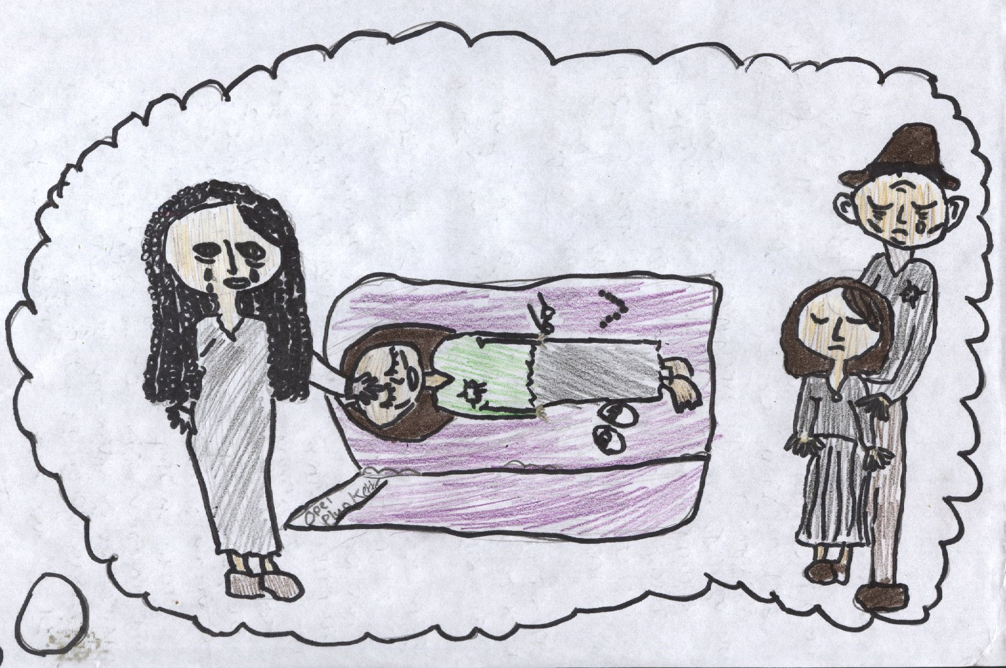

12th NOV 1913: The meeting was held at ten-thirty at the St Joan of Arc Church Hall in Ledbury Street across town. It would take me forty minutes to get there, so I would be late for the start. It felt good to walk at first, though my sister’s narrow skirts restrained me from taking reasonable strides. At least I was out of my gloomy little house. The only exercise I got nowadays was walking to and from Fairy Glen. I loved my new job there, designing the confectionary boxes.

I started to get uncomfortable as I turned into Ledbury Street. I wasn’t sure what I was getting myself into. Mother said suffragettes were a disgrace, shrill and unwomanly. My sister Cassie said that they were man-haters and looked a sight. I found their ideas liberating, but I tended to think them as warriors.

I reached the hall at last, hot from my brisk walk. I took a deep breath and crept in through the front door. I tiptoed as silently as I could, painfully aware of my leather boots creaking, everyone staring at me. The wealthy looking lady was staring at me while she was giving her speech. After she had spoken out to the audience, everyone clapped with appreciation. The grand lady walked over to me and shook my trembling hands. Her name was Mrs. Roberts and she was very proud of me for coming. Mrs. Roberts said I was the youngest volunteer there, which I was painfully aware of. Mrs. Roberts was very kind and caring, unlike the description my mother had given. Mrs. Roberts invited me over to her house in her car, obviously, I accepted.

At eleven-thirty, we reached her grand house with lush gardens. Her maid made us iced buns and a Sunday roast! These were much more tempting than rotten, slimy sweetbreads. After we devoured our meal, she got talking to me about doing a rally in the Albert Hall, this Saturday. She convinced me, so the next Saturday I would be taking part in a Suffragette rally!

18th NOV 1913: is this Opel’s diary? I THINK IT IS. I am Opel’s sister Cassie, Opel was always a bright girl but she wasn’t so bright going to that rally! She got herself into bother with the police. Now poor Opel is in prison! I think that she is being force fed there or something. I want her back so badly!

25th NOV 1913: after I finished my shift at Madame Alouette’s, I walked into my house. I heard the howling of Mother up in her bedroom. Opel had passed away due to starvation in prison. She was only eighteen. My family and I dressed in black and mourned at her funeral. I got to take a last look at her. Her poor body was so thin and frail. She lay silent as I hoped that her eyes would open, but all that i was looking at was a gaunt, lifeless face. I stroked her soft cheek for the last time and then shut the coffin.

4th JAN 1914: It’s a different life without little Opel, she isn’t there when I need her, like when I need help with my sewing but I suppose you can’t take these little things for granted. Every time I see the suffragettes in the newspaper, I always think of my little sister, strong and confident.

LEILA

THE RIGHTS OF WOMEN

I looked out the window of the local grocery shop, which I called my workplace, and I saw crowds protesting. I wasn’t sure what was happening. Suddenly my boss, Mr. Wharhall, called my co-worker and me into his office. I was excited because it was Friday, or payday as I call it. First he paid my co-worker. He dropped ten shillings into his hand. Then he paid me. He put six shillings into my hand. I knew I needed more that that since my father had died and I was the eldest sibling.

Before I even got a chance to thank him, I heard the door open. My boss snapped his fingers and said ‘GIRL, ANSWER THAT!’ I ran to the counter and a lady asked me a question. She said ‘young lady, are you happy with the way you are being treated?’ I shook my head lightly as I looked to see when Mr.Wharhall was coming. She dropped a note on the counter. I picked it up and read it. ‘Meet us for a meeting tonight at 9:30, at the abandoned Jacobs factory.’

It was all I could think about. I had to go. I sneaked past my mother. ‘Where are you going?’ she asked. I paused. ‘For a walk...’ I said, worried that my mother would crack the code. ‘Tell me the truth dear’ she said softly. I showed her the note. Luckily for me my mother was a reasonable woman. ‘Be back by half past eleven, and be careful! ’. I set off for the empty building. I didn’t know what was before me.

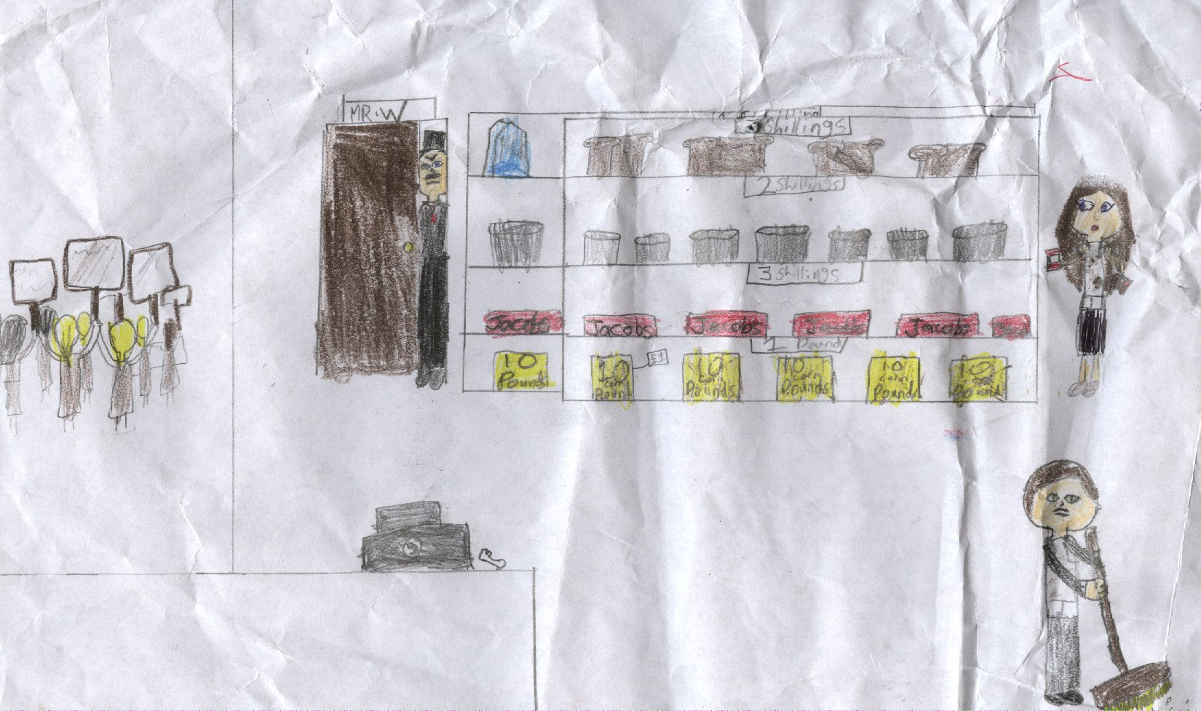

The factory closed recently because the production line moved elsewhere. I knocked on the door and checked the time. ‘9:34’ I thought to myself. Was I late or early?. Suddenly I heard a ‘Click! ’. The door opened a crack. Then it opened fully. ‘Aah welcome, welcome, please take a seat!’ said a lady. I sat down on a wooden chair.

‘Alright ladies quieten down’ said a soft voice. The room went quiet. I was probably the only person who had no idea why I was there. She started talking. ‘It is not fair how we are not treated equally. We can’t vote and we can’t get employment after we are wed’. The speech went on like that. I felt uncomfortable when she said we should protest with signs. Unfortunately, I agreed.

The next day came. I had a sign that I had prepared the night before. I went to the street where they were protesting. I joined the crowds. I felt good...alive! I felt that after the protest I had a purpose. One day I was in the crowds when a man had a gun. He shot at me. Luckily I dodged the bullet. Unluckily it hit my friend. As she lay there in a pool of scarlet blood, I tried to grasp my thoughts. ‘What am I doing here?’ was the main question I had. I made up my mind. I backed away slowly. I ran away, my eyes filled with tears and I put on my greasy apron and headed off to work. Even though I wasn’t very happy at work, I knew I was earning more than I was while protesting.

In 1881, New Zealand was the first self-governing country to grant all women the rights that they deserve. I was elated when I heard that news. From then on, I got better pay and, in 1884, my brother got a job in the same greengrocers that I work in, so he could support the family too.

Anneliese

The diary of a suffragette.....

20th Oct 1918

Dear Diary,

Today is Monday but, unlike most Mondays, this day began with a difference. I decided to devote my day to support my good friend Emmeline Pankhurst. It is two years since I met Emmeline at a political rally supporting the right for women to vote. If women in New Zealand and Australia can vote, then we should be permitted too!

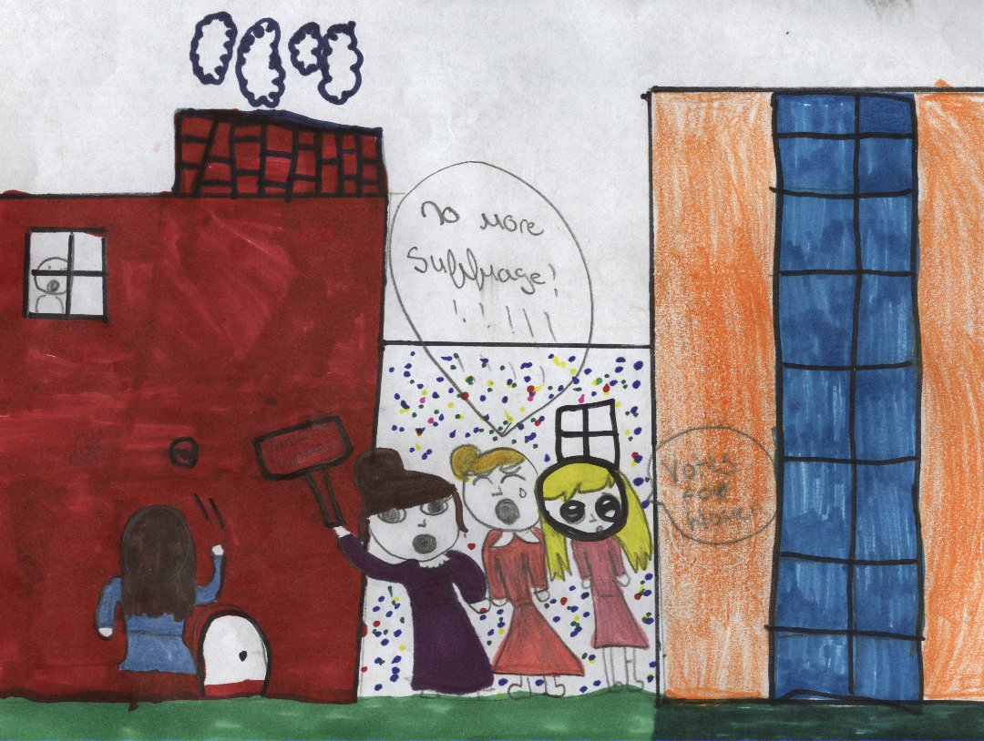

We met for lunch in Julie Davisson’s house where we discussed our plans for a peaceful protest outside the house of Parliament. Over thirty Suffragettes gathered at the gates wearing similar uniforms. We wore a purple dress, a white shirt and a green coat, each colour representing a powerful meaning. The purple was a sign of loyalty and dignity, the white stood for purity and the green for hope. I wore this uniform with pride as I stood with my friends and fellow suffragettes. We marched up and down the road for almost an hour until some of the ministers emerged from the building, escorted by the police. Even though this was a peaceful protest, they still felt in danger. The police began to push and pull us out of the way in an aggressive way. It was then that they recognised Emmeline who had a warrant out for her arrest for causing a political disturbance at the last protest. It was then decided that our protest would be called off and we would gather again at a later date. I have decided to get an early night after an eventful day. Bye for now, Alexandra.

1st Nov 1918

Dear Diary,

It has been a very busy few weeks since I last wrote. We have decided to change tactics because our peaceful approach was not working. We are using a more forceful strategy with violent protests. Since Emmeline was arrested, it has been my job to organise the gatherings. These gatherings have not always been successful, with many suffragettes being arrested for chaining themselves to buildings and setting post boxes on fire. Many of our women are on hunger strike hoping to get ate vote for women. Although I am disappointed that we have had to use a violent approach, this had to happen for our voices to be heard.

There are many protests planned for the next week. We will gather everyday outside the Parliament until we make a difference we have a meeting with a minister called John Stuart Mill on November 9th to discuss the right for women to vote. I have a good feeling about this, change is coming! I will write again when I have time.

Until then, Alexandra.....

(CHLOE)

Suffragettes

I fell out the bed with a THUD. I didn’t want to wake my husband, Harrison, up. I was on my way to march with all the other suffragettes. I took my coat and my shoes and went to the kitchen. “What on earth are you doing up?” I jumped when I saw Harrison standing in the doorway. “I’m just checking on the horses Harrison.” “Well okay, but be quick.” I ran outside and set off to Butcher Street which was the street we were going to march down.

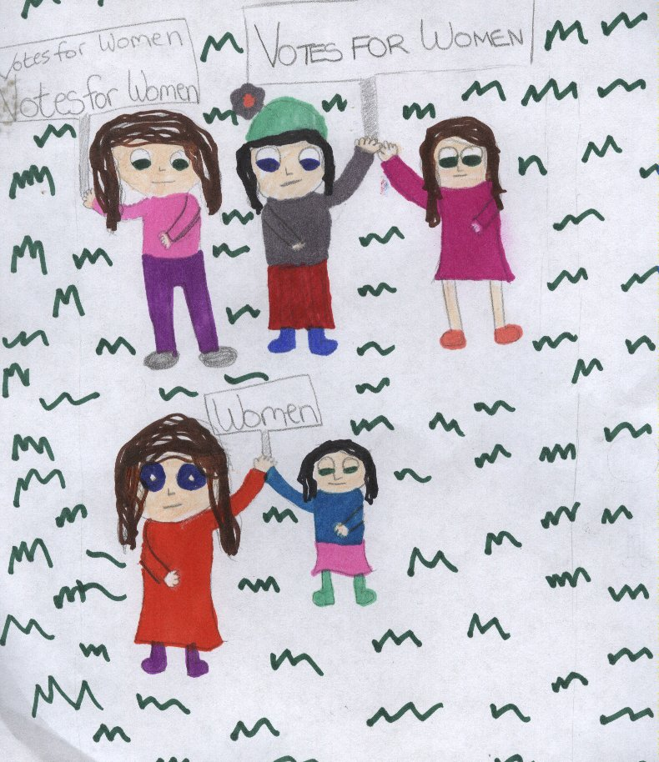

I started walking. After a while, I got tired but then I heard someone call out my name. “Patricia!” “Who is there?” A couple of seconds later I felt someone pull my arm. I let out a small scream, but then I saw who was there: my friend Julie. She told me that Harrison was looking for me, she said she saw him going up an alley shouting my name. “I thought he was going to go back to bed!” I knew I couldn’t miss the march because I had promised I would be there, but I couldn’t let Harrison see me. “Here, wear this. He will never know it’s you!” Julie passed me a huge brown hat that looked as if it had been made two hundred years ago. I put it on and we both laughed. When we stopped laughing I said that we should probably get to Butcher Street.

When we got there, I saw all of the suffragettes talking and getting ready for the march. “OKAY EVERYONE IN YOUR PLACES!” I was scared that Harrison would notice me but Julie told everyone to try and hide me. I marched with a huge sign that said “VOTES FOR WOMEN”. I loved every minute of it. We were about to end the march when a man came from behind a wall and shouted “ WHERE IS PATRICIA? TELL ME OR ELSE ALL OF YOU WILL BE IN PRISON! I looked down at the ground but he was pushing everyone out of the way and looking at them to check if it was me. I felt as if he was coming right towards me.

“PATRICIA! WHERE ARE YOU?,” he shouted. He had called all of his soldiers to come. After a few minutes, the soldiers came and started looking for me. They were told what I looked like and had to find me. One of the soldiers came over to me. “Hmmm”. He put his hand on his chin as if he was trying to think of something. After a few seconds, he walked off and started looking at the other women.

I sneaked out from the other suffragettes and ran home. When Harrison got back after many, many hours he slammed the door and walked over to me “Where have you been Patricia?” He looked angry. I have been at Julie’s house” “Alright just tell me next time” he said with a grin on his face. I smiled at him and then went to bed.

**Brooke Ní GHraith**

Suffragettes

Yesterday I went protesting so women could vote. I don’t think that it’s fair that men can do anything they want while the only thing women are supposed to do is clean and cook!

I made a giant sign saying Votes for Women!!!I also decided to go on hunger strike to show all the men that we are serious about wanting a change! Hunger strike means that you won’t eat until you get what you’re looking for! At least that’s what we suffragettes think it means.

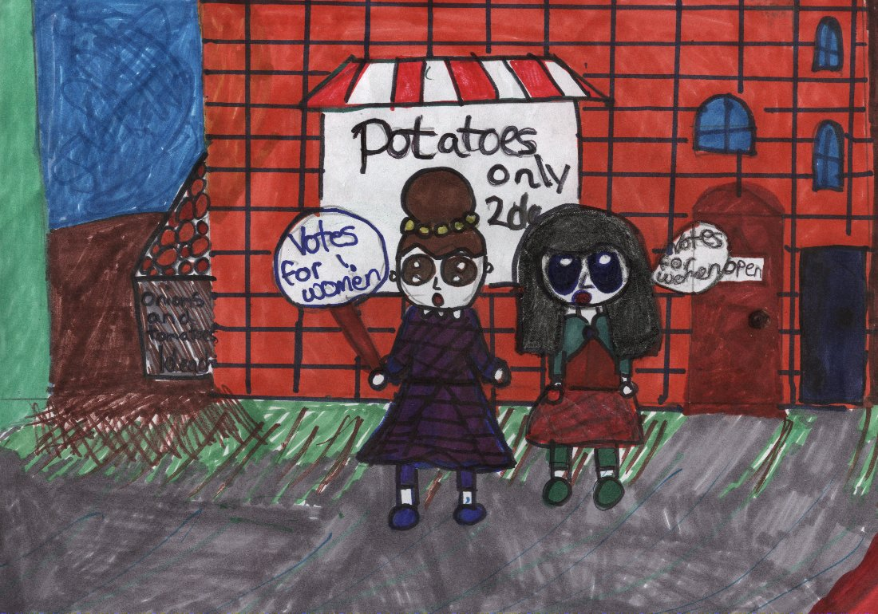

When we arrived at the corner store where we always meet before a protest, we got out our signs and we started walking towards the square. When we arrived there, everyone started booooooing at us. I felt like we would never be able to vote, but our Leader Christabel Pankhurst told us not to give up and that we would be able to vote soon! We kept protesting until six o’ clock that evening. When we finished, I walked home.

When I arrived home, I turned on the radio to listen to the news. Suddenly I heard them say something about the suffragettes! I turned up the radio full blast! The radio said “the suffragettes have won, women will be able to vote from now on!” I jumped into the air with joy, I felt so proud of myself! That night I cooked myself a lovely meal to reward myself for all my hard work!

***Casey***

Asquith’s Lucky Escape!

My dearest cousin Emily, I am writing to you from a prison cell. You may be wondering why this is so. These past few days have been unexpected and surreal. It all started two days ago when our Prime Minister, Herbert Asquith arrived in Dublin. As you may know, he came for public meetings with Irish Nationalists to sell their joint Home Rule Bill.

My friends Gladys Evans, Mabel Capper, Jennie Baines and I followed Asquith over to Ireland. My intention was to throw a hatchet at him while he was travelling on a carriage, to get him to notice us and our cause.

We hid behind a wall that was right beside the G.P.O. Once I saw the carriage coming over the Sackville Bridge, I aimed the hatchet at Herbert but, instead of striking him, I struck his companion, John Redmond, who was travelling in the same carriage. We quickly ran away and thankfully we didn’t get caught.

The next day we regrouped and discussed our next attempt to highlight our cause for women’s right to vote. We heard that Asquith was delivering his speech on Home Rule that evening in the Theatre Royal and we knew it was much too good an oppurtunity to miss.

That night we arrived at the Theatre. We saw a “strictly no smoking” sign and we knew that if we got caught doing what we had planned, we would be in big trouble. Gladys volunteered to set a chair on fire and throw it into the orchestra pit. I was quite nervous for this one but Gladys was unusually good at these things.

Once we reached the balcony, Gladys lit the chair and threw it off the balcony. Immediately we heard screams and knew our plan had worked but, after a few seconds, we looked down and saw that the fire was already extinguished. We made our escape through a back exit door but the police had both exits and entrances covered.

We are now captured and in prison. We face the charges of bodily harm and damaging property. I sit alone here in my cell contemplating my fate. I am sure I will be sentencedto penal servitude, but I do not regret my actions for a minute. I will continue to fight for the movement. I ask you not to worry about me. Please continue to do all you can for the cause on your side of the water.

Kindest regards,

Your cousin, Mary Leigh

*(Dearbhla)*

SUFFRAGETTES

Dear Diary,

It is 1905. My name is Christobel Pankhurst. I have been an activist for women’s rights for some time now. Together with my mother and sister, we established the Women’s Social and Political Union.

Today has been a memorable day in my life. My friend and colleague Miss Annie Kenny and I interrupted a meeting in Manchester. We asked Winston Churchill and Sir Edward Grey if they thought that women should have the right to vote. Neither of the gentlemen replied to our question. We then held up a banner saying ”Votes for Women” and shouted loudly at them.

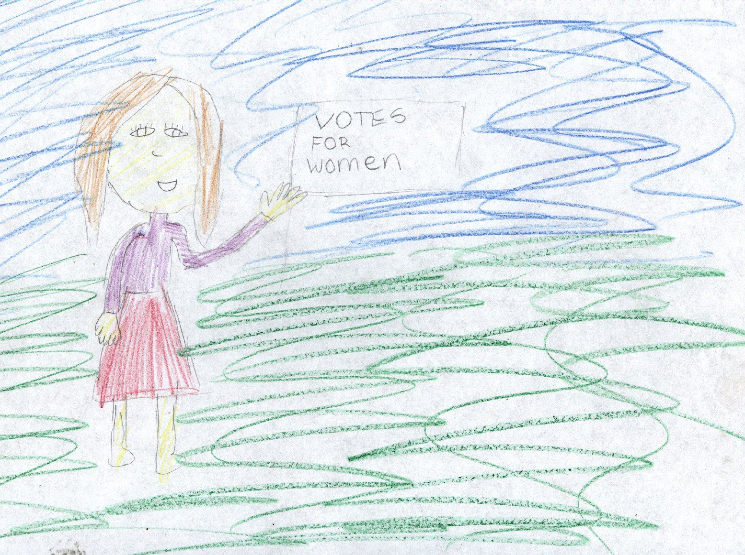

Our attendance at the meeting was not welcome and we were ejected from it. The police have arrested us and I’m sure that we will be fined for our action.

Today has been the start of a campaign. We will continue to interrupt meetings and get our point across

Signed

Christobel Pankhurst

(Ella L)

A Misadventure

I, Emily Davison, am a proud woman. It was my dream to be able to vote and I found it unfair that women my age could not vote for any local or general elections.

It all started around the summer of 1913. I’d sneak out during the night and start protesting with my friends. We’d smash windows, burn furniture and scream and shout all night long. One day, we decided to at mid-day. We were finished painting our banners and set off to go protesting, when something went terribly wrong. A middle-aged man approached us and started booing (just like many other people nearby). Suddenly I lost control of my actions and smacked the man across the face with a chair. The man fell to the ground. I then realised what I’d just done. I quickly knelt down to check if he was still alive. Luckily, he was still breathing, but he was out cold.

Soon enough, the ambulance and the police arrived. The man was taken to the hospital and I was arrested for attempted murder. This was the ninth time I was arrested and I wasn’t looking forward to it.

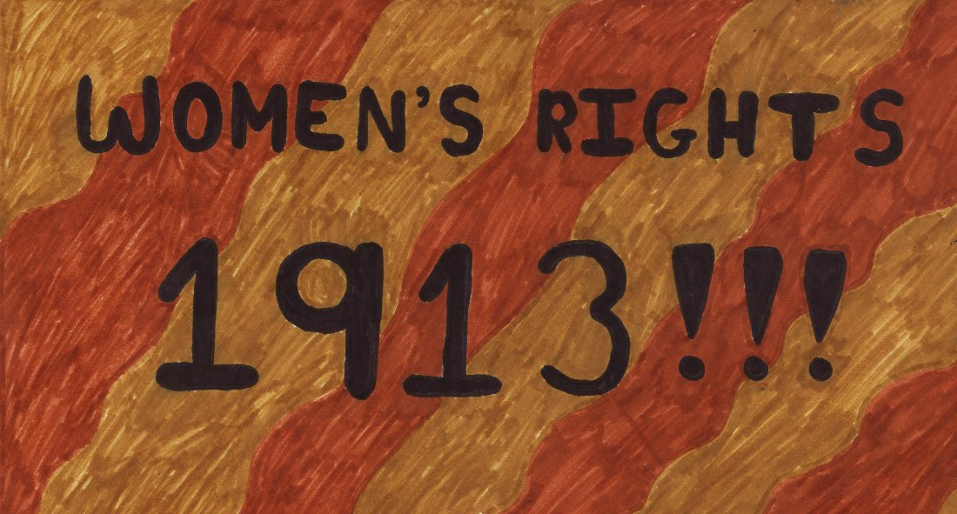

As soon as I reached my prison cell, I immediately went on hunger strike. I wasn’t going to waste any more of my time over there. One day a doctor grabbed me by the arm and pulled me into a room with some strange equipment and plenty of nurses. Out of nowhere, the nurses pulled me and strapped me to a chair. I attempted to fight back but it was no use. It was five against one after all.

When I was securely strapped in, the doctor pulled out a four-foot-long tube and stuck it down my throat. It was only then when I realised I was being force-fed. Liquidised food then came rushing through the tube into my stomach. I vomited all over my hair, my clothes and even the wall, but the doctor didn’t seem to care. From that day on, I tried to avoid passing by that room.

I eventually got extremely ill. My trial was postponed until I became healthier, and I was fit to be sent back to prison. One day, when I was strong enough, I went to the Derby. Right, when the king’s horse was passing by, I ran in front of it, and I was trampled. I then realised my mistake, but it was too late. I was sent to the hospital. Four days after, on the eighth of June, I slowly drifted away from the real world, never being able to fulfil my dream.

*Máire*