Eight Dog
I saw in the corner of my eye someone running towards me. He was shouting “THE PALE FACES ARE COMING!” I immediately ran towards him. I asked him to repeat himself. The second time seemed more realistic than the first. The only reason I believed him was because he was told to keep watch ever since our leader has a disagreement with the Europeans. But all the training I had at my telpochalischool finally paid off and I was ready.
I ran to my father, who was out hunting, and told him that the palefaces were coming. He immediately dropped his spear. He grabbed me by the hand as he said “Go make sure your Mother and Sister are alright.” Suddenly fear struck my heart. “What will happen to you?” I said with a lump in my throat. “I don’t know my son” he said. I could feel the sadness in his heart as he said it. I hugged him and I ran to my small house made out of mud bricks. Inside were my mother and my sister. I told my mother. She grabbed my three-year-old sister and carried her. I followed her down the small hatch in the corner of our house, disguised by mud and grass, and we went down a ladder. My sister, Six Rabbit, was fast asleep in my mother’s arms as my mother struggled down the ladder. It took us the last four years to make that little bunker. My father did most of the work but I liked to help. In the bunker was enough food to last us two months.
Suddenly it came to me that I was a boy and I had to be involved in the war. It saddened my heart to know I had to leave my mother and sister. I grabbed my bow and I climbed up the ladder. I could hear my mother crying quietly to herself. A few tears came to my eyes. I walked out the hole, that we call a door, and I saw my father on the floor in a pool of blood. I ran over to him. I screamed to his friend “WHAT HAPPENED?!” I regretted saying that as soon as I saw his face. He looked as sad as I was, after all, my father was his best friend. I could hear him say “a European shot him with a gun.” A gun? What was a gun? I’ve never heard of it before. I turned around and there was a European holding a weird metal object. I shot him with my bow. I took the metal object. That must have been what had killed my father. I was too distraught to even remember the name. The only thing I could think was “Revenge”. I shot every European I saw. I saw another European. He turned around. He was holding a gun too. I didn’t even delay. I shot him right on the spot.
Then I realised there was no happiness in killing all these people. I felt I did my part. I dropped my gun and took the bow off my back. I ran as fast as I could to my little house. I ran inside. I climbed down the ladder and I saw my mother and sister. I wanted to be with them not out fighting. I sat down next to her. Suddenly I heard someone above our heads. I put my hand over my mouth. I heard someone with a British accent say “I found a hatch!” I wanted to scream but I knew to stay quiet. He came down and shot my mother.Then he shot me.
I lay on the dirt floor as my life faded away. I wanted to save my mother but I couldn’t , at least not in my condition. The Europeans had won and there was nothing my small tribe could do to stop them. I had to face the facts that the Aztecs would just be history and nothing more.

Anneliese Ni Pheatain

The North Americans Attack
The air was dusty and the wind was blowing hard. I was in the middle of grooming my horse when I heard a deafening scream from the chief. “The pale faces are coming!” I was so panicked that I began to feel weak. I hopped onto my horse and galloped towards the village. My heart was pounding so loud that I was feeling sick in my stomach. The dust was hitting my face and the sun was reflecting off the Mississippi river. I could see the chief waving at me from the distance. As I approached him, I could hear the palefaces right behind me. Suddenly the chief fell to the ground. When I reached the chief, I noticed a bullet wound in his chest. I had no idea what to do, so I lay there feeling like I was going to faint, as the north Americans galloped away...
I could hear screams coming from the village and guns being shot. I decided to do something because I was being very useless. Once again, I was on my horse and heading towards the village. The village was empty, with not a person in sight. I was alone and had nothing to say, nothing to do or nothing to see. I looked around the village searching for any wounded people, but all I found was an empty village. After an hour of looking around, I decided to go somewhere where I could lie down.
The next morning, I heard crying from a house. I went inside to find a little boy crying because he was all alone.”I’m alone and scared”, he said in a timid voice. I explained that it would be okay but he had some explaining to do. “Men came and frightened people with a gun and they are holding everyone hostage in a cave, but I hid here when they came,” the little boy said. We both hopped onto the horse and headed for the cave. When we got there we hid behind two men that were standing outside the cave. We quickly ran into the cave. There we found everyone in a massive cage that was on the edge of a cliff. They were all pointing at keys that were on the wall. They begged me to hurry up because, in sixty seconds, the cage would fall and it would be a dramatic death story. Without thinking twice, I grabbed the keys and tried to unlock the door of the cage. 10,9,8...I was trying so hard but it wouldn’t open...5,4...The sweat was dripping off my forehead...3,2... I got it open! ”RUN!”, I shouted...1. Everyone was out and saved but the north Americans were gone. Everyone was saved and, from that day on, I was the new chief of the Apaches.

Chloe, new chief of the Apaches.

The North Americans
Someone shouted, “The palefaces are coming!” I grabbed my dun Appaloosa horse Sandstorm and galloped away over the hills. I dismounted and brought us both into a dark cave so we were invisible. I heard the shouts from the Natives, “Hide all valuables hide your horses!” Next thing I knew my mother came running in, her face distraught. “The white people have stolen all our goods, killed the chief and killed our father!” My heart sank deep, deep down not because of sorrow but of disappointment. My mother and I were going to have to find another tribe to live with, the whole tribe has died and the only survivors were my mother and me.
We both slept in the cave and the next day we were on our way to find the Choctaw tribe. Our cousin is the chief of the tribe. He went off from our tribe because of fighting and disagreeing with the locals. I loaded up the packs with some leftover bison from last week’s feast. It was the only thing we had. My mother got to ride Sandstorm south down to Choctaw. I walked most of the way so my feet were tired and sore. We had to stop a few times on the way because mother was tired. I hunted for bison because we were on the edge of starving. The worst thing possible happened. I actually ended up killing a bison of the Pawnees tribe. The chief came running over with spears in his big fat hands. You could tell that he was being fed well, that wasn’t the point though. I mounted my horse and hauled up my mother. She was still half asleep but it was as if she knew what was happening. Mother grabbed onto my waist and, even though she didn’t know how to ride properly, she went with the feel of Sandstorm.
We galloped across all the dry cracked plains of the land of Pawnee, Sandstorm just kept on going for miles and miles. I was amazed at his stamina and speed. We reached the Choctaws’ land. It was rich with plants and tees for horse grazing. We left our loyal horse Sandstorm to graze. Mother and I walked over to the chief, Chief Whirlstorm. “Us wanderers are your faithful cousins so will you let us join you?” He stood there staring at us dead in the eye. “We will hunt bison for big feasts” he still stood staring at us. “We will have to sacrifice two dogs’ lives for you to join, it will give you good luck for the rest of your lives. You will start fresh and start your new lives with the Choctaw tribe.” We were animal lovers mother and I, but we had to, it was our only chance to live. The whole village gathered to watch these two poor dogs being killed. I couldn’t bear to watch but when the chief lifted up the knife it was all over in a split second. He spoke in the traditional language of Choctaw, and then burnt the dogs’ corpses. I was so sad watching this all happen but, when the sacrifice was over, everyone celebrated our arrival.
The whole village was kind and caring to us and they gave me a bay majestic stallion. I rode him the next day and I felt like I was walking on thin air, although nobody could replace my beloved Sandstorm. My mother and I lived in a tepee that has enough room for our horses. We were accepted in every way and we enjoyed our lives thoroughly. The chief was the kindest person we ever met and once every week we had a delicious feast all together.
Leila Dickson
Young Dove

It was when I heard the warning horn I knew something was wrong. I’m Young Dove. I live in Crow. We had been receiving other warriors from other tribes for weeks but no one would tell me why. Our tribe leader, Big Bear, hasn’t come out of his tepee for days but, as soon as he heard the horn, he didn’t hesitate to sprint away from his beloved tepee. My mother grabbed me by the arm and dragged me away from the camp I had grown up in. I was so confused but I understood why when I saw a new race of people running towards us in anger. These were the palefaces, the people who our tribe feared.
Our weapons consisted of bow and arrows, knives, spears; and our horses to ride on. Their weapons were very different, things I had never seen before. They were long and when they were set off they gave an awful loud noise which always followed with a scream. I had never run as fast in my whole life. While I was running, I saw my friend, Young Tiger, running while holding her younger sister. I ran to her forgetting what was going on but, as I reached her, she fell to the ground limply. I didn’t have time to mourn about her death so I grabbed her sister and ran. I saw my mum looking around worriedly she then sat on the floor. I was so confused in why she flinched before she fell. I ran to her and bent down beside her and tapped her but she didn’t look up. I pulled at body it felt wet. I looked at my hand it was covered in some red liquid: blood.
I was flooded with tears. She was the only family I had, but I had to keep running if I wanted safety for myself and Young Tiger’s sister, Little Cub. I was her only chance. I had to keep running…and fast! The pale faces were still charging towards us. I would have to reveal my secret hiding place to Little Cub even though it’s a place I go to escape the camp and tribe, but that wouldn’t be a problem anymore. As we walked in, it didn’t even look secret anymore. It looked like a place I would be for a long time. This was my new home now. I looked at Little Cub with fake smile plastered on my face to give her some hope, but she wasn’t fooled. She burst out in tears as she looked around the shabby, hard, uncomfortable cave. We walked out of the cave and looked over our old camp. I had to hold back my tears. Several of the tepees I had walked into just an hour ago were ablaze. A few of the palefaces were still walking around looking for goods but, I didn’t have any energy to hide. We had to some get sleep because in the morning we would set off to find another tribe. It might take days but we have to keep going. Where? I didn’t know….

Isabel Ní Ghabháin.

Lizard Ten

There I was standing in our farm, waiting to hear the screams of my parents. I was hiding in the horses’ stable with my little sister. I was terrified for our lives. All of a sudden, I heard a big BANG! I didn’t know what I should do. I could run in and be killed by the paleface who had just killed my parents, or I could stay with my sister and I might be safe. I decided to stay with my sister and keep her safe because she was so scared.
After a few hours, my sister fell asleep so I went into the house to get some food.But when I went into the house, there were five palefaces waiting there standing in front of my parents who were on the ground.Their eyes were open and there was blood everywhere. The pale faces looked up and saw me. They all picked up their guns and pointed them at me. I stood there frozen with fear, I couldn’t move.
There I was staring death right in the eyes. Then… they fired. Only two of the bullets got me. I dropped to the ground in pain. I had one bullet in the arm and the other in my leg. I screamed so loudly that they had to cover their ears. They laughed and walked out of the house. My sister ran in. With horror, she looked at me and ran to get something to stop the bleeding. She ran back in with an old tea-cloth and ripped it in half. She put one half around my arm and the other around my leg. She told me everything was going to be alright.
I suffered in pain for the next couple of days. We stayed in the stable but we brought some food with us, but the food was scarce. We heard screams all day long every day and I was terrified even though we were safe…for now. For breakfast, we had a slice of stale bread, and for dinner we had raw beans.
We fed the horses with grass from outside. We helped each other because we had nobody else. After what felt like forever, the palefaces were gone and we could finally go outside. We were still very careful in case they were stillhere, but they weren’t.They were gone and they never came back again
Even though our parents were gone, we still had the rest of our family and friends to stay with, and we still had a long life to live.

By Brooke NíGraith

Lizard Four
“Run Lizard Four! Run!” shouted my father as I started to sprint.
I ran as fast as I possibly could to get away from ‘The Pale Faces.’ As I ran, I couldn’t hear my father anymore. I dreaded that moment, thinking back. My mother was already dead at this rate. I didn’t want to think about my father or what was happening to him. I couldn’t lose my mother and father. My little sister ran with me as we charged through the dark woods. My sister Panda Nine was only young and she was terrified that she would lose our father too.
We ran as fast as we could. At this stage we couldn’t even hear the screaming anymore... As we ran, a bullet was fired from a gun and I ducked down. I was so worried about my father. I’m sure Panda Nine was too. We kept running for about another mile. I got so tired, I stopped and fell on the ground. “C’mon! We have to keep running!” Panda Nine said as I started to stand. “How much further should we run?” asked Panda Nine. I didn’t stop, I just kept going.
I finally reached a bench, where we both sat. I reached into my backpack and pulled out some dirty water and a sandwich that my father got this morning. I halved it, giving some to Panda Nine. Panda Nine then began to cry. I knew that she was crying because our father was probably dead. I told her we should probably run back to our cottage to stay safe.
After three hours of running, we were back in our cottage. Our father wasn’t there so he was obviously dead. I looked in the pantry, which wasn’t even open. We had some raw fish for our dinner. Then I heard a knock on the door. I hesitated to open it. I did though. It was the palefaces. There I was standing in front of my death. I was terrified. Panda Nine screamed as the pale faces came even closer. I ran into the kitchen and grabbed a knife. I ran back in and stabbed every one of them. After that, they lay on the floor helpless.
Suddenly a broad, tall man barged in. It was our father. We were so glad that we were safe now.
Ella B

The Aztecs

“Run Vulture Nine”, screamed my mother as an armed man charged at her on a big horse. That was the last time I saw my mother. I then sprinted into the woods and didn’t look back. As I ran, I tried not to think about what was happening to my mum. I just ran until I couldn’t hear the screaming and couldn’t feel the pain. Two weeks later and I can still feel the pain, hear the scream, smell the smoke of my village burning away.
I have been living of the fear of dying and the will to live. The hope to get revenge on the palefaces for what they did to me my friends and my family and my friends. I couldn’t let go of life. I couldn’t die until I made them pay, pay for everything. I was living on dirty water and assortments of sour berries. But I was living, and that was all that mattered. I knew that the fighting was over in the village, and that the palefaces wouldn’t leave anything valuable or anything living. But I had to go back.
I had to kill the palefaces before I ran out of food and water. I knew I couldn’t kill all of them. I was determined, but not stupid. I had to build an army with what was left of us if that was anything at all. There were more of us all in different places and I had to find all of them if we stood any chance at all. I was worried about the other Aztecs because I knew that the palefaces were coming for them just like they came for us.
I knew I had to save them and maybe even catch the palefaces while I was at it. But I knew they wouldn’t listen to a little boy like me. They would probably just use me as a sacrifice. So I made a plan a great plan. I found the other Aztecs and pretended I was a young god. I told them the stories of the palefaces and they believed me. So we spend the next week preparing for them. Then they came and we were ready. We killed all of them. Some of our blood was shed but not enough to make us stop fighting and we won. We will be forever remembered for that amazing battle.
Freya.
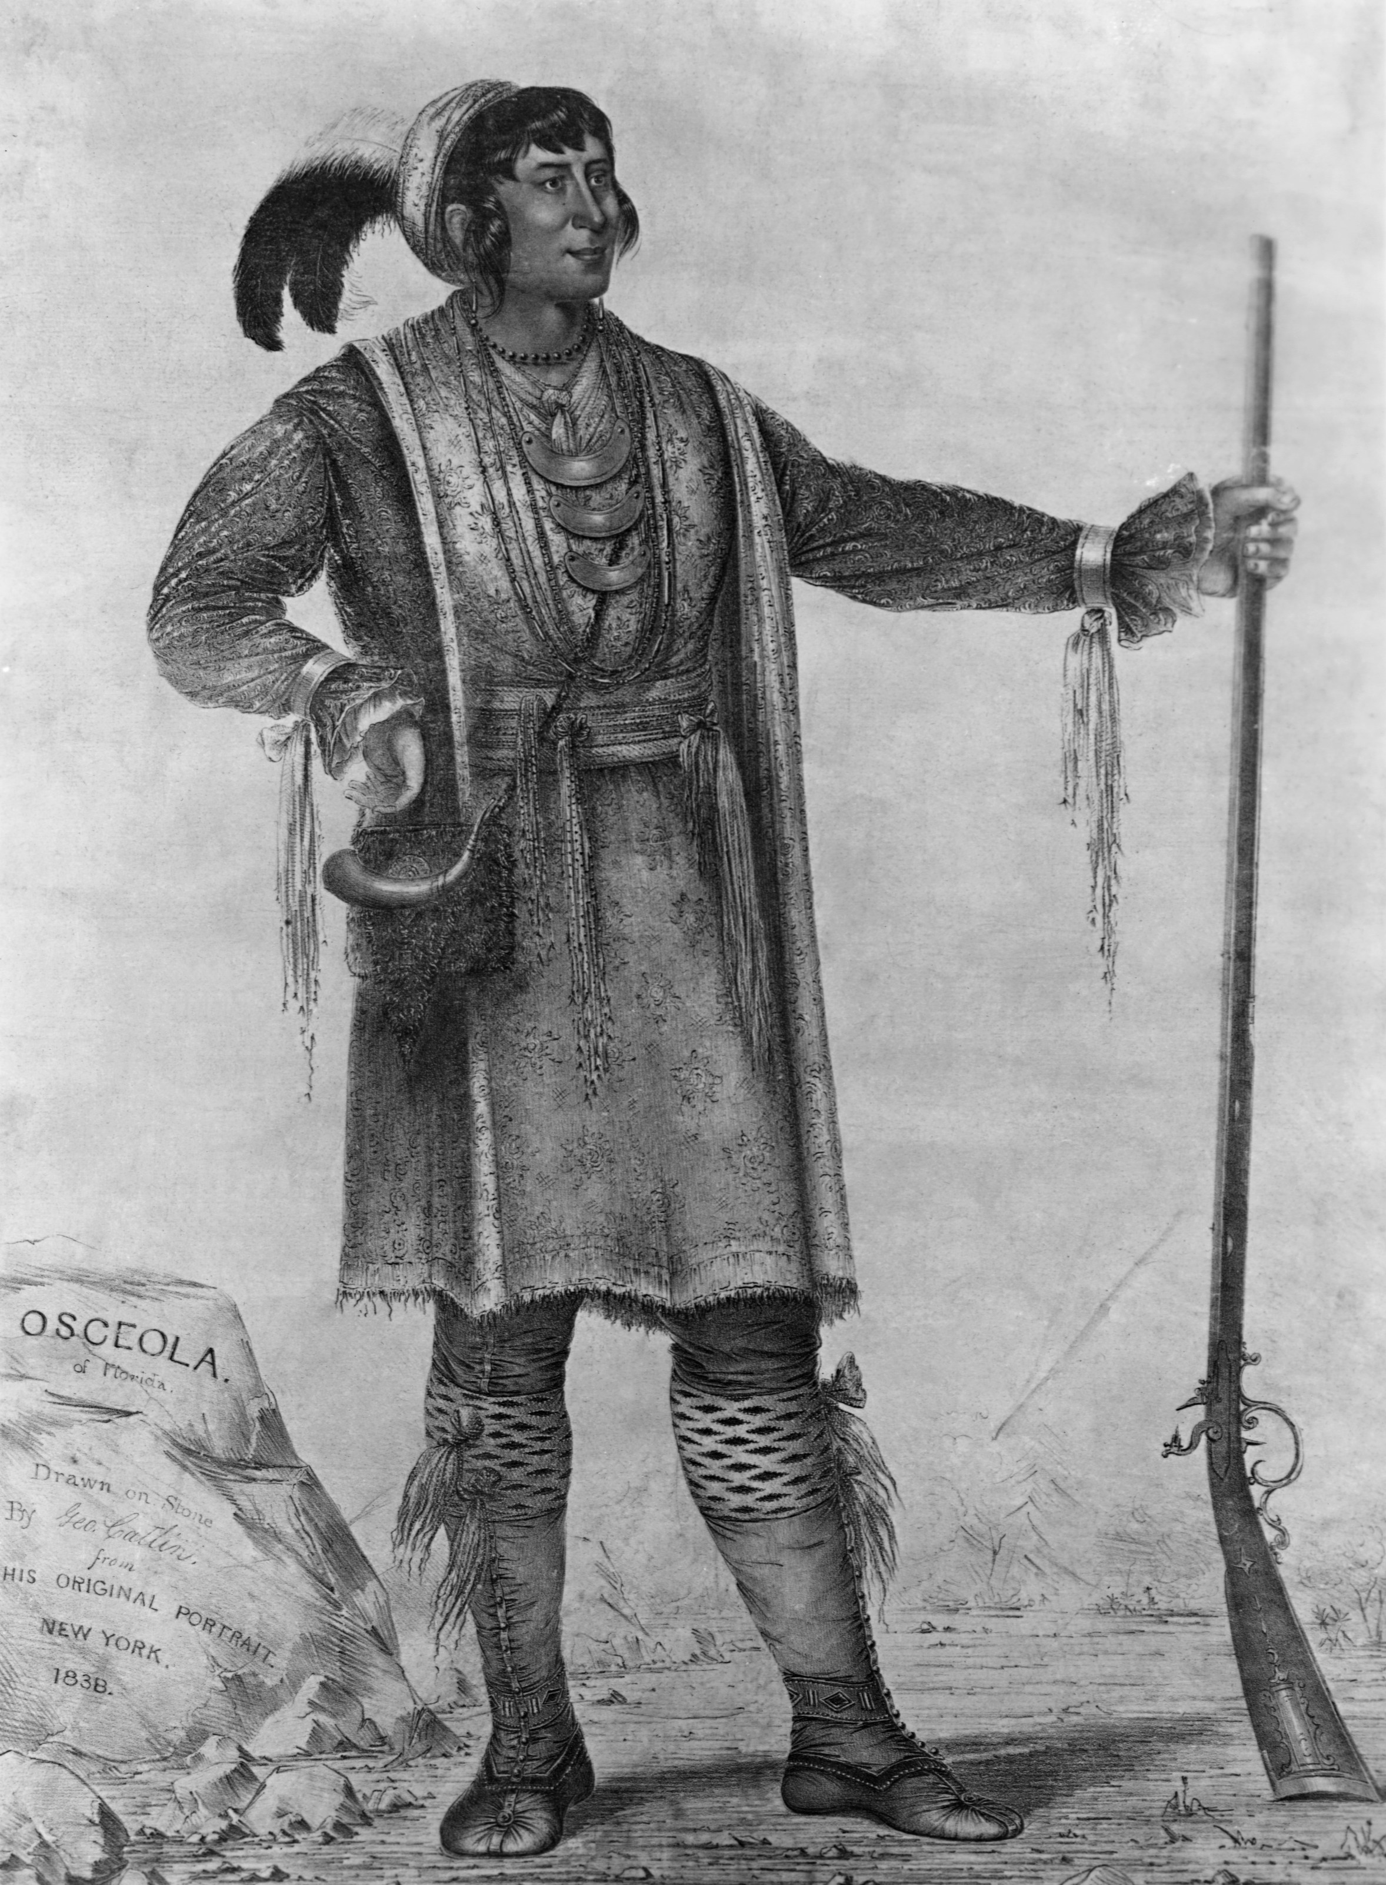
The Palefaces are Coming!
It was a normal day for us Apaches.
We were just waiting for our brave hunters to bring back tonight’s meal. I suddenly heard a high-pitched scream! I turned to the direction where the scream came from. I saw my friend running towards me! He started screaming “The Palefaces are coming!” In the distance, I could see the Palefaces on their horses heading in our direction. Suddenly my friend dropped to the ground! I ran over to him to see what had happened. Once I reached him, he was lying in a pool of blood! He had been shot by the Palefaces! He was well dead so I left him there. I started running towards the village.
When I reached the village everyone was getting ready to eat. I didn’t know what to do! I decided to tell our ruler Pilla, once I reached him I told him everything that had just happened! He told me that I had to get our bravest warriors! I did what he had told me to do, I gathered all of our warriors and I told them to kill all of the Palefaces. While the warriors were out fighting, I tried to get some sleep but all I could think about was the Palefaces destroying the village and everyone in it!
When I woke up, I heard the sound of guns and screams! I jumped out bed not knowing what was going on. I opened the door to go see what was going on outside when a big storm of sand and dust hit me and knocked me over! Once I was able to stand up again I walked outside to see what was going on. The first thing I saw was a lady lying on the ground screaming for help. I asked her what had happened. She told me that the Palefaces had killed all of our warriors and then they burned the village! I helped the lady up and I let her get some rest in my house. Then I grabbed my sharp sword and I headed out the door in search of the Palefaces.
Eventually, I found their main base. I ran into the tent full of anger! I charged at them with no fear, but they were too strong and powerful for me. One of the palefaces shot me in the arm and I fell to the ground in pain! They started shooting me over and over again, I tried to get up but I was in too much pain! I had to give up. A second later I was dead! There was know one left to save the village or the tribe, the palefaces had beaten us!

By Casey Ni Loinsigh

Five Crocodile
Before the Spanish came the in Tenochtitlan was blissful. I went to school and learnt about housekeeping with my older sisters, while my brothers were at the telpochali. I lived in a sun-dried, mud brick house with my sisters, brothers, parents, cousins, aunt, uncle and grandparents.
One day our Emperor, Montezuma 11 announced that one of our gods was arriving from Spain to rule his believers. This was all we talked about that night and at school the next day. When I arrived home from school, I heard desperate shrieks, hoof beats and wild howls. I felt a shiver run up my spine and my senses were alert. I saw a gruff man approach me on a black horse, with foam streaming down its powerful neck. ‘I am Hernán Cortés and I am here to take everything,’ he sneered.
Cortés was followed by hundreds of sunburned men on horses, and aggressive dogs, double the size of me. Suddenly, I saw my eldest brother, Ten Lion, who was the strongest in the whole tribe, sprint out of my house. He ran towards Cortés and tried to hit him with an arrow, but failed miserably as one of the dogs ripped him to shreds. Suddenly, the whole tribe was in chaos and I was frozen to the spot. I was no longer able to identify my family, in the masses of people. The only thing I could do was run.
I ran as fast as I could, with tears streaming down my face. Suddenly, I heard a dreadful moan. I stopped in my tracks and peered behind a nearby rock. I was flooded with relief, when I saw who the moan was coming from. It was my dear sister, Thirteen Cheetah! She had been shot in the leg, and it was pumping blood. I knew exactly what to do, as I had seen my mother tending to my brothers’ wounds. Once I had tended to her wound, we started to flee the area. She was still in pain, causing her to be very slow, but eventually we decided we were finally safe. As we sat on a boiling hot rock, as we went through our plan. We decided we had to keep going, as the Spanish would be arriving soon. We set off on our long journey off the island of Tenochtitlan!
Once we reached the border of the island we hesitated, but eventually we came to our senses and dove in. The water was warm and Thirteen Cheetah and I were accustomed to swimming in the sea, as we swam a lot when we were younger. I started to get nervous as I thought about the long journey ahead of us, but I realised this was our last chance of life.
We finally reached the mainland after a week and a half of swimming. We were exhausted and we both collapsed at the shore. I was relieved and shocked that we had made it the whole way without getting seriously injured. We lay there for hours just thinking about life before the Spanish came and our loved ones who were most likely dead. Suddenly I felt myself drift into a deep sleep.
Now it has been six years since the Spanish arrived at Tenochtitlan, and I have heard little about any survivors. Thirteen Cheetah and I have been planning to return to the island and today was the day. After the long journey, we finally set foot on Tenochtitlan, after six fateful years. We hesitated for a while, but we carried on. Suddenly, the tears started streaming down our faces as we realised all that was left of our once wonderful home was dust and our tribes faded flag.
Alexandra

Attack of the Spanish
Le Máire Ní Dhubhda
There I was... staring death right in the face. The pale faces were here. My body froze with fear, I couldn’t move a muscle. “Run Eight Gorilla, RUN!!! Come with me!!!” my mother called as she gestured to follow her. The more I stood there as still as a statue, the closer they were to attacking us. I had to do something ... I had to hide... but where? I looked around trying to find a safe place to hide. There was no time to run and that small bush beside me was my only choice. I scurried over to the bush and tried not to breathe too loudly. I could feel the tears running down my cheeks “Don’t cry Eight Gorilla, don’t cry. They’ll hear you, and plus... it’s embarrassing for a boy to cry.” I thought to myself, but it was no use, the little tear drops soon became waterfalls.
Soon afterwards I could hear the Spanish trotting along on their so-called “horses”. I popped my head around just enough so they couldn’t see me but I could see them. It was interesting to see what kind of armour they wore and the weapons they used. They were much more different to us. We never had such strong armour as they did. Their weapons were much more efficient than ours too! I moved a bit over to the side to take a closer look, but I never noticed the little bird sitting in the bush. My movement frightened the bird and flew away. “Wait!” began one of the soldiers in Spanish “I think I heard something in the bushes.” The soldier hopped off his horse and slowly moved towards me. “This is the end.” I thought to myself. The soldier peeked over the bush and he saw me clear as day. He paused for a few seconds, probably deciding which was the best way to kill me. “But it’s just a child.” He whispered to himself. He then quickly turned around and hopped onto his horse. “False alarm! Carry on!” he ordered as he looked back once more at the bush. “Good luck young one!” he whispered. “That was a close one” I thought to myself.
Eventually the soldiers left the area and I stood up to have a good stretch. “What do I do now?” I thought as the tears started to pile up again. “Hey...Eight Gorilla...over here my child.” I looked to my side, the tears suddenly stopped... it was mother. “I thought you had left!” I cried with joy. “Why would I ever leave my only child behind? I’d never be able to live with myself.” She replied with a big hug. “Where will we go now?” I asked. “Wherever the wind takes us.” she replied with great wisdom. We then walked on hand-in-hand, looking for a new tribe... to start a new life.

Máire

Seven Vulture
The place where I was staying was not habitable.
The next morning all my bones were sore from sleeping on the ground. When I woke up, there was mud all over me. I didn’t have to clean up after me because I was late for school. I have two sisters. They were all ready up getting their rooms cleaned, even though they don’t go to school because they’re girls and all they do is clean around the house. Sometimes they go over to the neighbour’s house and clean their houses too.
My school is very strict. If someone is late or lazy, the teacher gives you a painful punishment by being pricked by a cactus! I know that I am getting that today. At school we learn how to become soldiers so it’s hard if you miss a day.
My mum is a very hard-working mum. She does everything on her own. For example she takes care of three kids on her own because my dad has left us. Dad has gone off farming, but it’s kind of a good thing because dad is a very mean man. Every night he would hurt her and I would hear her scream. It was really upsetting. He would never get mad at us but if you looked at mums arms and legs they were all bruised. I never really liked him anyways. One day when dad was gone to work mum packed all our stuff up and left. Mom said if we ever see him, we would have to hide. I didn’t really know why but I’m guessing it because she doesn’t want him to know where we are.
One day I saw him walking with a girl. I had a feeling I knew who she was. I kept my eye on them the whole time. Just before I left, I realised who it was. It was our old house cleaner. I couldn’t believe my eyes! I was so upset; I hated the feeling of my own dad being with another woman. I hated it and I hated him. I wanted to run back home to mom and tell her but if I did I knew she would be so upset so I decided not to tell her. I then saw them going into our old house. How could he do such a thing?
When I walked into my class, the teacher was so mad at me even though I was only five minutes late. He pushed me up against the wall, and then he grabbed the cactus and stabbed it into my arm. He repeated it five times because I was five minutes late. My arm was over flowing with blood. I ran over to grab a cloth and covered my arm up. Just as I sat down on the ground, the teacher called everyone up to get their neck pulled. They did this to make our necks look taller. It was the most painful thing ever, not as painful as seeing may dad with another girl, I thought.
I have a great family. I love my mom, my sisters, but I really don’t like my dad. Some families don’t have enough food to feed their children, but luckily my family doesn’t have that problem, because we live right in front of a farm. This patch of land was up for sale so my mom decided to find out how much it was. My mum found out the price and she said it really, but I’m not too sure about that because she said that we didn’t have enough money to buy vegetables, but we already had some that we took when we left dad.
One day we were told to leave school early witch was very unusual because that had never happened before. I didn’t think much of it until I got home. Mom had every thing packed up and ready to go. I asked her what was going on. She replied with a very shaky voice “the palefaces are coming”. At this point I was so scared I was nearly in tears. I knew this was a very bad thing. A thing that could end my life, my whole family’s life. I knew that I had to stay strong and help my family. I never treasured my family, my life and my house as much as I did now. This could be it the end of us Aztecs.
Drew Courell

Nine Vulture

Hi my name is Nine Vulture. I am ten years old today and I have decided to start this diary because I feel like I need to tell someone or something my feelings. My mum said that because we are living in a dangerous place it is nice to have something to do to get your mind off the dangers of the world outside, she said that I can rant on and on and on about anything I like there is such responsibilities on boys that its nice to have a sit down anyways I’m going to tell you my life story now [I don’t know why I’m so nervous].
It all started on my seventh birthday. My dad said that he had to go out farming for a couple of minutes. He never went away on my birthday why would he? Is he hiding something from the family? Is he getting me a present [even though I know my parents can’t afford to buy me a present]? I told myself I had to stop worrying and that everything would be ok. After an hour or two, I started getting really worried. I told my mum I was going to go for a walk. I walked across to the farm to find a letter that said, that he [my dad] was leaving to go and travel the world. I didn‘t know what to say. I ran back, fighting away the tears, and said that I had to be strong for my mum. She was rearing to young children and had to look after my granny and granddad and also me. She always said that I was the hardest to look after and that I don’t deserve to live with such a loving and caring family but, deep down, I knew she was just taking it out on me. I knew it was actually my dad. He was always saying that he would go away someday away from the mayhem, away from all worries, away from Mexico and, most of all, away from me. I had to put those thoughts behind me and I had to put on a brave face. I walked in the door, clenching the letter as hard as I could. I could feel my palms sweating, my face going red and my feet giving up on me. I collapsed to the floor. I woke up after about twenty seconds with my mum looking into my eyes, and saying that she had read his letter. “I’m sorry, I shouldn’t have got into trouble in school.” “It’s not your fault dear, your dad is going to come back. Wait until you see.”
Ever since that day, if I see a dandelion I blow it making the same wish always for my dad to come back. To this day he hasn’t stepped foot in the house. A lot has changed since too Granddad died, we had to move house with another family because we couldn’t afford to have a house to ourselves. We had to go into hiding because Hernán Cortés came with five hundred people, killer dogs, guns, cannon and horses. Now everybody is terrified of the Spanish guns, and even the sight of the Spanish in their armour frightened them.
I guess I will have to leave it here for today my hand is in pain for writhing this much see you tomorrow bye.

Niamh Ní Fhearaic.

Eight Dog
“Run!,” said Pa “The Palefaces are coming” “But I can’t!” I replied “I’m crippled”
When I was five years old I was in an accident involving a cow. I was left without the use of my legs. All of Tenochtitlan were debating as to whether to use me as a sacrifice that day. In the end, they decided against it because I was an Aztec and there were plenty of people from other tribes that would do. My ma was over the moon but my pa was disappointed because he had wanted me to be dead.
My parents were debating as to whether or not I should be sent to Telpochali when I heard a bang. I saw my ma lying flat on the ground in a pool of blood. On closer inspection, I could see a small spherical thing in her head. “Run,” said Pa “The Palefaces are coming” “But I can’t” I replied “I’m crippled”
That’s when I had a brilliant idea “Give me two sticks and cover me in Ma’s blood, I can use the sticks to move around and, if The Palefaces see me, I can lie down on the ground and pretend that I’m dead.” “Great idea, but what about me?” “Well I never really liked you anyways.” “Wait. What?” “You wanted me dead.” “I’m sorry for all of that now.” “Well, now is too late,” I raged as I dragged myself out of the house with the sticks.
The happy city that I grew up in resembled nothing but a pile of rubble. I was heartbroken. I stayed just outside my house staring into the distance when I heard another bang. I ducked and lay on the ground. One of The Palefaces came over to me and started inspecting me. “He’s dead” the man said. “Are you sure?” said another. “Certain,” he replied.
I waited there until midnight and that was when I started moving. Though slowly at first, I eventually gained momentum. I dragged myself into the forest and fell asleep.
The next morning, I wondered through the forest looking for food. After one hour, I eventually found a hog with big juicy legs. I decided to save it for later just in case I ran into another tribe.
I spent about five days in the forest with very little food. It was very scary. I was prey to a lot of the other animals since I couldn’t walk. Most of the time it was raining and I was very cold.
On the fifth day in the forest, I decided to venture back to Tenochtitlan. When I arrived, I could see that the place was ruined. There was a mountain of bodies where the old market used to be. I started crying maybe a bit too loudly because an army of Palefaces came charging towards me. I was terrified so I dived into the mountain of bodies. I instantly froze and pretended I was dead, but it was no use. One of the army men grabbed me. I pleaded with him and promised that I would run far away, but he wouldn’t listen. He pointed a big black thing at my face and pulled the trigger. The last thing I remember seeing is how quickly my city had been demolished. Then my life slowly ebbed away
Ella Nic Liam

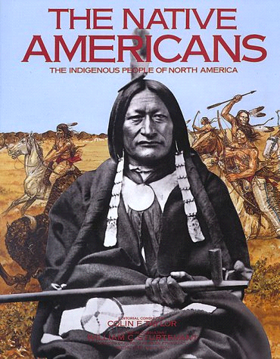
The Native Americans

I heard a loud shout and a gunshot. My mother was lying dead on the ground with a bow in her left hand and a sack of arrows. I picked up the bow and put an arrow through a white man’s head. I ran because a shot whizzed past my head.
When I got to the forest, I heard a shout they said “Get that boy!” I took out another arrow and shot the man that attacked me. I saw a wild hog grazing. I shot it. “I’ll have dinner tonight” I said. I saw a member of my troop making his way over it was my brother. He said “Mom and Dad are dead”. I cried for only two seconds because I didn’t know them that well. We went over to our hut and cooked the hog. A chicken pecked me on the leg. My leg was pouring blood. The chicken pecked my brother on the head. He died from blood loss. I was not sad because he was adopted. I buried him after a while.
I heard yodelling. It was my uncle. He knew how to help my leg. He chopped it off. He picked up a gun and shot a pale face that was dying because of the chicken. My uncle said we could use the chicken to our advantage. We went to the army of soldiers, but they grabbed us and slit our throats. We died slowly and painfully. The chicken wiped out the pale faces. We were victorious in our coffins.
Unfortunately thechicken got killed by another troop, it was a nicemeal.

Aenghus o Cofaigh

Seventeen Vulture
Before Hernán Cortés invaded Tenochtitlán everyone was so happy. I am Seventeen Vulture. I lived with my parents, my sisters, my uncle, my auntie and my grandparents. We lived in a sun-dried, mud brick house. It was very small but I loved living there because I had my sisters to play with everyday! My sisters and I went to a school to learn how to do housekeeping. If we were late or if we didn’t try our hardest at our work the teachers would stick a cactus into us. It was very painful but we had to live with it!
One day I came home from school, and I was expecting a huge welcome from my parents like always, but not today. My parents were running around the house packing up everything. My dad was home which was unusual as he was always in the chinampa until late in the evening time. My mother told me earlier that day that the emperor Montezuma 11 had allowed the Spanish in as guests because he believed that Cortés was the white-skinned, bearded Aztec god and took their wealth. Hernán Cortés came but he didn’t come as a guest. He came as an intruder along with five hundred men, killer dogs, guns, cannon and horses. People were screaming and running for their lives outside, trying to hide from the Spanish. I quickly ran to my bed and packed up my belongings. My sisters weren’t home and my father told me that we had no time to wait.
I loved my sisters so much and I would not be able to live without them. I was determined to find them. I knew it was dangerous out there, but I couldn’t hide until I had found my sisters. I left my house very quietly. I looked at my family for the last time, and ran out the door. I said goodbye to my little house. There were stampedes of people running towards me, trying to escape from the dreadful Spanish people. I ran towards my sisters’ school. There were so many girls running out of the school that I couldn’t recognise my sisters. I ran in the direction that the other girls were running, still trying to find my sisters in the crowd. I knew that if I couldn’t find my sisters now then I would have to leave with my family. I kept searching for my sisters but I could hear guns firing in the distance and the sound was getting closer every minute.
All I could think of was the screams of the people and the growls of the killer dogs. The crowd was getting smaller and I was getting weaker. I still had hope on finding my sisters. The Spanish were getting so close to me and I could hear the gunshots. There were inocent people lying on the pavement with blood all over their bodies and bullets through their heads. It was a disgusting sight and I hoped that none of those people were my beloved sisters.
After a few minutes, I gave up hope on finding my sisters and I guessed that they had gone back to my house. I snook through dirty alleyways and I made my way back to my house. I opened the door and walked inside. No one was there. I called their names but I didn’t get any reply. I ran to my small room that I shared with my sisters but no one was there. My sisters’ belongings were no longer there. I ran into my grandparents room but their clothes were no longer there either. I was beginning to realise what had happened. My family had left me. I suddenly felt really sick. My hands were shaking and my body was shivering. I had to stay strong. I decided to leave and hide with the other people. I ran out of my house and I started searching for a hiding place. I knew that if I wanted to survive out there on my own, I would have to get some food and water first. I ran to my local shop. I used to love this place but now it looked like a haunted house with all of the dead bodies around the place.
After I collected all of the food I needed to survive on, I started to look for a hiding place. I knew exactly where to hide! Whenever I got mad or frustrated I used to go to a tree that was a few minutes down the road from us. It used to calm me when I was nervous so, that is where I went to hide. I set out all of my food there and I watched the other people running! I wished I could help them but it was far too dangerous. I didn’t want to end up like the people on the pavement or the people in the shop so I stayed where I was. The night went very slowly. I couldn’t stop thinking of where my family could have gone or if they found my sisters.
The next morning I woke up to the sound of gunshots. I hopped out of the tree and I walked through the fields. There was smoke everywhere. I couldn’t see my family but I wanted to find them, so I kept going. I walked for a long time but I still couldn’t see any famliar faces. I didn’t know whether to go back to the tree or keep looking. I was going to get lost if I kept looking but I was going to freeze if I went back to the tree. I just wanted someone to tell me what to do but the only people that were here were the dead bodies surrounding me.
Dearbhla

The Apache Attack
Hello, my name is Rabbit Fifteen and I am writing this story in my cell. I was put in it for no reason. I want to tell everyone that the native tribes aren`t the bad guys, but that it’s the explorers from another land who are evil .
Last month, we were just out hunting whatever animals we could find in the forests and nearby lakes. Today was a good day. It was very hot. We found lots of bears, snakes and crocodiles. When we were walking back to our village to give the women our food to cook, we came across men on horses. They had very pale faces. They wore red uniforms with gold belts. We said “hello” but they didn`t reply. Instead, they took out long swords and slashed many of us to death. I dashed to cover and took out my bow and arrow. I shot one of the soldiers. While they were helping the wounded soldier I sprinted away into the forest in my bare feet. I climbed up the tallest tree and waited there for an hour
Once the coast was clear, I went out on the road where they ambushed us. The soldiers were gone, I was so happy. I made my way back to the village. I saw smoke in the distance but at the time I thought it was the women cooking the food we had got. But, as I got closer, the fire was getting bigger and bigger. When I reached the village, I found out it wasn`t a campfire, it was our house! I couldn`t believe it! My beloved mud and brick house was on fire. So were all the other houses.
I went inside my house. I found my sister, Leopard Twenty-One trapped in the corner. I pulled her out of the house and brought her to safety. I heard shouting, so I went over to main hall where the shouting was coming from. I saw the soldiers outside the hall that had ambushed us earlier. I took out my bow and arrow and fired another shot at them. I missed all of them and then they started to charge at me. I turned the corner and even more came at me. I was cornered. I picked up one of the swords from the dead soldiers and ran through the group of soldiers using the sword to protect me. I ran through the streets and ran up the hill into the forest.
I found some of our warriors hiding in the bushes. They gave me some arrows and we started shooting at the unsuspecting soldiers. Soon they found us and ran up the hill. We shot our final arrows at them. There were more soldiers than I had expected. We were surrounded by heavily armed soldiers while we had nothing. Our village has been burnt to the ground. We had no choice but to surrender. Otherwise we would`ve been killed. We put our hands up turned ourselves in.
I have been in a jail with my sister for the past eight years. They treat us as like slaves. We have to do everything for them. They kill a prisoner every few days for no reason, so I know I don`t have long to live. I have also learnt that these monsters come from a place called England in a place called Europe. Other people are attacking other nearby tribes for no reason too. It`s like they want to take over this place and kill us all.

Ronan O Raghallaigh
The Native Americans
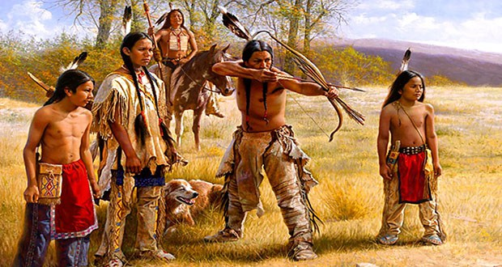
There was a deafening bang! And at that moment we realised the palefaces were coming.
It was just an ordinary day. My family and I went off on a quick trot on the horses when I saw buffalo racing across the fields but just when I was about to take the shot, a bullet whizzed past my ear. Another one came, and before I knew it bullets were whizzing everywhere! My family and I made a run for it.
We sprinted to the village and told everyone the horrible news. The villagers wanted to fight so as my family! I tried to stop them from fighting but nobody listened. I knew my parents would die and me too. In that case, I decided to do something big, dangerous and probably regrettable: I would to Quito where my uncle lives. I knew I had to pass through a lot of countries like Honduras, Mexico, Costa Rica and even dangerous cities like Guatamala.
Of course I was sad to leave my parents and I also knew that they would most likely pass away in the battle but I knew that I should be on my way by now too. I grabbed a bottle and a bag full of bread and fresh clothes and I was on my way.
I was in the middle of Mexico when I got in a bit of trouble with the Aztecs but managed to scrape away. When I was in Guatamala, I was nearly pushed into drugs but I got away. I passed Tegugicalpa without a bother but I only scrambled away from Panama. I kept on going down the coast of Colombia until I got to Venezuela. After a couple of days of Venezuela, I was in Quito! It took me a long time to find my uncle in the enormous city, but did eventually. My uncle took me in and I was doing completely different things than what I used to do but I am still a native American through and through.
Fianach
THE AZTECS
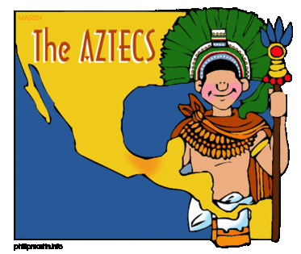
The Aztecs were peacefully singing when one of the chief’s slaves heard the sound of a few dozen horses galloping. Frightened, he hopped on his own horse and rode off towards his master. “What did you hear?” demanded the chief. “We need to warn the villages!” said the slave. “Yes that’s exactly what we will do!” said the chief as if he came up with it.
When they got to the first village, they gathered everyone up, and told them all what was happening. “So the white people are coming?” shouted one of the slaves. “Yes, now we must *BANG* the chief fell over. He had been shot by a gun. Then three of the Aztecs started yodelling. The white people had come with looks of battle on their faces. Suddenly a group of men raced down the hill on their horses. “Come now my brothers we must fight against their power!”, and my sisters you must get the children to safety inside tepees!” shouted the slave.
The battle for the land had begun there was shouting, shooting, stabbing, horses falling on people and blood was everywhere. All the men had arrived from the different tribes yet they were still outnumbered. The women and children had taken shelter but some were found and slaughtered. The Aztecs fought long and hard, but it was not enough to make the white people retreat.
In the end, the men knew that they had been beaten. Then the leader of the white people came, a conquistador called Herman Cortes. When the battle was over almost all of the tribes were captured and turned into slaves for the Spanish empire. The Apache tribe was out there. ”We must not lose hope” said the dead chief’s slave to the few the warriors that were still alive. ”Be quiet” said the guard. Then there was noise, *Ssssss*, and then *BOOM* a hole was blasted in the wall. After a couple of seconds, seventy Apaches rushed into the chamber. It was a distraction for the slaves to escape. They took their opportunity and ran out through the hole all 103 of them! They did they got away from the white people whom took over their home!
DONAL

The Aztec overthrowing
  - Wolf the Third’s Diary
Tenth of Lizard:
The news came TODAY; Lord Quetzalcoatl sent his pale-faced messengers to us. just like the scriptures tell us. The messengers speak gibberish and where a cloth which covers all their body. Around five-hundred arrived. they arrived on A FLEET of boats, EXCEPT THE boats were bigger than anything we had seen before. They looked tired and sick, but maybe that’s because their faces are always pale. When THEY ARRIVED, the chief, Lizard the Seventh greeted them. Nobody hesitated to sing their PRAISES; though I’m not sure they understood the praises. They ONLY UNDERSTOOD their Godly LANGUAGE. Their leader looks exactly like our lord, Quetzalcoatl. There was a mass- SACRIFICING SESSION in our lord Quetzalcoatl’s temple afterwards, there was a celebration in the messengers’ honour. The guests seemed shocked that the children were allowed watch the sacrifice.
Hernan Cortés’s Diary
Today, we have made history! We will be remembered for years to come. My name and the conquistador name will live on forever! This land is very basic, but full of potential. The inhabitants are pagan and will be easily converted. Today, they welcomed us. We couldn’t understand what they were saying, but they didn’t seem hostile. The people seem mostly peaceful except when they are sacrificing their rivals. They treat their children like adults and are extremely religious. We will take their land, convert them, and give them happy lives serving his Majesty, the King. The people seem to worship us, me in particular. They keep adoringly staring at my face, it’s like I am Jesus to them. Tonight we will celebrate whatever we have to celebrate. Tomorrow we will begin the invasion...
Info:
When the Spanish Conquistadors arrived in Mexico in 1521, they didn’t realize how lucky they were not to be captured and sacrificed to the pagan gods the Aztecs had. The Aztecs were a tribe of people, who lived in modern-day Mexico. They were pagans, who believed in Gods of their own creation. They were constantly sacrificing people of other tribes to postpone the end of the world. They worshipped their gods in temples.
The Aztecs didn’t kill the conquistadors and use them as sacrifices because they thought that the conquistadors were messengers sent by their god, Quetzalcoatl. The conquistadors then went on to destroy the Aztecs and their way of life.
By Muiris Cloherty

The Aztecs
We Aztecs had peace until those terrible white men came and terrorised and tortured us. I was the one that got away into North America but there were white men there as well, so I escaped to Canada. This is the story of my survival.
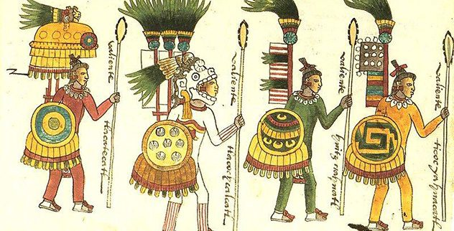
It all started when a white men boat arrived at our beach. At first, we thought that they were very powerful gods that had come to visit us in human form, but then we realised they weren’t immortal gods. They were humans stealing our gold. My father was one of the first to die fighting for our gold.
The fight for gold became the fight for freedom, but we lost that fight and we were enslaved. The palefaces killed us if we tried to escape our frightened village. My mother and I once tried to escape, but she was found. I didn’t look back. I just ran for the exit, ignoring my mother’s cry for help. I jumped on a horse and rode for the hills.
As soon as I got there, I jumped off my horse and hid under some multicoloured leaves. The pale men came on their horses, but they couldn’t find me so they left for the village. I was on my own so I left for America with my flint arrows and my wooden sword. It was a dangerous journey up North. I even fought a bear for a cave. I was hurt, so I strapped myself to a branch of a tree to avoid being eaten by predators. I went far up the continent of America, but there were still white men there, so I went to Canada and built my home there.
Tadhg
Apache Attack
The first day of the year we were scheduled to attack the Apache. As I got up, I remembered that we had to meet at the town hall. I got dressed and went downstairs. My wife looked tired. I asked her if she had been up all night. She replied “I was scrubbing the blood stain from when I had stabbed a man to death with the knife that was at the top of my gun. I took my uniform and headed to the town hall.
When I arrived there, the mayor announced that every soldier would be going to war. When we arrived, we came up from the back of the tribe. We were prepared. We had dogs, horses, guns and more people than them. We infiltrated with the fury of four generations.They didn’t even know we were there.
The battle was over within four hours. We had control by this point. We put all of the elderly, the children and parents in crates and brought them to the quickly-made jail. As we were bringing them to the jail, I said to the general that a couple had escaped. He told me just to shoot them. I aimed my gun at them and pulled the trigger. I then heard a scream. He had died.
I sead to my self “He deserved to die,” even when I knew he didn’t.
My friend said to me that it didn’t matter. He was just a person that probably was starving and was going to die anyway.
We finally got there. The people were dreading to go to jail. I had been assigned to a new post in the prison. So far all the prisonors were so evil. I was expecting all the other guards to be nice. Sometimes they were but most of the time they were mean to the prisoners.
One of them was called Princess. He loved eating meat. He had no friends mostly because he was feared in the prison. He had once stabbed a man with his unicorn pocket knife wich he kept with him at all times . As I went in to the prison with the prisoners, the first face I saw was Princess. Two weeks latter I returned home . As I arrived, I saw a man with two guns. I went and hid in a bush. He knocked on the door. My wife appeared scared. I jumped out of the bush and quickly pulled my katana. I sliced his head right off of his shoulders. It fell to the ground in a bloody mess. My wife said “Welcome back, you’re just in time for dinner”.

Caoimhín

The Native Americans
My name is Vulture 18, one of the many of my family. But on one horrible day, the red-faces ambushed our army. I saw my papa lying on the floor, blood pouring from his stomach. He said “Go with the Lizards.” Those were his last words. I screamed with all the breath I had.
I ran to the Lizards’ Tepee. I said “I will help you. Follow me.” I ran towards the horses. “We will go to the Apaches tribe, my grandfather is there.” We got onto the horses and went. It took us several days as we are from Cree. We met many different tribes. Some were nice and we had to fight our way through others.
We arrived at the Apaches tribe we went to the chief’s Tepee. We asked him if he knew Cheetah 5.He said “He was long dead”. “No there is a big mistake we’re looking for Cheetah 5 not 4”. “Do you think I’m stupid?”. “He died last year but his son is still here just go to tepee 9 section b”.
War went on for many years the English took over us and the Spanish took over the Aztecs. We are now in a place known as Mexico.
Ríoghan

The Native Americans

Hello, my name is Lizard 12. My dad was a soldier in the Apache tribe. He fought in many battles and came back with many injuries. In his last battle, he died right in front of my eyes. That was the last glimpse of him before the Navajo soldiers swarmed the battleground.

I joined the army at around ten years old. I had to carry a heavy spear twice the size of me every time I went to war. We had a small village with a very small amount of soldiers.

The day our village got attacked, we had to walk for days and days looking for a place to settle. We ended up in the Pawnee tribe. They let us sleep in the prison for a while. After a while we became one big tribe. Our tribe was called The Apawn. I was so happy, and so would my father. I made a grave so I could remember him.
When I was fifteen years old, I was sent to battle against the Navajo. I couldn’t wait to get in to battle. It was a long and tough war, but we won.

A couple of years later, I was on lookout duty. I saw huge men with swords, armour and shields. They busted through our walls before we could prepare. They killed people and they captured people. I fought as hard as I could, but I got hit on the head with a shield

I found myself in a huge ship with the English flag. They put me through torture and eventually I closed my eyes and never opened them again.

Pádraig

The Worst Time of my Life

It was tough watching my father defending our home, our family and our tribe. We knew there was no chance of winning. They were too strong. All their armour and their weapons were ten times better than ours. My father “Lizard twenty one” told me to go and find my brother. It was the fastest I have ever run. I picked him up and ran to my home to find my mother she was crying. She was trying to gather all of our belongings it was tough seeing her in such a wreck. My brother “Dog fourteen” didn’t know what was going on.
Two hours previously, we were having fun playing our favourite game, patolli. My Mother “Crocodile two” was cooking the meat for the dinner. My father was collecting the herbs and vegetables. The village was peaceful. People were running around, having fun. My brother was sitting outside of our house smelling the fumes from the chimneys. He loved doing that, especially when Dog six, his best friend’s mum, was cooking. But all of a sudden we heard horses and a loud roar was coming from the north of the village. We knew we were under attack and there was nothing we could do. All of a sudden, a bunch of arrows flew past my head. One hit my brother in the head. He died straight away. It was depressing. That’s when my Father told me to find my brother.
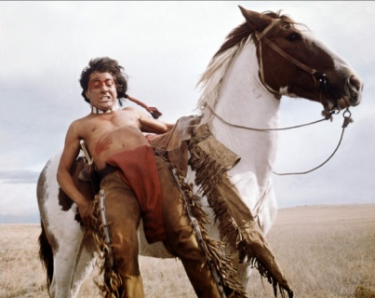
As my mother was gathering our belongings, I told her Dog twelve, my brother, her son, had died;. She didn’t give off a big reaction as she didn’t want Dog fourteen to be upset. She told me not to tell Dog fourteen about his brother. I was hard keeping such a big secret but I knew I couldn’t tell him. My dad came rushing in the front door panicking. He shouted at us to get everything and to go. He told us to leave without him, but that wasn’t an option. Then we heard shots being fired. We ran out the door to the horses, leaving a lot of prized possessions behind. We persuaded our father to come with us.
We headed south to a neighbouring village to warn them but it was too late. Their whole village was on fire. It was one big pile of burning rubble. It was sad knowing in a couple of moments our village would look the same.
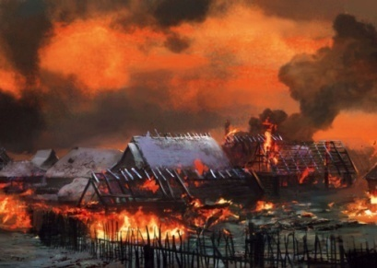
We were going to go another village but a survivor from them fire said not to. He told us to go as fast as we could. ”They had no mercy on us” he said whilst crying. We got back on our horses and we headed to Veracruz the city, where we wouldn’t be under a lot of threat from the Spanish. We were planning on moving to the suburbs. We planned a new start and a new life and to make new friends, new neighbours and a new life. It will take a lifetime we all agreed. Veracruz was two-day journey north west of our house. We tried looking on the bright side of things but it was hard saying goodbye to our home. We had so many good memories in that house; in that village. I have lived in that home for the eight years since I was born. But at least we were still alive.
As we were leaving the village, he saw some crops. We went over to gather them because we had no food. I was over the moon because I thought we were going to be two days without food. We knew we would have to savour the food. Then we trotted off on our long journey. We decided to walk five hours at a time. We would go to bed at sundown and wake up at sunrise. We travelled two hours north. Then suddenly we heard a rattle. Dog Fourteen looked down to the right of him he saw a large rattlesnake. He screamed. We walked slowly trying not to aggravate the snake. The horses didn’t want to walk past the snake so we had to go right beside a ditch. It was sore. All the twigs were scratching my arm but it wasn’t the worst. Another three hours passed and we decided to settle down for the night. Father started a fire and tied the horses to a large tree. Mother put a small piece of meat in a pan for all of us. We were starving. She only put on a small piece of meat because we didn’t have a lot of food. We slept on the horses saddles. It was not nice at all.
The next morning, we commenced the last leg of our journey to Veracruz. I was so excited. On the way, we started to collect materials for the new house. We gathered some wood for the fire to keep us warm, and some straw for the roof. My brother was crying for hours on end. He was scared that that around the next corner there would be a Pale Face. Then suddenly my mother screamed with joy we arrived. I got such a fright but it didn’t matter. I caught my first glimpse of my new neighbourhood. It wasn’t as nice as I thought but was better than a pile of burning rubble. My mother stud in shock as she saw who was coming, it was the Spanish. They were coming to raid the neighbourhood. My heart was beating 1000 times a minute. My father shouted “Go go go!” It was scary. The place was a shooting range. Within two minutes, we went as fast as we could. The horses were trying to go up on their back legs but we didn’t let them. A soldier came after us. He shot bullets through the air but none hit us. My father was shooting at him. He landed a lucky shot. We were in the clear. We headed back to our old village. The damage wasn’t that bad. We salvaged some materials for a new house. There were two survivors. We built a new house. It was amazing. The two survivors lived with us for a while till they built their own. I am so happy in my new home.
Lee

The Apaches
As I woke up in the morning, I could hear gunshots being fired. I got my shawl and my trousers. My mum’s gun was left on the table, so I took it and practised my accuracy against my brother Ethan. He only had a spear, so I had the advantage. Suddenly I saw a white man running towards my house in a fierce way. He had a rifle in his hand. My brother and I hid behind a bush. Then my brother spotted another man marching towards us. I tried as hard as I could to shoot him but he was running very weirdly. Suddenly there was a gunshot. The other man had been shot by my mother.
She must have been searching for some animals to kill. I ran as quickly as I could to her and hugged her. Tears burst out of my eyes. I asked where she had gone in the morning. She replied “I went out searching for your father.” Then she said “Your father has been shot.” I burst into tears again for three seconds, but it didn’t really matter because I had only seen him twice. My mother said “Aren’t you sad?” I replied “No, I’ve only seen him once. A white man tried to snipe at me but I ran into the house and got my assault rifle. I shot him with two bullets. My mum ran towards him and took his guns, bullets, and his ammo shell.
Suddenly a paleface ran from behind and tried to stab her but I shouted “Turn around!” and she stabbed him to death about eighteen times. She shouted “If anybody comes near me again you will suffer so badly and I’ll stab or shoot you so be careful I’m the queen around here.” I shouted “Mum, why did you do that? What if someone did that to me and you would have to stand there and watch me suffer. What do you think about that mum?” She replied “I don’t understand what nonsense you are talking about son. Your brother is dead and your father has probably gone off drinking like he always did and always will.” “Stop mom, dad’s dead. I shot him last night because he said that you were going out with another man but I didn’t believe him but now I do I regret killing him. Now you’re next.” Guns shots were fired and I had no family left.
The next day I woke the house was so quiet.
Gavin

The Native Americans

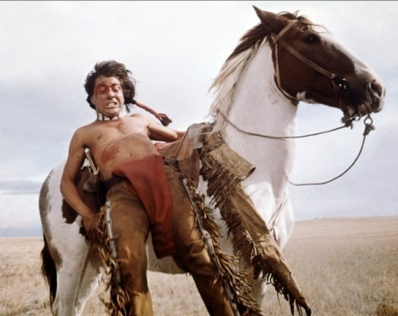
We were once a happy village, where we farmed crops. I was practising my bow and arrow and playing games. One day, while we were waiting for our Braves to come back, I heard a shout going: “You!” Then, “Run, the palefaces are coming”.
I was terrified. I heard an arrow zoom past my head. I ran to get Owen but he was crying. He said mom was killed and so was dad. I got very mad. I grabbed a quiver of arrow and a bow I shot three palefaces but I was nearly shot. I ran to the tree line hid behind a fat old tree, with my brother Owen. We climbed up to the top. When we got to the top, we saw a ton of motionless bodies. We got so scared. Then a paleface with a tomahawk grabbed Owen and chopped his head off. I ran as fast as I could. I just escaped from him in the woods. Then I grabbed my brother’s head and put it in a plastic bag and threw it on a branch on a tree. I was very sad. I was the only family member left.
It took weeks for me to settle into life by myself in the village of New Mexico.

Ethan

