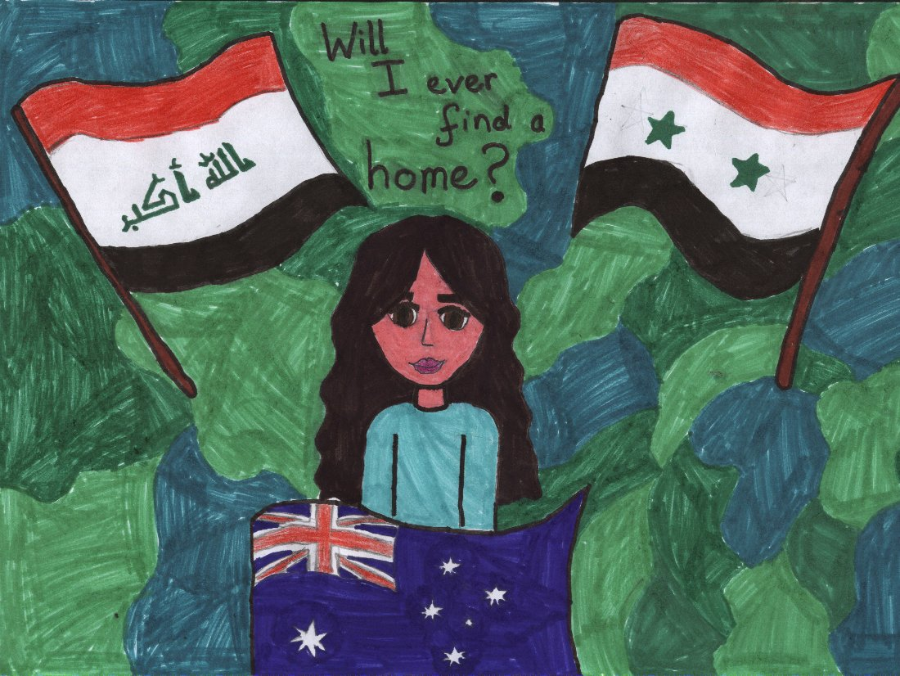

It was the Wednesday twenty first of August 1989. The ninth time I tried to escape my country, Azerbaijan. I remember it as the day that changed my life for the good and for the bad. I had to flee the country before the war got any worse. Now you probably want to know a bit about me and the truth is so do I. I don’t know my name and I don’t know my age. I was abandoned as a child and I have taken care of myself ever since. I managed just fine all by myself when I was sick or hungry. I was better off by myself with no one in my way.
That was before I met my brother Alexander and found out that I was named Ali. Isn’t that a beautiful name, it just rolls off your lips. A family and a name is something I missed my whole life. That’s why I was leaving the country because I didn't want to lose something I had only just found. Alexander and I were in great danger because we lived in Baku, the heart of the War. That time the next day we would be living in the heart of the world, America.
Between us we had just enough money to get me and Alexander across the ocean to America. Some of the money was hard earned and some of it was stolen because you have to do tough things in tough times. Once we finished packing the essentials we got in a hot truck with loads of other people just like us, scared, hopeful, and excited. We then had to pay and get on to a small squashed old boat. It was a long journey. We went from boat to boat as more people fell into the ocean. We had left the country and there wasn’t a seed of regret or doubt in my mind.

That was until we got there and got beaten and thrown into cages just like animals. Eventually they let us out but some people didn’t survive the beat down. Some people like Alexander. This is an extract from my bestseller book, Escape that I circulated around America. I live in a nice house now with a great lifestyle. I will always be a refugee at heart which is what I was when I wrote my book. I had a hard life but my two years as a refugee were extremely difficult. There wasn’t a day I wasn’t hungry or tired or hurt. My life is now devoted to rescuing people who are living in a country at war. I am giving them the chance I always wanted and never got.
Freya

Refugee Escape
As I walked slowly over the hill, I spotted a group of people getting on a boat. I quickly ran down to them. I asked “What’s going on?” A refugee replied “We’re trying to get away from this sour, cheap country.” As I looked and stared at my family, they looked really poor, so I asked the captain “Do you have room for four more people?” He replied “Of course I do but you have to squeeze in at the front of the boat.” As we passed the little islands of Syria, I spotted a little crocodile being hauled in by Isis. I took my assault rifle out and shot the Isis. We stopped to get the rest of the gang.

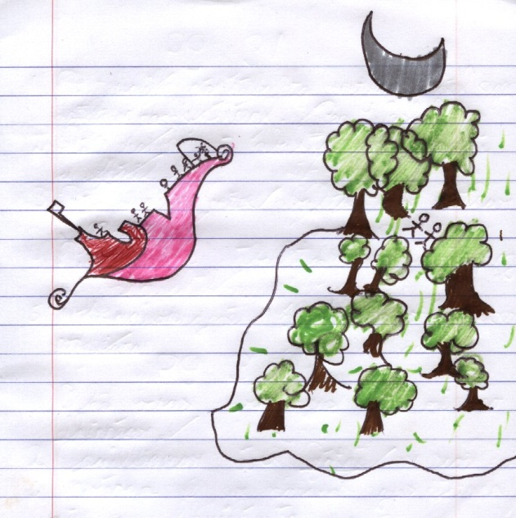

As we reached Turkey, we got hungry so we jumped of the boat and searched for food. We found a dead chicken. Sadly, the boat had gone without us so we were stuck in the woods forever. I passed away three days later from hunger and thirst.

Gavin

As I was walking down the blitzed city, I turned and found my favourite shop mauled to pieces. Suddenly I heard a deafening BANG!!! I saw my dad charging down the street “They’re coming!” he said. “Who’s co...?”NO TIME TO EXPLAIN, COME ON! ”, he screamed. We ran down the street until we came to a US army jeep. The jeep drove as fast as it could, I could hear bullets zooming past us, grenades exploding. The jeep came to a stop, BANG!!!
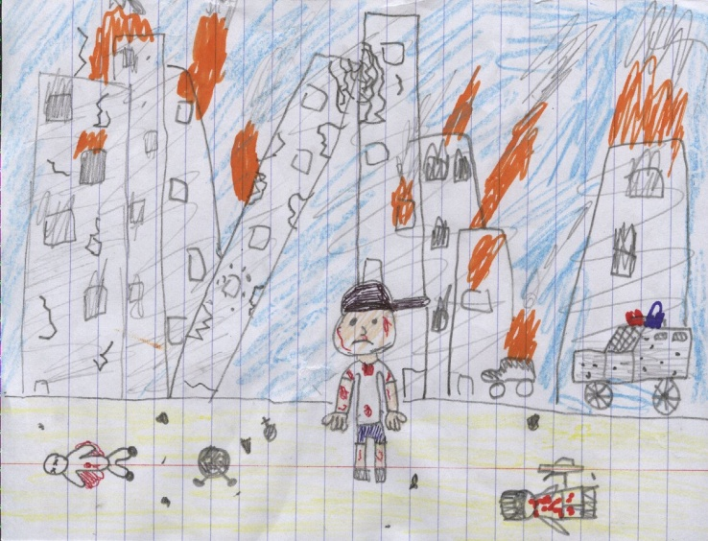
I woke up with a ringing noise in my ear. My dad and I had blood on our face I could barely see a thing, I felt someone pick me up and an engine start. About an hour later I found myself in a tent, I was in a hospital bed. I was exhausted and I went to sleep.
After a couple of days later my dad and I were up and running again. We planned our escape. We would hop into a cargo truck that would go to Turkey; we would go to Antalya and sail to Ireland.
First we went to the warehouse. It was hard to find which truck to get into so we had a look around. After ten minutes of solid looking we eventually found our ride. We were driving for ten hours. We came to a stop. I heard men shouting. We opened the side door and ran out. There were hundreds of people. We had no money so we had to beg. We stayed over night. We made 40 Turkish pounds. We bought food, water and clothes. We snuck onto our boat and sailed of. It was a really rough ride because the waves were horrendous. I got sea sick once or twice. The waves became bigger and wilder as we travelled along.
We could see land in the distance as the waves lifted us. But one huge wave crashed into us, it sent us flying. We were about 300m out from land. We looked all around; there was a fisher ship about 50m away from us. We swam over to the ship. We started shouting up at the captain, and luckily he threw a rope down and saved us from drowning. We were so happy and relieved.
Pádraig

It was the tenth of April 2012, a day I will never forget. After all, it was the day that started my adventure as a refugee, trying to make it to Dublin, the capital of Ireland. I heard it was a nice place but I had no intention of leaving my home in Syria.
I woke up to the sound of gunshots every morning. I got worried because my mother was sick and she was in no condition to leave. I could hear the bombs exploding on the other side of town. My mother seemed to get worse every day. Eventually she needed a wheelchair. I tried to organise a ferry to take us away but I failed since I had no money. I wanted to die in the city I was born in but of course I wanted to stay alive.
My mother saw how bad the war was getting in Syria. So she told me to go to Dublin without her. She said she would die even if she left the country. I knew she had promised herself that she would die in Syria like her mother. I packed a small bag with enough food and water to last me the trip to Dublin.
I left at midnight since it was dark and the guards at the gate would not see me. The ferry was on the other side of the wall. I had an old rope in my bag so I threw it over the wall. To my luck it caught on something and I climbed up. I had to sneak onto the boat since I didn’t pay. But I had my ways.
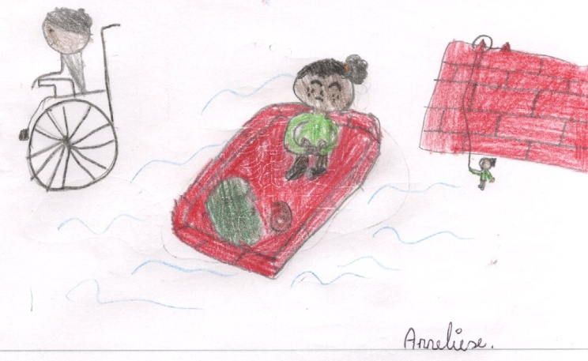
“Your ticket ma’am” said the worker on the boat. “Umm that’s my father on the ferry, he has my ticket” I said, worried that he would find out I had lied. He gave me my life jacket and we sailed off. The only thing I could think about was my mother. She was probably dead already. I had promised her I would make it to Dublin safely but I was starting to doubt the promise I had made. I needed to try my best to make it there safely and hopefully people would accept me.
Suddenly I saw somebody coming towards me. He was double-checking the tickets people had. My heart started pounding. I started sweating. I had no idea what to do. Then he came to me. “Can I just check your ticket,please miss.” I wasn’t thinking. I just stood there, frozen. “Miss I really need to see your ticket” the man said, starting to get a little agitated. I ran. I grabbed the little lifeboat. It was one which inflated right away.
I had no oars so I had to row with my hand. It was about five hours until I found land. By then my hand was frozen and numb. I had hope in my heart. Could this be Dublin? But I was wrong. I got off the lifeboat and wandered around. I asked a man in a suit where I was. He answered in a stern, yet kind voice. “You’re in England young lady” he said.
Now I was no geography genius but I knew that England was quite close to Ireland. That meant I had about two hours on the little lifeboat. What I was worried about was that I was running out of food and I only had five euro. I decided to just go to Dublin and then eat.
It took more than two hours because I had to take a little rest. But in the end I found land. I stepped off my little lifeboat. I asked a lady wearing jeans and a cardigan where I was. “Dublin” was the answer she gave me. I didn’t care that my clothes were soaked. I jumped up and yelled “HOORAY”. I was so happy. My life changed from then on. But I promised myself I would die here in this amazing place that took me in and treated me as its own.
ANNELIESE

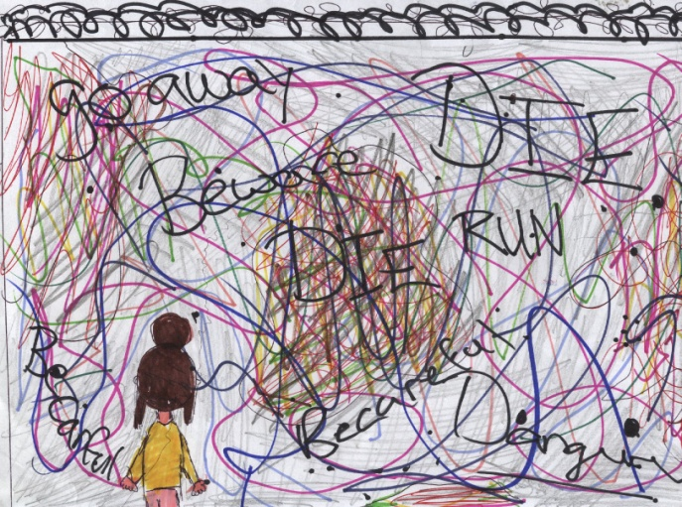
BANG BANG!were the only sounds I could hear! My legs were sore and my mind was racing. I just wanted to be with my friends and my family, but there was no time to think about them. I just had to focus on the wall! But the guards were right behind me.They had guns and different weapons that I had never seen before! I felt like I was going to get sick but I had to keep it in until I was over the wall. Eventually I was face-to-face with the Berlin Wall! There were bullet holes and blood all over the wall, but I just had to think positive. I threw my bag down from my back and I pull out my climbing gear! I didn’t have much time. The guards were getting close. I started climbing up the wall as fast as lightning. Suddenly my leg slipped and I started sliding down the wall rapidly! With a loud thump, I fell to the ground! I picked myself up and I tried again. This time it was successful. I was over the wall! But this was no time to celebrate. The guards were probably looking for me!
I was told that a green truck would be waiting for me, but the truck was no where to be seen. Eventually, the truck arrived. It was dirty and it didn’t seem verystable, but I had no choice. I jumped into the van and I started thinking about mynew life. “What would it be like?” I asked myself.
When we arrived at the dock, it was around twelve o’clock. I walked onto the tiny black boat full of fear! The boat looked like one of those tiny life boats that were made out of rubber. I sat down beside a creepy man that kept on talking to himself. I fell asleep after an hour. When I woke up, we had arrived in Norway! It was around three in the morning and the sky was still pitch black. I stepped off the tiny black boat full of joy!
The next thing I had to do was try to find shelter and some food. I found a small old shed beside the lake; I decided to sleep there for the night. The next morning, I woke up and my head was pounding with pain. I had no money to buy any medicine so I didn’t take any heed of it. Later that day my head started swelling up. My head felt like it was going to explode! Later that night I died of a stroke! I never got to live my new life.
Casey Ni Loinsigh
Our Chances
My family and I ran as fast as we could to run away from this horrible gruelling lifestyle. We ran to the nearest coastline we could find. It took us three days. Nadia, Khan, Leila and Abdullah and I walked for miles and miles west. We didn’t get much food besides dates, figs and some raw beef from our friend Amina, who butchered cows for the locals. It was always very hard to farm animals in these parts, with bombs going off every few hours.
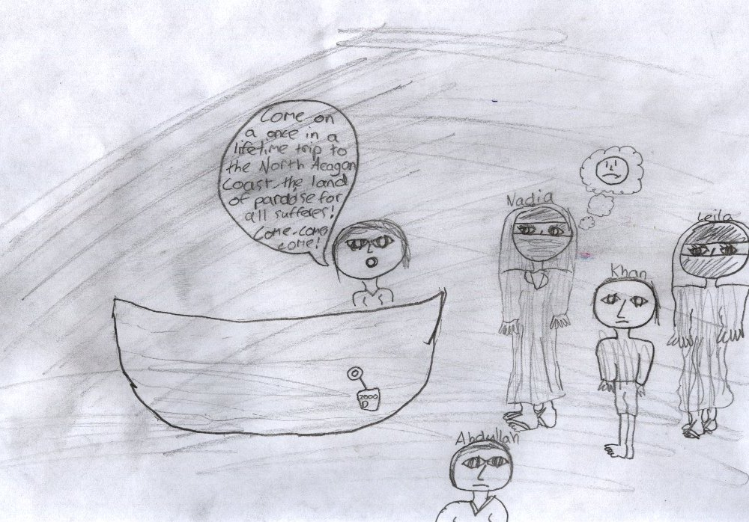
My family set up a camp fashioned from some sheepskin and thick poles. We knew what to do when the sirens went off for attack. All that you had to do was hope for the best and prepare for the worst. For first few days when we reached the coastline, we all took shelter in the soup kitchen. There were lovely people there and they were offering us all their money for a trip to Turkey. We already had the money but they were being very generous. Those poor ladies making the soup were all widows. Their husbands had died fighting in the war due to the bombing. The ladies were very positive and happy to be alive. We invited them to Turkey with us but they refused to go. They said they wanted to help others on their harsh journey.
The next day we made way to the coastline. There were men selling off trips to Turkey for 4000 Dirhams! We could not afford that but there was a very small shabby boat for 2000 Dirhams. We chose the small shabby boat because that is all that we could afford. We climbed onto the boat along with ten other people, most of them were coughing and spluttering and some of the children were getting sick overboard. It was horrible conditions over sea. The waves were crashing against the mouldy boards. The screws in the boards were working themselves loose. Water started to push in through the tiny holes that were appearing due to the rough conditions of the sea. The so called captain of the boat strangely had ten kiddie seaside buckets to spare in his boat. He sent us refugees to work filling the buckets with the salty seawater, and pouring them out over the sides of the boat. Most of the children were in distress, with their mothers at their side cradling them in their skinny arms. Once dawn came, the sun was blinding our eyes. We all saw the coastline of Turkey. I felt a wave of thankfulness come over me.
We all clambered onto the shores of the North Aegean coast. The sands were beautiful and white and the seas were so clear and turquoise compared to the deep dark seas on the border of Syria. My family and I walked barefoot on the soft smooth sands. It was so nice compared to the rough ground and the sharp stones of Syria. Turkey is a paradise. We found a community with free apartments for the refugees. We moved in the day we arrived which was very lucky for us. It was quite run-down and smelly, but at least we had a shelter away from dangers and the war. Our chances were low of surviving on that boat, but if we pray we will always succeed. My heart said that if we die we would go to heaven and live in peace but I would much rather live in peace down on the earth with my beloved family.
Leila

Once again I found myself running away from my hut. I had nowhere to go but I couldn’t turn back. The guards were on their horses riding quickly through Lake Garda. I was frantically trying to run away from them. I could hear them right behind me but I didn’t want to look back to see how close they were. I could hear the water crashing against the rocks. I got an idea. I had to do something drastic. I had no choice but to....Jump! After hitting the water, I realized that my leg was bleeding.
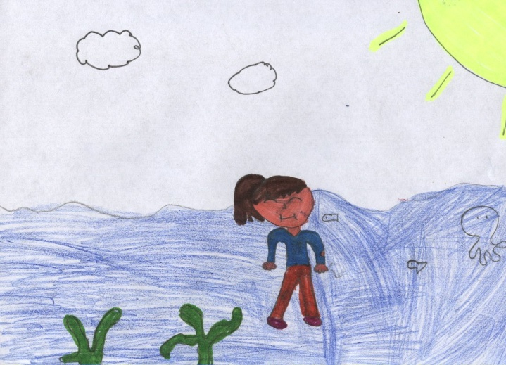
After a while, I crawled out of the lake. I made a small shelter with twigs and rocks from the lake. Then I lay down under the shelter, hoping tomorrow would be a better day. At the crack of dawn, I got up to find the boat that would go back to Bosnia. My head was ringing as I ate my last piece of stolen bread. When I finished my bread, I checked my map. I was ten minutes away from the dock. When I arrived, people were getting in the boat. Because I am a refugee, I couldn’t board the boat, so instead I crawled on the top of the boat and hid under a life boat. Time passed and I was thinking about my family in Bosnia. When the boat stopped, I hopped off boat and onto the dock.
Finally I was home and away from those snobby Italians. I looked around for my old house, but I had no luck. I tried to remember what street I was on, but I couldn’t remember. My leg was stinging so I stopped and sat down and I looked at it. Blood was pouring out of a massive cut on my leg.
Today my leg is sore and very red. There is more blood coming out. I’m feeling weak and I can’t breathe properly. I need help but I can’t see anyone...........
Chloe

My name is Elena. I’m fourteen years old. My brother’s name is Alexandros. He is sixteen years old. We live in a three-roomed home. I would call it a home, but others wouldn’t. I like my home a bit, it is quite small but it just about fits my mother, my father and my neighbour. We don’t own much. Our house has an awful bathroom. (Well it’s just an old bucket.) We also have a pantry in our kitchen. We rely on our pantry a lot as it usually has meat in it as our father goes hunting.
We live in Athens, Greece.
I love living in Greece because there are great sights like Mount Athos and Delphi Theatre. My brother and I are home-schooled and our mother teaches us. Our father has been looking for a job, but he can’t get one. He hunts animals for money and sells the meat. Our father brings meat home every night for our dinner. Steak and beef are my favourites. We only get steak once or twice a month. Alexandros hunts with our father sometimes. When Alexandros helps our father, our father pays him. He is quite lucky to get paid though. I would love to help our father, to earn money but he says that it is just a man’s job.
On the twenty third of November 1987, I set out to prove my father that hunting wasn’t just a man’s job. I went out to hunt with my neighbour, Eli. Eli was about a year older than me. “Are you sure that you want to do this?” Eli asked. He is quite protective. He doesn’t really like to have fun. “Yes.” I said as we walked towards the woods. When we reached the woods, I saw a deer. I shot it. I saw a man who was hunting too. He reminded me of my grandfather. My grandfather loved to hunt back when we were in France. He passed away in 1984.
We shot three deer and a hare. My father will be proud. I also proved that hunting isn’t just for men. Before we left, I heard many gunshots, as we obviously missed out on a good few animals. Then we heard a very loud gunshot. Someone was close to us. Very close. Then another gunshot was fired. Followed by two more. Eli and I ran.
Then all of a sudden, Eli was shot and lying on the ground. I shouted and ran home to my mother and father. This was my entire fault, as I was the one who brought Eli hunting with me. “Mother, Father!!!” I shouted as I burst through the door. “What’s wrong?” my father asked. “I went hunting with Eli and he got shot!” I said nervously as my parents were staring me in the eyes. “You went hunting? What did I tell you about hunting?” “Father! Eli got shot!” My mother and father ran out the door as I followed them.
“They’re after us!” my father shouted as we ran. “Who?” I asked as I sprinted. “The police! They know we are refugees!” When we arrived at the woods, I took my mother and father where Eli had been shot. “Eli!” my mother shouted. Eli’s parents were shot by the police when we arrived in Greece. My mother was very upset about Eli. She told me to go home and wait in what we call my bedroom. I walked home and sat on a barrel in my room. Alexandros came in. I then told him what happened to Eli. He told me that he was disappointed in me for bringing Eli hunting with me. “We are going to get arrested” I told Alexandros about the police knowing that we are refugees.
Alexandros and I went back to where Eli was shot. My mother and father were still there. The police were there. It was one of the police officers that shot Eli, as Eli was a refugee. We were all taken to the police station, Dafni. They didn’t charge us for emigrating from France to Greece. We were very lucky. It was a crazy day that I will never forget.
Ella B

THE GREAT ESCAPE!
Nadia was thirteen years old when her parents were killed. She has been trapped in Syria ever since. “I must try to escape this wretched war” she kept on saying to herself repeatedly. When going out in public, she had to wear a burka and cover the rest of her body with black clothing. Escaping to Turkey was the only thing that was on her mind. Even though she had two brothers and one sister they, didn’t help her much as she, was the only one of the four trying to escape their horrible fate. They hadn’t many Syrian pounds. When they were allowed outside they were always followed or supervised to make sure they didn’t try to escape. Her sister’s name was Ola and her brothers were Adnan and Nizar.
“Mohammed, change shifts with me” shouted one of the guards. When Mohammed walked to the next cell he accidently left the gate open. Adnan was the one to spot this. “Guys look: it’s open, we are free!” he said feeling joyful. “You are right let’s go,” said Ola agreeing with him. “Siblings please!” Nadia interfered. “Yes we must escape but that doesn’t mean that we can just run out of the cell when there are six guards down the corridor, we need to find another way out” she said to them. “Maybe we could try and sneak past them?” suggested Nizar. “Won’t work they will see us won’t they?” Adnan asked hopefully. Suddenly Nadia had a brilliant idea. “Guys it won’t work unless we have a distraction of some sort,” she told them.
All of a sudden a gunshot was heard by most of the prison. It was their uncle Miran, “come on you lot let’s go!” he bellowed at them. One by one they followed each other out of the window that Miran had filed through. Once they were out they started sprinting towards the north Of Syria. After twelve minutes they had finally made it to the border. At the border there stood three men whom were pointing at a sign that said: Payment of fifty five Syrian pounds if want transport to Turkey:“Do you want transport?” snarled the tallest of the three. Then they all heard the sound army trucks approaching. “Last chance!”, he said. Miran handed over the money and then the men showed the family a truck which they all hopped into.
Two hours after that they had, reached their destination, everyone was tired and dirty but pleased that they had made it. As they climbed out of the truck the children hugged their uncle with pride and love. “Thank you Miran so much” they said.
DÓNAL

Hi diary. I had one drastic day. We left Syria because, sadly, there was just too much war going on. Our house was falling apart, but luckily our car survived. We had enough fuel to go to the port. Our neighbours weren’t as lucky. Their houses were blown up. I was really sad because my friend from China, Theo died. ISIS threw four bombs in their house. I saw Theo flying out his bedroom window, covered with blood. He was listening to his favourite song Déjà Vu. I’ll always remember you Theo. We were on our way to the port.
When we arrived there, it was really foggy. We saw a tall man waiting for people so he could take all your money. We asked him if we could buy a ticket. He said “Two hundred.” “What! That’s too much money. Sure money doesn’t grow on trees. “Do you want to go or not?”. We went to Turkey. On our journey, we fell asleep on the boat.
On the next day, we were in Turkey and by now I was starving. We went to a restaurant called McDonald’s. We got something called a Big Mac. It was nice, but it had something green on it. I think it was a pickle. Talking about a pickle, we were in quite a pickle with money. I have to go to Greece. We had to walk, as the ran car out of gas. By the time I got there I almost collapsed. It was just like the port in Syria, but the man was a lot nicer than the guy in Syria. It was a fair price to go on his boat: 100 euro.We gave him the money and off we went. The boat was in brilliant condition. The journey took only five hours.
On day three I woke up on hard ground in Greece. I asked if anybody could give a lift to the refugee camp. A nice man stopped and drove me to camp I thanked him so much. That is the way I escaped the war in Syria.
Ríoghan

Amir Hossain
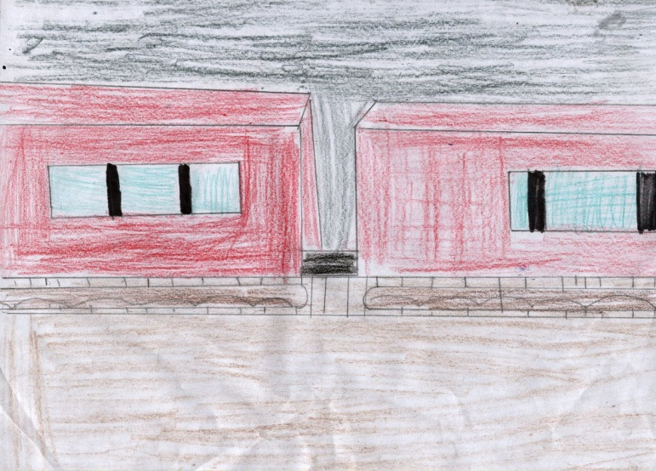
Before San Suu Kyi Was Elected
My name is Amir Hossain. I’m eighteen years old. I live in Maymyo, Myanmar. I live in a small one-roomed house, with my sister Shofika and my mother Anjul. My father left my mother when I was five. We always relied on our neighbour Khatun for meat and sometimes for money. My mother always received abuse she would come home shaking. There was never a day were she didn’t come home bruised. She would always go to the neighbour’s house so that Shofika wouldn’t see her in pain. Shofika was only four; she didn’t realise what was going on. We always told her that it wasn’t real, it was made up.
The Election of San Suu Kyi
But that was before San Suu Kyi was elected. When Aung San Suu Kyi was elected, my race weren’t being abused. They were being killed. It wasn’t that bad until the army started burning down homes. On the eighteenth of October, we got news that the army was coming our way. We gathered our belongings straightaway. We had gunny sacks to keep all our belongings in, while we were travelling. We tried to act as normally as possible so that we wouldn’t scare Shofika. We were going to leave the village at two o’ clock in the morning on the nineteenth of October, when the army was least active. It was a long night thinking about the journey ahead of us.
The First Leg of the Journey
On the nineteenth of October, Kathun, my neighbour, Shofika, Anjul and I set off to Bangladesh. We only had a small amount of money so we would have to walk for the most part. We would sometimes use local buses throughout the night so we could rest. Our first leg of the journey would be to Mandalay. It was only an hour away. We had gone many times before for water and for rice. For the most part it wasn’t that bad as we’re used to the journey. We arrived in Mandalay at half past three in the morning. We got delayed because one of the gunny sacks split. We had to leave a couple of pans behind.

Our arrival in Mandalay.

When we arrived in Mandalay, we got on a local bus for the night, to Monywa. On the way to Monywa, the bus broke down. It was only a small problem. The driver assured us that he could fix it. But that wasn’t the problem. The Myanmar army were after us, we were under attack. We hid in the bus, but Shofika was crying. They heard her. They started shooting. It was the scariest moment of my life, my mother was crying. I saw a man in a bush. He pulled out a pin from a grenade. In school I learnt that the grenade takes three seconds to blow up. I ran out of the bus knowing that I only had two seconds to get it out of the his hand. I didn’t get there in time. The bomb was in mid-air. I knew in one second I would watch my family die. I ran when the soldiers were looking at the blaze of fire. I ran into a shack, it was falling down. I was so silent. I waited in the shack until sunrise. I was fortunate because I was carrying the food. I tried to salvage something from the explosion. I got one pan but that’s all. Everything else was burnt. I was completely and utterly depressed.

The Long Hall

I walked for a while two Shwebo north of Monya I knew from there I could get a train to Falam it was going to be a two day journey on the train. We would stop every hour for air. I met some people and we made a football out of rags. It was really good fun. I was the only pupil in my school fortunate enough to have a leather football. Everyone was always so envious. The first night was tough because the man beside me was snoring. I didn’t sleep well at all I was moving around throughout the night. The second day was good we stopped near a hotel. I went in and got a shower it was amazing! I got back on the train, I found a free seat. It was my lucky day. The train set off nearly as soon as I got the train. I had planned on not getting out of my seat, because it would be impossible to get another. We stopped in Haka one hour away from Falam. That was my final stop before Falam. I was preparing myself for a long walk to the border. I off the train happy knowing there was only one more hour to Falam. I went and got some wood for a fire so I could cook. I had rabbit with a weird tasting broth. The fire took so long to light. I put the rabbit on first then I tried to make a broth. I was savouring every bite. I walked to the platform my train was gone, my luck had run out. I started to shout in anger. But at least I knew there was a train in forty five minutes. It gave me time to say a few prays for Kathun, Shofika and Anjul. When the next train arrived I ran as fast as I could to get a seat. I got one, I lay down so now one could sit beside me.

The Last Leg of the Journey

When I arrived in Falam, I went to a hotel to go to a toilet. I then had to walk to the border. My feet had blisters all over them, but I could be free if I got to Bangladesh. It was only a short journey but, after my long trek, I was exhausted. When I arrived in Bangladesh, I got on the train to the city. It was a thrill that I was still alive.

Lee

We were in our humble home when dad said “People are firing shells”. We saw a shrivelled old man being torn apart by the ISIS. They threw a bomb at our tepee. At that stage, we were in the forest. We saw a Chinese man called Lee Chong with a machine gun in his hand. He shouted “ZHÈ SHÌ CUÒWÙ DE!” (This means “this is wrong” in Chinese traditional). They laughed and shot him dead on the spot. They said “CHING CANG CHONG will be remembered”. Then I said “racism is mean”.
We ran to the sea as fast as we could. We saw other people getting on a boat we asked them “where the boat is going”. They said “it was going to Italy”. We then asked how much it was and could it hold the boat. They said it was 800 Dirham to come. We said “We have that money back at the tepee in a case.” We ran back to the remains of our tepee we got the money, some clothes and food. Then we ran back to the boat and hoped on. Our parents were nowhere to be seen. A man said “Your parents fell between the boat and the dock and drowned. We started laughing because we thought he was joking. Then he said “why are you laughing it is not a joke”. “OO”. It was a long trip before we stopped. We saw a couple of small boat my sister fell off on her way off the boat and sank to the bottom of the sea. I started crying.
When I got to Italy I met a couple that were in their 90’s. They allowed me to stay the night. I got hungry and murdered them for food. In the morning, I travelled to Spain but couldn’t find shelter so I had to sleep in an alleyway.

ETHAN & AENGHUS

I had to escape. I ran like I never ran before, with bullets whizzing past my ears and bombs exploding behind me.
I live in Niamey in Niger. My parents died years ago while fighting against the Mali police forces. They always said that I would make it to Europe where I would meet my uncle in Bari, Italy. I knew that the Mali police forces would be coming back some day and that day is today. I managed to get away in a truck that was travelling to Tripoli. It was packed with people all over Niamey. After a few days we all got desperate for food and water until we found a small city called Agadez, where I got off and bought five bottles of water. I got some food as well and jumped back on the truck. The heat from the Sahara cracked my lips and a lot of people died from starvation.
Finally I got to Tripoli. I had to pay sinister smugglers a load of money to go on a raft. The maximum capacity was for six people, but fourteen of us were packed onto it! After a day, our hopes were getting further and further away.
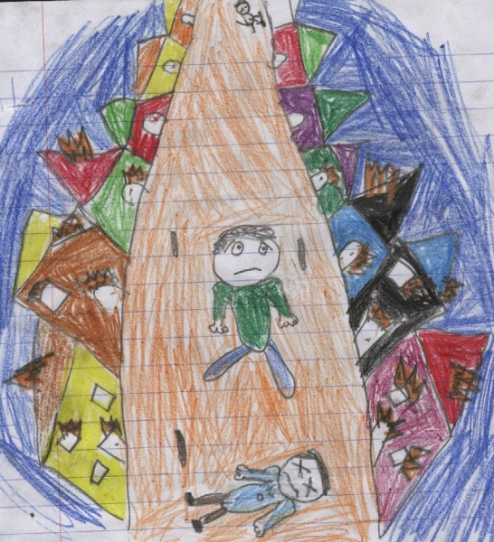
We were all starving and thirsty when, suddenly, we saw an enormous ship in the distance! It was full of people. When it got near someone threw a rope down. I went to grab it. The next thing I knew I was up on the ship! I found out that all the people where from Algiers trying to get to Europe just like me. In a blink of an eye, a rescue helicopter and lifeboats came to save us! I was put into a lifeboat and soon I was skimming across the waves to Italy. I made my way to Bari in a taxi and got a big warm welcome from my uncle. I am now living in Turin, playing with the Juventus soccer team.
Fianach

Ameria was only twelve years old when her mother was killed. She remembered seeing her beautiful hair fall loosely down her shoulders as she fell to the ground. Ameria was just about to scream when she realised that the soldiers didn’t know she existed. Instead she crept upstairs, past her bedroom and straight to the attic. She gasped when she saw a person crouched down in the corner. “Who is there?,” whispered Ameria. “My name is Amily,” said the girl. “How did you get into my attic?” said Ameria. “Well, the soldiers were chasing me and I saw a tree leading to an open window and well you probably know the rest.”
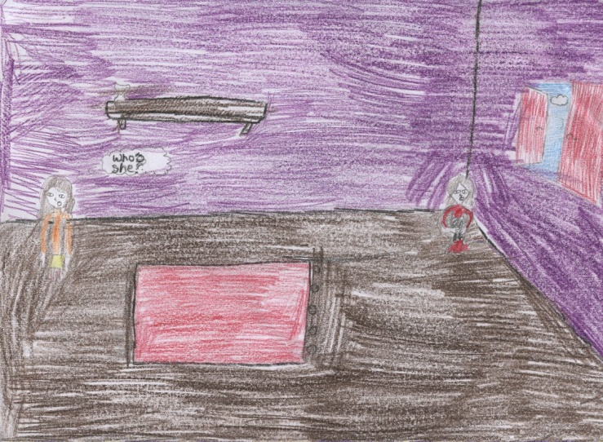
After a few hours of chatting, the girls decided to venture downstairs. They grabbed some water and a few snacks before they set off into the great beyond. They girls both had some spare money so they decided to put it to put it towards a boat.
Ameria and Amily decided to look around the more suburban parts of Sarajevo as the boat dealers would be more likely to hang around outside town. They were right. They ventured into an abandoned warehouse and found a handful of middle aged men smoking some kind of mysterious substance.
Ameria eventually gained enough courage to ask them if they had a boat. “We do, but a small girl like you couldn’t possibly have enough money for something this rare or expensive,” said a small creepy man. “Well we have have one........” replied Amily “That’s not even a fraction of the fifty we want,” said the man. “You didn’t let me finish...we have one hundred each” “Okay we’ll take the lot.” “But!” “All, or nothing!” “Fine,” groaned Amily.
The men took the two girls to the coastline. They threw the girls out and said to walk two miles to the right and they should find a small group of people boarding a small inflatable boat. The girls ran for their lives until they reached the group of people. The boat was already at sea. The girls had to swim until they reached the boat. The people on the boat reluctantly helped the girls up. The weather was very bad so the girls nearly drown two times. Ameria had made a very nice friend on the boat called Quena. She was always positive and happy, that’s why she was liked so much by everyone.
There were about fifteen people on the boat that was made for five. We quickly ran out of food and water and were slowly starving to death. One night there was an unusually bad storm. Everybody was clinging on for dear life. Ameria, Amily and Quena were all holding hands. The small boat shook vigorously until finally it tipped over. The water was so cold. None of the people that were on board the boat knew how to swim. They all grabbed the boat and paddled. They paddled for two whole days. They were just about to give up when they saw a helicopter in the air. Suddenly Ameria remembered she had got a flash light for her birthday. “Does anyone know morse code?,” said Ameria. “I do” said Quena. “Here,” said Ameria as she passed the flashlight to Quena.
Soon enough, they were in a hostel in Germany. They got their refugee status and became citizens of Berlin and they couldn’t be happier.
Ella Nic Liam

Hello my name is Aman Shenu and I am from Raqqa in Syria. I am in a family of four. I have a big sister called Safaa. She is fifteen years old while I am only twelve. My dad Aylan is a doctor in a traditional pharmacy. My mum Anat works at home and minds us. She would cook the dinner and shop for food at the local markets.
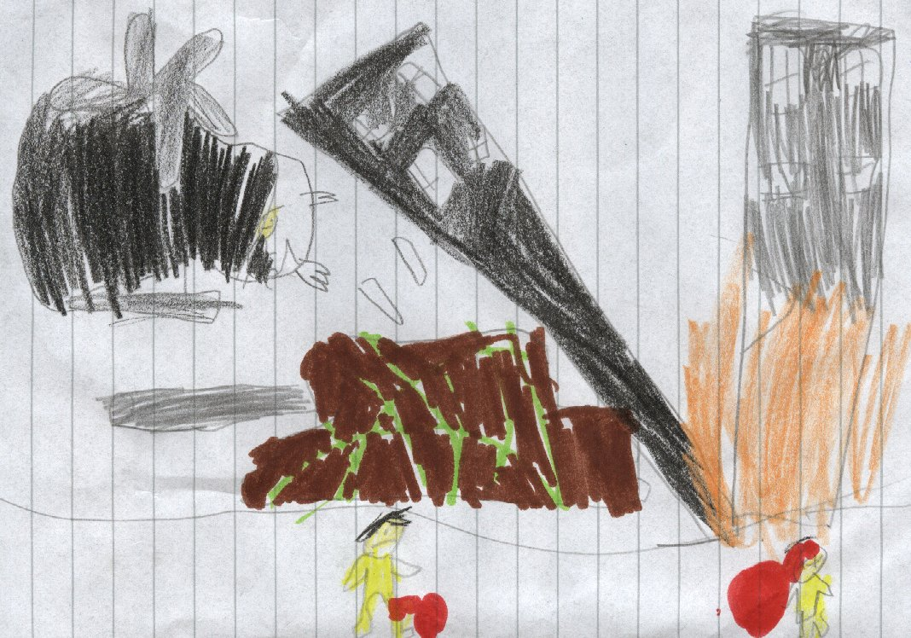
But two years that all stopped. Isis took over the town and made women wear hijabs and burkas. If you didn`t, they’d arrest you and torture you. Mum hated being covered up. Isis would take over the schools and hospital. They would blow themselves up sometimes. Every night the airstrikes would wake you up. After months with dealing of this constant fear of being killed we decided to move to Europe hoping to find a new life.
We woke up very early the next morning and packed our bags. I brought my good t-shirt, tracksuit and sandals. I also brought my favourite book and my Nintendo. We took a bus to Aleppo. I was disappointed to be leaving Raqqa but i knew I would end up dead if I stayed. When we reached Aleppo we took a smaller bus to a village three hours away from the Syrian-Turkish border. It was getting late so we decided to book into a shelter for the night. The owner gave us some fruit and sweet tea.
The next morning, we left the shelter. We were very grateful for the owner who fed us and let us sleep on a comfy bed. We got another bus to the village nearest to the border. When we arrived, we set out for a long twenty-mile walk to the border. It was scorching hot outside. After three hours of nonstop walking we finally reached the border. I was so relieved that we were almost there.
That evening we started talking to man. He said it was incredibly difficult to cross the border. He said that he was a week waiting for an opportunity to arise. We knew that there was no point waiting here so we bribed some men to take us through the mountains in the dead of night to Turkey. It was painstakingly hard to climb the mountains in the dark. After hours of climbing in our sandals, we crossed the border into Turkey. The guides asked us if we would be willing to pay them extra so they could transport us to the docks, where we could get a boat to Greece. We agreed and the next morning they packed us and some other Syrian refugees into a lorry. Every few hours they would come in and give us some bread and water. It was so tiring, sitting in a compact room filled with dirt with three or Syrian families.
After a day of driving non-stop, we finally arrived at the Turkish coast. We explored the nearest town. Dad managed to convert some of his remaining money into lira. We bought some Turkish pizza and a few pastries in a Turkish bakery. This place was amazing. It was like a different world and yet it’s only a couple of hours away from Syria. We tried to book a B&B for the night but it was way too expensive. Instead we took out our blankets and cushions and slept on the main square for the night. The next morning we woke up to find some money beside us. With that we were just able to get a boat over to Greece. We hung around the town looking in the shopping centre for some cheap food. We found a fast-food restaurant and we bought a portion of chicken and chips. When are food came we were amazed. The chicken had this golden glaze on it and the chips were so skinny. After eating our food, we looked in the shops and waited for the night to come.
Tonight was the night where we would leave the middle east and go to Europe. We were all excited, but nervous at the same time. What if everything went wrong and the boat capsized? We all tried not to think about but we all knew it was a possibility. When we reached the beach, the man gave us lifejackets. They were worn out and Safaa and I had to share one. When the boat took off things went well, but suddenly the engine stopped working. We were about an hour away from the Greek coast and we were able to see it in the distance. The captain tried to restart the engine but it was no use. The waves were starting to get very choppy. We all thought we were going to die! But out of nowhere, a ship appeared. We shouted at the captain of the other ship. He sailed towards us and pulled us aboard. We finally arrived in Greece at dawn. We were about to leave the docks but the crew on board wouldn’t let us. Instead they put us on a bus and transferred us to a refugee camp.
As soon as we arrived, we knew we were in a refugee camp. We were very disappointed because it was the end of the road for us. This place was a dump. The camp was filled with rats. There was only a couple of toilets and there weren’t many ovens in the public kitchen area. At least there was a school and there was no more war and Isis here. The woman said we would only be here temporarily and we would get a proper home soon enough. But I guess this is where I will be staying for now.
Rónán

Refugees’ Plan
It started with a bang! I ran for my life as bombs exploded and bullets whizzed past me. I was in the middle of the war. I looked left and right to see people die all around me. I wondered how they missed me. I took my chance and ran. I ran until my legs gave up on me. I fell to the floor, hunger and thirst struck me with a smash. I could still hear the terror behind me but I was safe for now.
I found the next small village had not been destroyed yet. I went over to the well for some water. The sensation was so good as I had not had water in almost a week. I told the villagers what was about to happen. Many women and children cried as the men prepared. I left after that to go to the port.
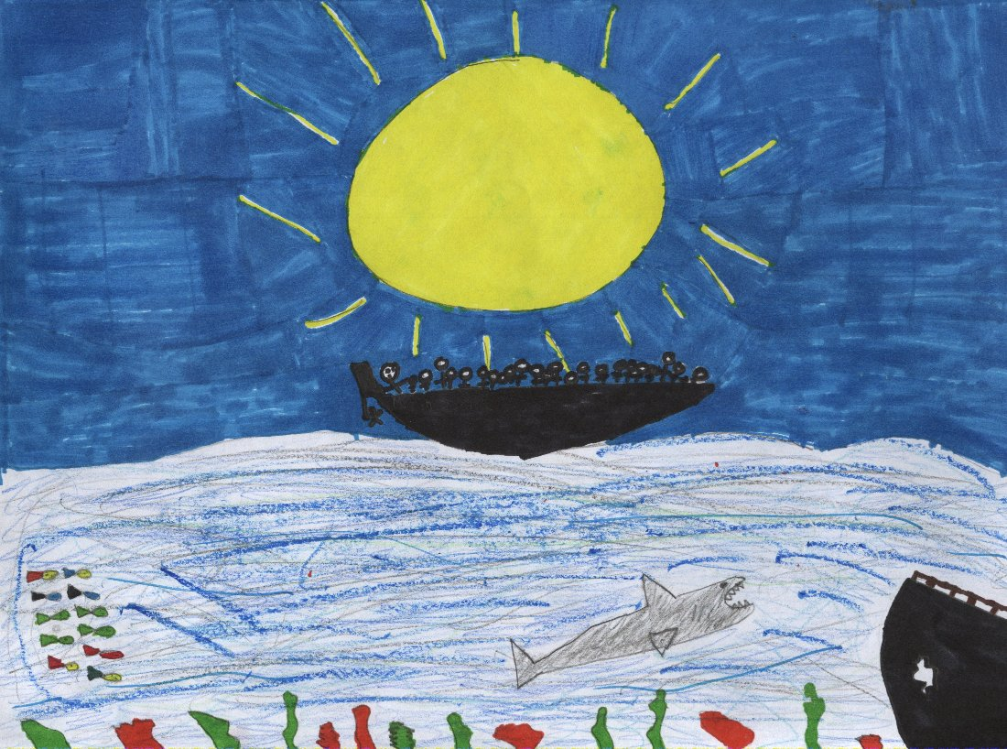
When I reached the port, it was packed as I had heard beforehand. I had hoped I would never have to go there. I was pushed and knocked over, but I kept moving. Not only was the port dangerous, but it had a lot of sicknesses as well. As soon as a boat came, everyone started shouting. People got on the boat and I snuck on with them.
I had made it! I was on the boat to hope, freedom and a new life. The only thing in my way was the big blue sea. It would be a long journey but I thought I would make it. That was until someone shouted “Get that boy!!” I hid under some people, but that was no good. I was caught and thrown off the boat.
I was so mad but I knew that I couldn’t let rage control me. After my parents’ death, I got so mad I destroyed the house. I promised myself I would never do that again. That night I thought about a walking journey to safety. I thought it was impossible. I knew a few people survived that extraordinary journey and I also thought about the less lucky people who didn’t succeed. It was a long dreadful night.
I awoke with a start and found the war had found me again. I ran once more. As I was running I planned my journey I would go to Oran as that was near Spain and freedom. I lived in Reggane and it was a long journey. I went to my home town and packed up with water, food, more clothes and a backpack I had got as a boy. I was twelve now and thought I could do it. My mother once told me that, if you believe, anything is possible. I planned I would go to Timimoun, Taghit, Béchar, Tlemcen and finally to my destination Oran.
I began my trip to Timimoun. It took me five days to reach Timimoun. I rested and had some of my food and water. My feet were blistered and very painful. People had heard about the war and were running around preparing.
I left Timimoun and headed for Taghit. It was a painful journey and every step I thought I would collapse. When I finally made it to Taghit I had no food left. I searched around Taghit for any kind of food. I was lucky enough to find some leftovers. I scoffed them down but I still heard a rumble in my stomach. I thought I would not be able to continue my journey as I was in agony. I rested but could not sleep I kept hearing the wails of all the poor people fighting for dear life. I rose very early the next morning but I wasn’t sure if I should keep running from the war or should I face it off. I knew my life would end if I stayed and fought.
I left for Béchar which was only a small journey from Taghit. I still had blisters all over my feet and every step got worse and worse. The trips felt longer every time as I was getting weaker. When I reached Béchar, I felt so weak and I thought it was the end of the line for me. I lay down and took my final breaths or that’s what I thought. I had been given another chance at “the walk” I gathered my things and headed away again it was a miracle I was back to my old self and was on the move. I had a very big walk ahead of me. I had to go to Tlemcen. It was along journey and I wasn’t certain if I would make it. I stopped many times but carried on ahead. I finally made it to Tlemcen and I knew my journey was almost over. All I had to do now was go to Oran. I didn’t even stop in Tlemcen I started walking to Oran my final destination.
When I reached Oran, I thought about the people who weren’t as lucky as I was. I went to the port there and got on another boat I hoped the same thing would not happen again. This boat was bigger than the other boat I was on earlier that month. My feet healed while our journey to freedom took place. A couple of people died on the boat but most of us were ok.
When we reached Spain I jumped to my feet. I ran off the boat to freedom and peace. That was until the police came...
They said that refugees had to go to a “home”. We didn’t know what a “home” was so we said ok. That was a very bad idea. We were thrown in with all the other refugees and given small meals. It was better than being in the war or worse but I didn’t like it. Everyone slept in the same room and ate together. Many new people came in each day and I made some friends for the first time.
When it got wet every where got mucky and slippery. I fell over many times and hurt myself. I was brought to a doctor who put a cast on my leg. I was in pain but kept going.
Many years later, I was let out to the world. It was so beautiful. I got a job as a postman and got myself an apartment. I was one of the lucky refugees who made it to a new life.

Caolan Ó Coinin

ESCAPE
Before war started in Daraa, I lived in a small house in the middle of the city with my mother, father and my brother. My family and I didn’t enjoy living in our house but we had to live there as we couldn’t afford to buy a new house. We always knew that Syria was a dangerous country but, when war started, we didn’t feel safe anywhere. My parents warned my brother and I not to go outside as children were plucked off the streets everyday for suspected anti-government activities, only to be tortured by authorities.
It was March 15th 2011, the day war began. I didn’t know what was going on. My parents wouldn’t tell me why they were so worried and why everyone outside was more frightened than usual. My little brother Faez was crying because he was so confused. I wished I could explain to him what was going on but I didn’t know what was going on either. We were both too young to understand. My father was on the phone to someone and he seemed very frustrated. He was shouting into the phone, but I could only figure out a few words he said. He said something about fleeing to another country, sneaking past soldiers and travelling on a boat to Turkey.
My father told me to gather all of the food, blankets and clothes in the house, and to put them in a bag so we could bring them with us to the country that we had to flee to. I asked my mother where we were going again and she told me that we would have to walk a long way to the dock in Greece so we could get on a boat to Turkey. Once I gathered everything, I gave the bag to my father to carry and my mother picked up my brother who was still crying. We checked to see if we had forgotten anything, and then we left our home.
We started running to Greece but it was getting dark and we weren’t sure if we were going to make it before it was dark. My father was worried that the soldiers would catch us so we had to beware of the people surrounding us. Eventually it got very dark and we were not able to see anything. Suddenly we saw a light in the distance and my father said that it might be the soldiers. My mother insisted that we should go back because it was too dangerous and that there is a chance that we will get taken away or killed but my father said that it was too late now and that we were already half way to the dock. We continued walking until we got very close to the light.
We heard voices and it sounded like men talking in Greek. We quickly ducked down and thankfully the grass was long so the soldiers weren’t able to see us. We thought that we would be able to get past them, but suddenly my little brother started crying. My Mother blocked his mouth but you could still hear him. The soldiers quickly looked over in our direction. We prayed and prayed that they couldn’t hear us but they started walking over to us. My father told me to get ready to run but the soldiers were way faster than me and I wouldn’t be able to keep up with my father and mother. I started getting very worried. The soldiers were getting so close.
My father started running and my mother followed him. The soldiers saw them. They were running after them and shouting. I started running but I didn’t know if I was going to catch up with my parents as they were ahead of me and the soldiers were also ahead of me. I decided to take another way to the docks but this place wasn’t familiar to me. I saw a gap in the fence so I went through it. I could hear my little brother crying in the distance, so I followed his cries. He finally stopped crying but that meant that I would no longer be able to follow his cries and catch up with my family. I decided to keep walking forward and, after a few minutes of walking, I saw the soldiers. I quickly hid in the bushes until they were out of sight. My parents weren’t with them so they must have got away, but where to?
I heard a whisper. I listened carefully. I heard it again and the voice was familiar. It was my father! I ran to him and my mother and little brother were there as well! I was so relieved that they didn’t leave me. My father said that we were very close to Greece so we just had to get there without being seen again.

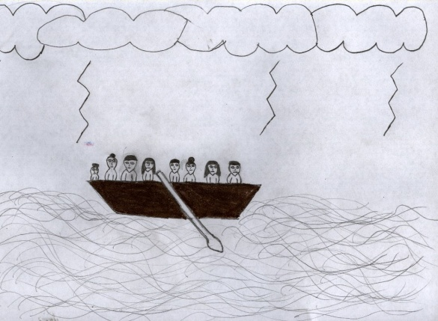
When we arrived at the dock we were so tired from walking. There were many other people trying to get on the boats. There weren’t many boats and we weren’t sure if there was going to be any space left for me and my family. We ran over to the boats and pushed our way through the stampede of people. We found a small boat and we managed to get on it. I hopped on first and my mother gave Faez to me. Then her and my Father got on but it was a squish. There weren’t any lifejackets left for us. I wasn’t able to swim and this boat wasn’t very safe. It was going to be a very long journey to Turkey. I asked my Father if he still had the bag that I gave him earlier that day but he said that when they were running from the soldiers, most of the food and supplies fell out of the bag so we only had two bottles of water, a loaf of brown bread and a blanket left. I decided to go to sleep as I was very tired from all of the running I did. I grabbed the only blanket we had left and I covered my head with it. I couldn’t get to sleep for a long time because I was worried about the war and if we were going to be able to flee the country safely. The other people on the boat with me were very loud and there were so many babies crying. We had no food on the boat and the loaf of bread was not going to last me and my family for the whole journey.
The next morning I woke up to the sound of rain. I usually would love rain as we don’t often get it in Syria, but not now. My blanket was wet, I was shivering with the cold, Faez was crying and the boat was rocking from side to side. The waves were crashing onto the sides of the boat and I was getting drenched by the freezing cold water. I thought that the weather would get better but it got worse. The boat was getting slower and it was going under water. I began to think that there was a hole in the boat because there was a puddle of water on the floor and my feet were soaking wet.
I searched for a hole and I eventually saw one in the corner on the floor. There was water coming through and no one noticed. I shouted out that there was a hole and everyone jumped up and started screaming. My Father asked me where it was and I showed it to him. He quickly grabbed his jacket and started blocking the hole but that wasn’t any help. The water was bursting through the hole and the boat was nearly fully under water and I knew i was going to have to swim.
My father said that he would hold me up above the water until we got to the shore. I trusted him. Everyone on the boat started swimming but I was the only one who wasn’t able to swim. My Father grabbed my hand and we jumped into the water. I wasn’t sure if he was going to be able to keep me and him above water. It felt like I was in a bucket of ice. My Father was getting weaker and he started sinking. I tried to swim with him so he wouldn’t have to carry me the whole way to shore, but I wasn’t able to. I started sinking and my father let go of me. He told me to hold onto his arm but he was not strong enough. Faez was far in the distance on my mother’s shoulders and everyone who were travelling on the boat with me were out of sight. I knew that we were not going to make it. My father let go of me for a few seconds to take a break and I sank down. He tried to grab me again but he didn’t pull hard enough. I was losing my breath and I wasn’t able to stay up. My Father was no longer trying to keep me above water and he left. I wasn’t cold anymore, I was hot, really hot. My body felt like it was sweating. I felt like someone was suffocating me and wouldn’t let go. I had no hope that I would be able to survive. I stopped trying to catch my breath and I was gone. I could not feel anything or hear anything. I began to feel relaxed for the first time in a few days.
Dearbhla

Escape
20th December
Hi my name is Lely and I live in Syria. Well not for long. I am one of the thousands of refugees. There are so many families fleeing to different countries. My parents are refusing to tell me where we are going. I think that I would be able to help if I knew where we are going and why are we on a boat with no food. The only thing my mum said to me was that Syria is a very violent place. All sides committed crimes using chemical weapons and more. I did not get this one bit, because who would hurt so many families. I am not allowed to meet my friends. My friend [Amena] and I had planned to travel the world, see the Eiffel Tower, climb the Sydney Harbour Bridge and eat bangers and mash. But I think it is time for me to face reality and deal with what is ahead of me even though I know it is going to be painful.
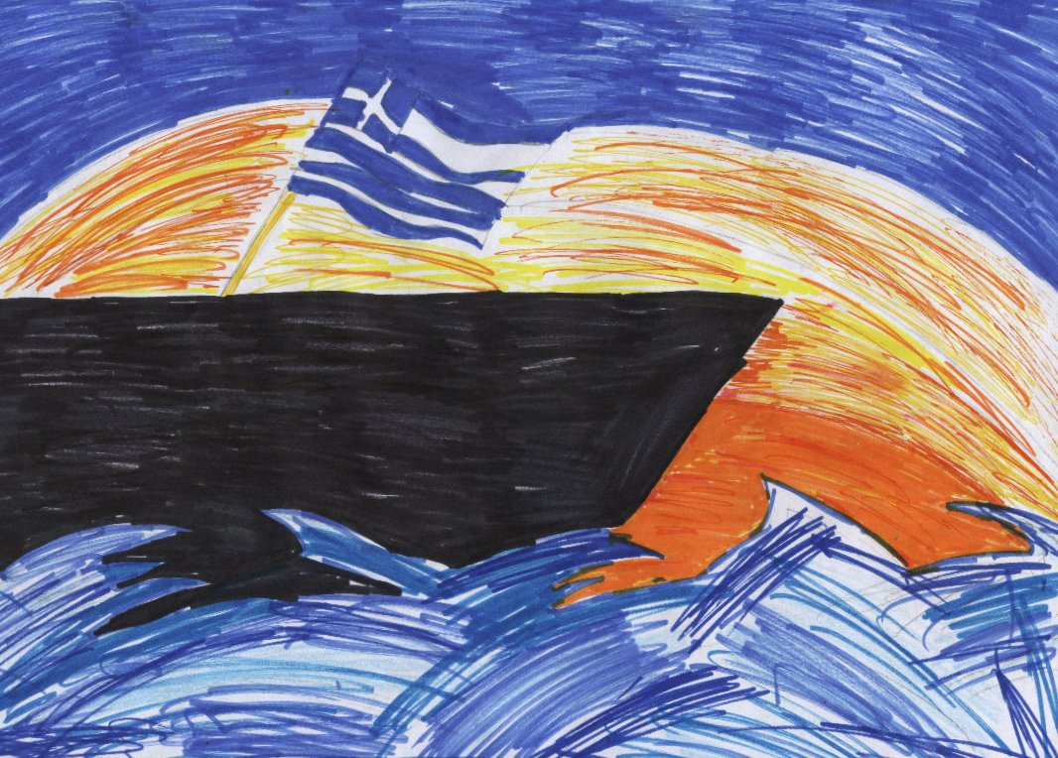
22nd of December
It is two days after my first paragraph. I have resulted to eves dropping when I am supposed to be asleep in the opposite side of the boat. I heard my parent saying that the Isis say militaristic Jahadis group used the opportunity and entered the chaos with a goal to build a totalitarian Islamic caliphate. Very quickly, it became one of the most violent and successful extremist organisations on earth. The Syrian population was trapped between the regime rebel groups and the religious extremists. A third of the Syrian people has been displaced within Syria whilst over four million have fled the country, the vast majority of them recite now in camps in the neighbouring countries who have taken care of ninety five percent of the refugees. The UN and the world food programme were not prepared for a refugee camps are crowded and undecided subjecting people to cold, hunger and disease. I knew that my father and mother were very well educated but if we were on the boat for the last few days how did they know all this new news they could not have heard of this earlier on because this is what is happening now. I went to sleep with the question running through my mind it was like a really annoying alarm that kept going on and on.
25th of December
I just realised how much I wrote the last day sorry about that. It is so hard here, I never imagined the world to be so cruel to be so mean and especially for families I know there are families out there that can spare a couple of Euros it is so hard to think that people waste money and they could really be giving it to the people in need to the people that will appreciate it. I never pictured my life turning out like this. I took everything for granted and never realised what people are going through. I am still bursting with curiosity about where I am and how does my parents know about all this new news?
1st of January
As I am writing the date I realise that it is the first day of the New Year! The children would parade the streets celebrating the New Year. I was looking forward to this all year and I never pictured myself in a corner of a boat cradling my younger brother whilst crying and saying that everything will be fine. There are five other families on the boat with us and they are all doing the same exact thing to what we are doing…crying.

3rd of January
I decided that I need to cop on to myself and thing of a plan to get me out of here out, out of this torture and to help my family. Even though I might only be eleven that doesn’t mean I still can’t help my family. I have recognised my father has a rectangular thing in his fanny pack. I was always allowed to look in his fanny pack to see if there was anything useful to keep Faez [my youngest brother distracted] he is only seven and the least thing that I would want for him to worry since he is only five. I am not allowed to look in my father’s fanny pack any more. I wonder is the thing in the fanny pack the thing that is telling him the interesting news. I wonder a lot of things nowadays and it seems that I never find the answers.
5th of January
I don’t believe what I am holding in my hands at the minute. My father is risking everybody’s lives at the minute at he doesn’t even realise it. It was his phone that was giving him that information, he brought his phone. Above anything in the world to bring on a refugee boat he brings a phone. Does he know that there is GPS on his phone? It is so hard to pretend that I don’t know he has a phone with him. I snooped through his phone and I found some very useful information.
Information
The European Union is investing around two billion Euros in defence, high tec security technology and border patrols but not a lot in preparation in influx of refugees, so it was badly prepared for the storm of asylum seekers.
In the EU a refugee has to stay in the state that they arrived in first which put enormous pressure on the Border States that were already in trouble.
A UK search and rescue operation called Mare Nostrum that was designed to stop people from drowning in the Mediterranean.
8th of January
The waves are making me dizzy now. It has been thirty nine days since I saw land and I am just after recognising something tucked in on the side of the boat, a flag. After all this time I know where I am going….Greece. I am furious with myself for not looking around. I was too stuck up about finding that phone I never realised what I really had to do. I am going to start thinking straight and start realising my priorities.
10th of January
In the distance I saw a big black boat heading towards our boat with a sign that said Mare Nostrum we are being saved I exclaimed with joy! I waved the flag with power and pride. I was proud to say that I was the one who found the flag and I was the one who first heard about the Mare Nostrum. The man pulled us onto the big shiny black boat.
12th of January
The man told us that the only place we could sneak into was Greece I said that that was our plan at first and that we had made a plan and we are going to stick to it and that’s that. He said that he had a secret way to get into Greece but if you are not happy with that then I will just have to go by your wishes. The ship moved slowly since there was very choppy waves and so we could see the pretty sunset too.
14th of January
As we crept underneath the docks, we could see people’s feet above us. Somehow we managed to swim about a kilometre west. The plan was to stay under the docks holding on to the poles that are standing the timber up and listen to what the soldiers were saying and see if there is any possible way to get on dry land. But then I saw a man coming towards us. We swam like fish I could feel my heart beating and my lungs trying to get as much air in them as possible. I could smell smoke from the factory beside the docs and I could taste the salty sea water in my mouth. My clothes were gripping to me and that definitely was not a help it was weighing me down. We finally could not hear the swishing of the man behind us I looked back and I saw him floating under. I felt a twinge of guilt run through my body but then I realised he wasn’t wearing a military uniform, he wasn’t a soldier. I wailed with guilt. I could do nothing about it now. I finally found land and we rested there for a couple of minutes. Then I heard the phone ring I could not believe the phone survived the water I looked at the lock screen to find the worst message I could of imagined Amena’s mum had texted…..Amena died.
Niamh Ni Fhearaic

Hi I’m Ayla. I’m a refugee and I’m twelve years old. I live in Syria and I hate it because I can never sleep at night. I always have nightmares and i wake up to the sound of guns and screaming children. I hate it here in Syria.
“Yarkud Ayla!”(Run Ayla) screamed my mother” “Alaibtiead ean hdha almakan!”(Get away from this place!)
They were the last words I heard from my mother. They were the last words I heard from my mother. It was the worst time of my life. I started to run, when i looked back i saw my mother on the ground with a bullet between her eyes. It was the worst time of my life. I started to run, when i looked back I saw my mother on the ground with a bullet in her head. The sight was awful but I had to keep running if I wanted to survive. After ten minutes of running I had to stop because I was so tired. I sat down on the dry sandy stones, I had no water or no food. I knew I had to keep running because they were probably looking for me. After a small break I got up and started to run. I heard screams from behind me and i looked back in horror, there was my father with blood all over him. I started to cry with happiness after he caught up to me and told me he was fine, because now I had someone to go with instead of going on the journey by myself.
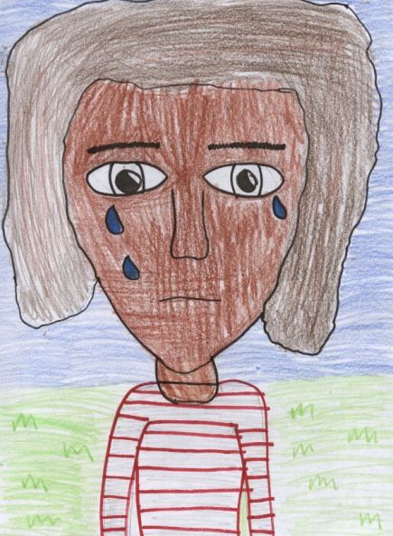
After about an hour of running and stopping for quick breaks we had made it to the boats. We were just about to get on the boat when a big man stepped in front of us. He was a broad man with a big grey beard and he looked very cross. “Madha turid?” (What do you want?) he said in a low voice. “Nahn nurid 'a nadhhab ealaa matn alqarib.” (We want to go on the boat) said my father with a weak voice. “Hal ladayk tadhkira?” (Do you have a ticket?) “La.” (No) Eventually he let us get on the boat but we got the worst place to stand. We had to stand in the middle where we were squished between everyone else. We were on the boat for two days when the man who had let us on the boat shouted out “Nahn taqribaan hunak” (We are almost there). I was so happy that we were so close to making it to Turkey. I knew I wouldn’t be completely safe in Turkey but we could stay in the refugee camp and we might be safer than if we stayed in Syria.

We were about an hour away from where we were getting off when the boat started going down. Nobody noticed but I did, it went down a bit more and then people started to notice. I was terrified. My dada held me tight. The man jumped out and started swimming towards the shore. I thought maybe he was going to get help but I later found out he wasn’t getting help he was saving himself. When the boat was going down I thought I was going to die but I felt someone pull me into the water it was my dad. He started swimming but I let go of him and started swimming myself. He looked back and smiled and then started swimming again. I caught up with my dad but I could barely swim. I was so tired but we were almost there. The water was freezing and i was numb. When we got there we were cold and wet. We sat down on the wet sand and shivered. My dad held me tight and eventually I warmed up and we started walking to the refugee camp. My dad knew how to speak Turkish so he asked an old woman “multeci kampi nerede?” (Where is the refugee camp?)He asked politely. The woman pointed to a long road and said with a weak squeaky voice “O yoldan inip sağa dön” (Go down that road and turn right) “Teşekkür ederim” (Thank you). We walked down the road about eight miles and then we saw a right turn. Down a big hill was the camp. There were people who looked like skeletons and some other who looked like they were about to die. I knew I was going to die here too. We walked down the hill and we looked at each other... This is our home forever.

Brooke

Escape...

It was December the 22nd in the year 2011 when my home city Aleppo went into war. It was really scary. I never thought that our country Syria would go into war. It was a big shock. Just because of someone, I didn’t really know why because I wasn’t allowed to know about what was going on. I don’t know what put our country to war. I wasn’t allowed to know because my mother didn’t want to worry me, but of course I was worried. I have one sister called Jihan. Jihan is my best friend and she tells me everything, including about the war. She is sixteen years old, four years older than me. She told me that at her school, there were ten people missing from her class. She reckons that they got killed or that they got taken away. She wasn’t allowed to go to school because that blew up when an attacker threw a bomb in. It happened during the weekend. Thankfully no one was in there.
My name is Amena; I go to very small school far away from where I live. I walk to school with my best friend (Lely) everyday. Lely and I plan to travel the world one day, to see the Eiffel Tower and loads of more stuff, but most importantly eat bangers and mash. I love Lely; she is like sister to me. We were friends since we were babies. I don’t know what I would do with out her, and I don’t know what she would do without me.
My mothers name is Ranim; she is the best mother ever. She is 33 years old. My dad’s name is Adnan and he is 36 years old. My mother doesn’t work but she looks after the house all the time. My father is out fighting in the war, but I don’t know if he is alive any more because one day mom got a letter from the army saying something that set my mother to tears. She didn’t tell me why though, so when my mom left the room to go to the bathroom I ran over a grabbed the letter.
On the front of the letter it said ‘private and confidential’. I did worry too much about that because that is on every letter that comes to our house. I opened that letter and the first thing I saw was a tear stain that mom left on it. I put the letter close to my mouth and kissed the tear drop. Then I read the letter and everything seemed fine until I came to a part that said “Adnan is missing at the moment, there is a big chance that he was killed, we will contact you if we find out more, thank you”.
Tears came to my eyes. I haven’t seen my father for three months now, and what if I never see him again.
Now that the war was here we have to move. I don’t know where to, but somewhere out of Syria. My mom had everything packed up and ready to go and she then told us to get our stuff packed too. We had everything packed up and just as we were ready to leave mom thought of something. “Food and water” she screamed. I got the fright of my life and I ran to the press and stuffed everything in my bag. We then left to go to the dock.
We ran to the docks as fast as we could to avoid any shooting. We didn’t have time to talk, we were so focused. When we reached the docks we went over to the dealer and asked for three tickets. Mother wanted to know what the boat looked like because she didn’t want to put us in danger. The man replied in a very low voice “you can’t see until ye buy”. He then said “if you want to be safe you can upgrade”. Mom agreed and then she asked him how much it was. He said “it’s a very cheap deal so... for three people it will be ... around 9,000 pounds please” “WHAT?! What do you think you’re doing here trying to get me to pay 9,000 pounds to get on a boat, a boat that I don’t even know what it looks like!?” He then got really angry. “Well if you don’t want to pay, then go back to your house and see how long you’ll last back there. “Fine we’ll take it,” she replied, looking back in the distance. She then gave him the money and he gave us a ticket and a really bad life jacket. We took them without complaining and put them on and we did try to blow them up but there were holes in them so there was no point. We gave the tickets to another old man that worked there and the he let us on the boat.
The boat was not an upgrade for any other boat there was three boats and they all looked the same. I thought we were going to have a great ride but of course I was wrong. We were crammed in a tiny wooden boat with around fifty people on it already. I prayed that we were going to be the last people on, and my wish came true. I had to sit on the side of the boat. It was horrendous the boat was so shaky, that I fell in.
I couldn’t swim it was too hard I was too weak. I could see a lot of dead bodies and the very bottom. I kept thinking about what if I was going to be one of them. And I reminded myself that mother was going to save me or maybe Jihan might save me. That didn’t happen, they didn’t save me.
All of a sudden I could feel myself floating up and up and up. I could see clearly; even when I was under the water. When I came to the boat I kept going up, it was like a magnet was pulling me up towards the sky. No one noticed me; it was like they didn’t care about me. I could see my mother crying. Jihan wasn’t crying she was comforting mother and praying at the same time. I didn’t understand why no one was looking at me. Then it came to me, I was one of them, the ones at the bottom of the sea. This was it the end, the end of my life. It felt great to be safe again. I had one wish and I put that wish to good use. I wished that my family and friend would find a safe new home, in a safe country.
I took one last look down. I could see that mother and Jihan were sad because they thought they would never see me again. Yes that’s true, they won’t see me until they come to this glorious land of peace. But what they don’t know is that their lives will be full of happiness and joy and that I will always be there looking down at them.
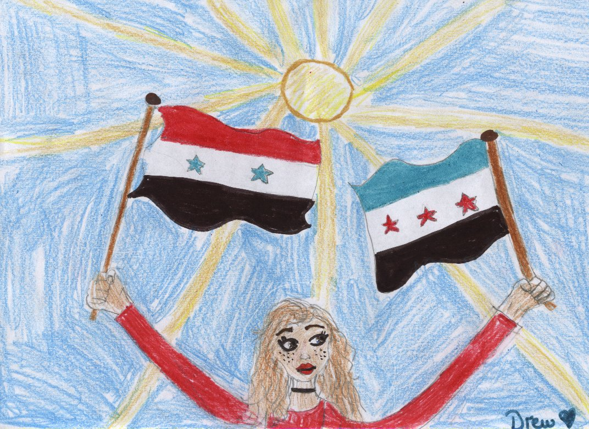
It was true my father had died. He is up here with me, and we are really happy together. I explained everything to him and he told me every thing about the war and how he died. It was really sad; we were really sad telling the sad stories. He made a wish too, that mother and Jihan will be safe and happy and live a healthy life. We hugged each other for a long time. Then he showed me around this great place. I’m happy now in this glorious land of peace

Drew Courell

I was in the trenches of World War 3, serving my country. A bomb whizzed over my head as I saw the US air force rushed to counter attack. The battle of Bangladesh had reached his peak and it didn’t show any signs of slowing down. One of us had had enough and he took a belt of grenades and charged the enemy. He got shot down almost immediately. All this loss of life could have been prevented if the cooler heads had taken charge. Our commander realised we wouldn’t survive unless we surrendered, and he reached for a white flag. “Stop!” I shouted. “We can’t surrender now! The civilians are being held captive. If we surrender they’ll kill them!” My commander nodded and recognition of my suggestion reached his face. “Men, to the end!” He shouted. I wish I wasn’t here. I wish the Chinese hadn’t decided to blow up that American nuclear base. I didn’t want to die, fighting a war in a foreign country. But those Refugees had to escape! And like I said that day in New Delhi, This war won’t win itself! I remember how I joined the war effort. It was on the day that India joined the war and Russia bombed New Delhi.
I was watching the president’s speech on our small T.V surrounded by the fifteen people in our two bedroom house, when the public service announcement interrupted it. She was saying something about the Chinese military exploding one of the US military bases and how the US military had taken up arms against them, and as a US ally, India would join the US military in that taking up of arms. Basically, it meant we were going to war. Anyway, it was cut short by an announcement; it showed a man looking at us with glasses and a smart, black, official looking suit. “We interrupt this speech to bring you an urgent announcement from the Nuclear Command Authority of India. Recently, Russia has launched a class five Atomic missile, targeting the city of New Delhi. We have launched all our intercept missiles but at least two will make it to the capital city. We our organizing bunkers and a city wide evacuation, but not everyone will be able to evacuate and the bunker will be extremely overcrowded. If you cannot find a place we recommend going to the houses of court or parliament, after the explosion you will be tasked with the search for the bodies. The price for safety will be conscription to the Indian military for any person the Generals see fit. You have an estimated two hours to make preparations. Good luck to everyone listening and stay safe.”
We turned off the T.V immediately. We set out to look for a suitable place. We checked the hospitable first, on the off chance that they had space. But they turned us away quite quickly. I didn’t blame them. They would be up to their eyes in patents. We than ran to the chocolate factory, half a mile away from us. Our bare feet were scraping of the ground and I could feel them bleeding. Unfortunately, it was all in vain as they were full to the point of bursting. We tried to protest but the owners were insistent. We didn’t waste any more time protesting and sped off to the industrial estate full of warehouses. People had got there instead of us and they were unsafe to travel to. We looked and looked but every place turned us away. When I checked my watch and realised we only had half an hour until the missiles hit Dhaka. We saw a huge explosion over the horizon. It must have been the intercept missiles. “Father, we need to go to the parliament house. We will be accepted” “But we will have to join the military, we m-might d-die” he replied. His stutter was always worse when he got nervous. I looked at the picture of Ghandi which I had in my pocket. He is my hero. “Father, Ghandi made sacrifices so we could have a better life. This war won’t win itself! I say we should join the Army. We’ll die if we don’t go somewhere! I think that it’s better in an army than completely dead, this is the only way Father” He realised what I meant and gave in. “Ok everybody follow me!” he exclaimed as he ran towards the parliament building.
Only six of our fifteen members of the family were accepted to join the Military. My sister, my cousin, my uncle, my aunt, my other cousin and I were all separated from each other and put on different lines. I was put at the front lines after a rigours training course which lasted one month. It was run by an old, kind, but demanding general who tested our squads’ fitness and resilience. Life in the training camp was tough but it was better than the vicious poverty that we lived in. It was like an escape. Suddenly, on the last day of our training, we received news of North Korean soldiers capturing refugees escaping Bangladesh. We were quickly loaded on to a plain and dropped off at the front lines.
So there I was, fighting the government’s war. But I was also protecting innocent people. All those poor, frightened refugees! Some people were calling this the last battle of the War. But I’m not so sure. Suddenly an Idea hit me. I told the commander, Dmitri. “Commander, Commander! I have an idea!” I say. The commander looked at me strangely “What is it Soldier? This better be important” He looked cross and scared when he said this.

Evidently, the battle had taken its toll on him. He had watched three of our men die and one commit suicide. He needed one victory; my plan would give him that.
“Sir, we should pretend to surrender, and when the enemy forces come, we can take them hostage ourselves. We can interrogate them and squeeze the location of the refugee hostages out. Then we can give the info to the military.” “I like your plan! Soldier, let’s do it!” He told the other men and woman and they were all for it. A minute later, he waved the white flag in the out of the trench.
Two enemy troops walked over the ‘wasteland’ briskly with their submachine guns by their sides. Suddenly, I leapt out and tackled one to the ground. The commander tripped the other up. Suddenly they were in our trench. With five guns aimed at both their faces! They gave a frightened look around the trench, excepting help of some kind. Then they put their hands over their head and gave us their weapons. The commander immediately set about contacting the closest General to us in the Battle. A red, armoured helicopter landed outside the trench and picked us up with two prisoners. We set a course for Area sixty, a US military base located in south Japan.
We landed in our red, military, helicopter on the helipad. My commander and I left the helicopter with the prisoners. The other troops in our trench squad were ordered to stay in the helicopter. My commander and I walked out of the helicopter. Outside of the helicopter, I saw a huge warehouse with the Indie- US allies’ flag. I was awestruck as I walked in. The suits of the people were the most expensive thing I had ever seen. I had never been inside any headquarters or base, never mind a military base! I was fascinated by the efficiency of the workers and the tidiness of it. I had never been inside a building like this before. There was a vibe of business. It suddenly struck me; I want to work in a place like this when if I survive the war. We brought the prisoners from the battle into the interrogation room. The prisoners confessed the location very quickly. The refugees were located in a warehouse in an industrial estate in Dhaka. We immediately took off in our helicopter. We left the prisoners in the base.
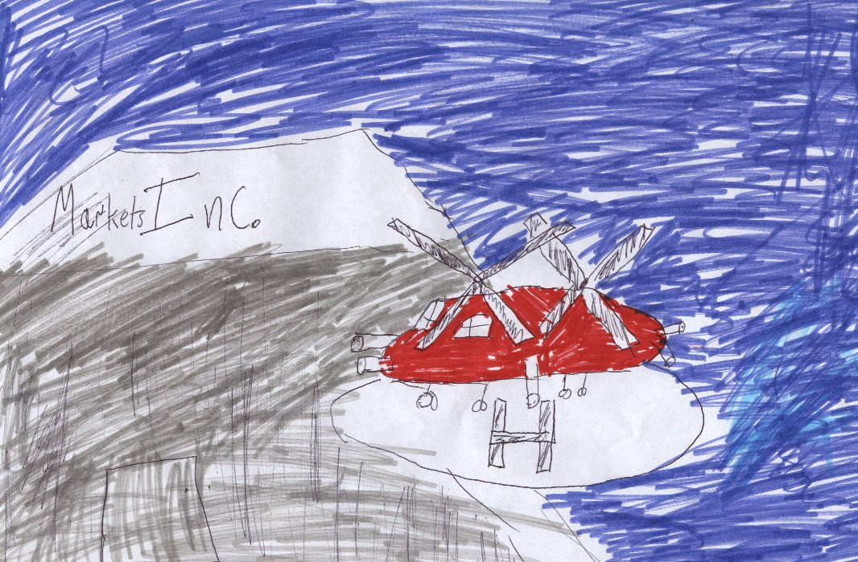
When we landed, we saw the full size of this industrial estate. There were factories, supermarkets, fast food restaurants and a huge warehouse with a big sign with the letter MARKETS INC. There were two guards. They made a weak attempt to stop us at first. They pointed there cheap pistols at all our faces. But when they saw our guns they surrendered their weapons immediately. The older guard handed the commander the electronic key. He opened it with a sense of pride. Hundreds of pour, starving, thirsty, refugees rushed out. They seemed overjoyed that we had rescued them. I was told some of them had died in the warehouse, from either lack of sleep, thirst, or suffocation from the overcrowded environment. They were there a week when we rescued them. Another day or two and they might have all died. We walked back up to the helicopter landing after calling some Ambulance’s for the sick people. We flew of happily. The war wasn’t over, but we had just brought a step closer to winning the war.
Our commander received a promotion to General. He eventually got the victory he was looking for. We remain close friends and whenever I need advice I go to him. The new general requested that I could become a commander. I received my promotion a week after the battle of Bangladesh. Because of that win the Indi-US allies are in the driving seat of the war and the escape of the refugees gave everybody hope.
Commander Muiris Cloherty

Escape!

We were dashing through the snow in a one-horse open sleigh.
Through the fields we go screaming all the way. One second let me tell you how we got to this point. We had just lost our house and we were going to go for a lovely holiday with the remaining money that we had. But when we got there, we were not welcomed as we had expected. The hotel blew up as we got there. Some terrorists had planted a thermal bomb on the boiler so that when the boiler turned on it exploded. As the building exploded, we ran for the nearest cover which was another building that had recently exploded. We still had our money and the small sleigh we had used to get to the hotel in beforehand. We were on are way to Europe but first we had to get over the sea. We had gotten to the nearest boat centre. We rented a small Choi Oi. We were to travel the seas with this tomorrow. We went to the nearest motel for the night. The next day: We got up early the next morning. We had to if we wanted to get to Italy by tomorrow .My brother and I went to the super market to buy food for the next two days. We sold the sleigh. It had no value to us anymore. We were sailors now. When we got on to the boat we started sailing. My brother and I took shifts sailing during the night. We had bought tons of food for the days to come. When we got to Italy, we took train after train till we get to the other side of the country. When we got there, we paid a man $2,000 to take us to the other side of the country. We all hopped on to a very small bus. It was hot sweaty and there were mushrooms growing in the corners in the bus. It looked very old and made strange squeaking sounds as if there was a mouse in the engine. It soon broke down. Taxis started collecting people.
The bus driver must have called some of his colleagues. The company did taxis to they took us to Belgium. At the end of the trip, we had to pay him $160.40. Soon after, we took a plane to England. There, we checked our money. We had about $1,800 left. We went to the bank and converted it to euro. We then had €2,000. We bought an old SUV, got jobs and lived happily ever after.

Caoimhín

Escape!
Hello my name is Aliza. I live in Rothenberg, in Germany. My name means joy but since the war started I have not been feeling very joyful. We are living in a safe house. This very nice couple let us stay in their attic. The attic isn’t very big it has; two bedrooms, not much bigger than a hot press, a small lavatory, a kitchen that smells like lard, a study room that I even smaller than the bedrooms and a hallway that no one dares step foot in, in case they are heard. There are five people in my family. Me, Aliza, I’m twelve. My big sister, Bina, is sixteen. Bina means intelligence, wisdom and understanding that is Bina to the bone. Then there’s my younger brother Ariel he is seven. Ariel means “lion god”, Ariel isn’t a god but he sure is wild. My mother’s name is Atara which means crown and my father’s name is Elimelech which means “my god is my king”. My mother and father always say they were meant for each as their names have quite similar meanings.
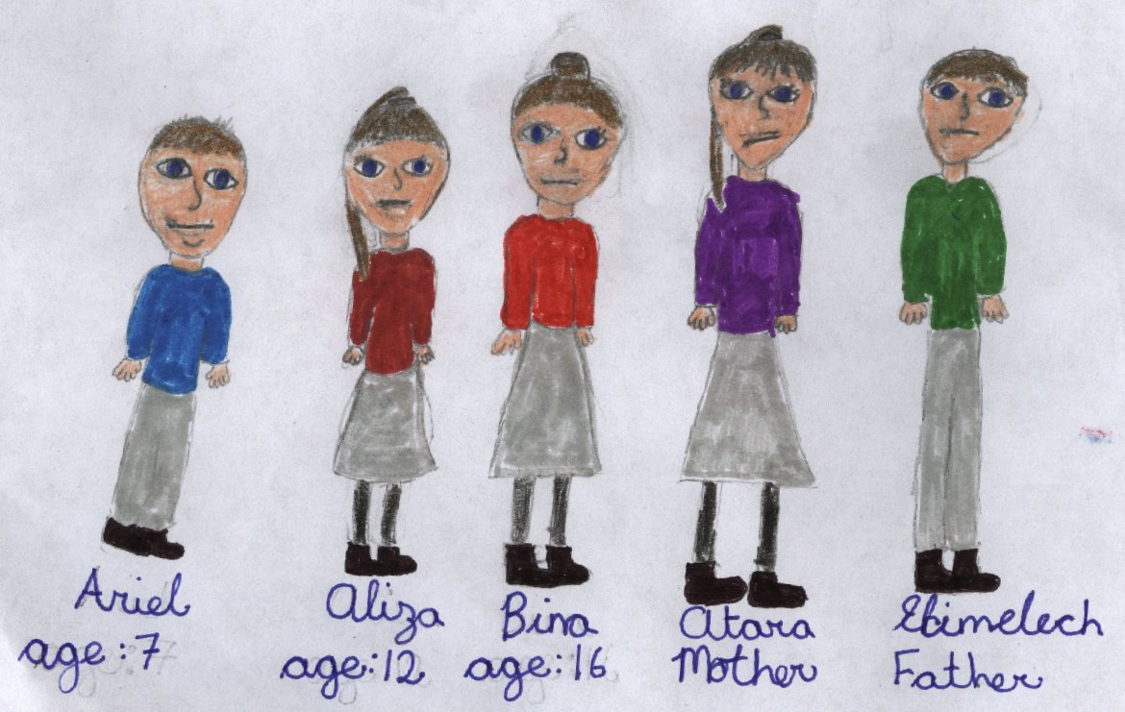
Bina and I share a room, and Ariel shares with Mother and Father. I distinctly remember the day we went into hiding. It was such a rush. I can remember my Mother racing into my room in a panic; I could hardly understand what she was saying. I packed my bags remembering to take lots of books and my favourite necklace that my beloved Grandmother had given to me before she passed. I grabbed my brother and ran as fast as my legs could carry me. In distance, I could see moving vehicles in the distance; Germans coming for us. Oh and did I mention we’re Jewish. But the important thing was we were all still safe.
It is now the fifteenth day of the month December in the year 1942. For the last few days we have been hearing banging downstairs. Then today we got a visit from the couple downstairs. This time they weren’t that nice. They told us that they were moving and that we had to leave the attic. This was the day the horrible journey began, the journey to France.
My mother told to pack light and that I shouldn’t bring anything valuable as it could be pick-pocketed. Ariel didn’t seem to understand why we were going; he was still convinced it was just a nice holiday. We left our safe, warm attic with much despair.
We took a car and paid the driver extra to make sure that he wouldn’t tell anyone. He took us as far as the outskirts. Then he told us we were on our own. We would have to travel a long way to get to France and, even if we got to the border, we couldn’t be sure that the border guards be fooled by our fake ids. My father heard about a train that brings Jewish people close to the border, but it wasn’t cheap and people had died from multiple illnesses.
It would a seven-day journey. It was still three kilometres until we got to the station. We started to walk. Within twenty minutes, Ariel started to complain. All I could think was how was I going to put up with this child. Our first glimpse of the train was not pretty. The driver didn’t look very respectable either. There were lots of other families there too. Most of them looked like they hadn’t had a good night sleep in years, but the most worrying thing was that some of them were sick. Since it was a seven-day journey, we would have to sleep on the train. For some reason, I had this idea in my head that we would all have lovely little carriage rooms with crisp white sheets and comfy pillows, and that we would be given breakfast in bed. I was so wrong.
When we got on the train, it was clear we weren’t going to sing to lift the spirits, like they did in the movies. There were rough, dirty, worn blankets on the ground. These were our beds. I got shivers down my spine; I didn’t want to stay here, who would? I ran towards a corner and saved it for our family. At least we wouldn’t have to separate. As night fell, it began not to feel like an adventure any more. All the passengers we crammed beside each other, I was worried I would get sick as they were all coughing hysterically.
When I woke up the next morning, my bones were very stiff. I would have loved to stretch my legs, but Ariel was asleep on me. I rubbed Ariel’s head, it was very warm. I listened to his breathing. It was quite hoarse and short. I woke Mother up to tell her about Ariel. She seemed very worried. She rummaged around in her bag for some medicine. Ariel’s breathing was getting faster and shorter by the second. Mother gave a sigh she had left all the medicine at home. We would have to care for Ariel until we got to the border and then we could get him some help.
The next few days were very boring; we had to make sure Ariel got everything he needed. Our foods were rationed and I was starting to become very hungry. The people on our train started rummaged in everybody bags while they were asleep, so we had to take in turns to stay awake. On the second last day, Ariel was getting very ill. He had a burning temperature and he was finding it very hard to breathe, but he settled when he got to sleep. When I woke up the next morning. I was so happy this was our last day on the train. I went to wake up Ariel but he wasn’t moving. I started prodding him harder and harder until a vigorously shoving him. Tears started streaming down my face. I started yelling for help. Everyone woke up with a start. My Mother woke up and asked why I was yelling. I couldn’t get my words out all I could do was point at Ariel’s dead body.
I was very depressed all that day. I could barely talk. I was so happy to get off this disgusting train. Father had wrapped Ariel’s body in the blankets, and buried him. I couldn’t watch. When we got to the border, I was started to get very nervous. They soldiers looked like they would take one glimpse at us and take us to a concentration camp. When we reached the top of line, the German soldiers looked at ID’s. They looked sceptical but…… they let us through! After that we walked for two miles and met up with a truck that was going to bring us to Strasbourg, where a new life would begin.

Isabel Ní Ghabháin

Escape!
One morning, my mother rushed into my room… Well… when I say my room… I actually mean a blanket on the floor of the kitchen/dining room. “Uri get up and pack your things!” she said as she picked up everything she saw and put them in a rucksack. “What? Why?” I questioned as I stood up to take a proper look at her. “We’re leaving… NOW!!!” Mother announced. “Where are we going?” I asked with great curiosity. “I don’t know yet, but we’re not staying here, that’s for sure.” She answered. “Fine,” I said as I reluctantly got out of bed.
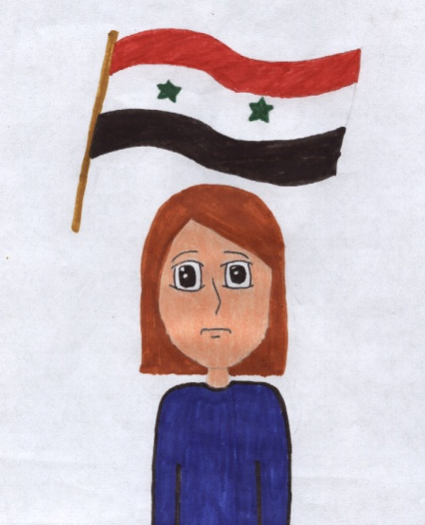
I finally finished packing and sat down where my “bed” once was. “Where is Father?” I asked. At first Mother hesitated. “He’s… out.” She answered, but somehow I could feel she wasn’t saying the full story. “Out where?” I queried. “He’s… not coming with us… he’s out in the battlefield.” Suddenly Mother’s eyes began to tear up. “Oh…” I knew this affected her just as much as it affected me, and talking about was just going to make it worse… for the both of us. “Well… I’m sure we’ll meet him again.” I tried to lighten the mood but it was no use.
When we were finished packing up, it was time to leave. This was it… I was never going to see my home ever again. We had so many memories here, but now they’ve all gone down the drain. “Where do we go now?” I wondered. “Well, we’re going to take a boat to Greece and sail from Greece to France and take a boat from France to Ireland. I have a few friends there, they’ll take us in.” Mother replied. “But that’ll last an eternity!!!” I complained. “We have no other choice!” said Mother and from there, we began our journey.
The boat trip was horrible! I could smell an awful stench from the passengers getting sea sick. It was so full, Mother and I almost fell out a few times. We finally reached Greece. I didn’t like it there. Everybody was giving us dirty looks. “Mother, I want to leave, the people aren’t nice here.” I whispered. “Don’t worry we won’t be here long, just a few more minutes and the boat will be here, I promise.” Mother assured. She was right, the boat came in no time. We hopped onto the boat just like we were ordered to, and began our trip to France. This time, the boat was much smaller, and it felt way more crowded than the last boat trip. This time, people were falling out. Mother held onto my arm as tight as she could.
We reached France. What a relief! There was only one more boat trip left. The next boat came as soon as we reached France. This boat was much more pleasant than the others. Maybe it’s because I had become immune to the smell of vomit and seaweed. By the time we reached Ireland, I started to get hungry. “Mother do you have any bread left?” Mother managed to snatch two loaves of bread with us and we had to eat it bit-by-bit during the journey. “No, we’re all out. Don’t worry, John and Mary will take care of us and give us food. We just need to find them,” said Mother as she scanned the faces of passers-by. “Who are John and Mary?” I asked. “The friends I was talking about. Don’t worry, they’re wonderful people.” She replied with her eyes still set on the crowd. “There they are!” she exclaimed. We rushed over to them hand-in-hand. We were saved, I couldn’t believe it!
Máire Ní Dhubhda

Escape from Bangladesh
It was terrible in Bangladesh. Buildings were destroyed, as well as families and lives. I had to leave Bangladesh. If I didn’t, I would be murdered for sure with my family. Most of the city was destroyed.

It all started when I was at my neighbour’s house playing with my friends. Out of nowhere, shouts, screams and gunshots came from outside the house. At first I thought it was the drug lords squabbling over something stupid. I thought it might stop after a few shots, but they didn’t stop. They kept coming. Slowly I started to become scared and worried. A few weeks later I was forced to leave my country or die young if I stayed.

It was hard leaving Bangladesh, especially when it costs nearly 2000 coins to go on an unsafe faulty boat, but it was better than nothing. So we went on the overcrowed boat. After a while, we reached our destination in Manus in Australia, but we weren’t welcome. We were attacked and had to leave again.

We then travelled to Chile in another long dangerous journey to freedom. After that we were welcome in Chile. It was great. We settled after a while in a small house in a small town in Brazil. We then lived our lives away from war and hate. At first they were scared of us, but then we became friends.

TADHG

Escape!
12th November 2014
My name is Elena, which means the bright one after the Greek Helen, but currently I don’t feel bright at all. I am twelve years old and I am from Mosul in Iraq. I have two brothers and a loving father and mother. The war has just started this year, but there has been many more in the past thirty odd years. Mother and father tell me tragic tales of their friends being killed and how they regret not leaving sooner, but now is the time. Isis has been attacking with terrorist attacks all over the world, but it is the worst here. Syria, Iran and the United States (and a dozen other countries) have been doing airstrikes here and my parents simply can’t bear the thought of one of us being killed. Today is the day that we finally our home-from-hell.
30th November 2014
My family and I have been walking for days. I no longer understand where we are going and the dream of a happy life is fading away. My parents are trying to keep positive, but I know the hope is being drained from their eyes and every day they seem to look a lot older. My little brother is very weak and as I look back I can no longer see him. Suddenly I realise that the limp body I saw earlier through the crowd was him! I tell my parents and we use all our energy to run back, but we were too late, it turns out the walk was too much for him and he was relieved of his troubles.
15th December 2014
We have finally gone through the Islamic State city and crossed the border. Sadly my other brother past away from hunger and thirst. We have just arrived in Damascus, the capital city of Syria. My father has found an apartment for us to rent and finally it seems that happy days are among us. I can’t wait to make new friends and have nice food and drink.
24th July 2015
Syria is just as bad as Iraq, if not worse. The apartment isn’t home at all and it’s completely crowded. My father didn’t sign a contract, so the landlord could exploit us as we are so vulnerable, which makes me very worried. I can’t sleep at night, because of the cold hard floor and the many worries swimming in my head. The wonderful school and friends that I dreamt of is no longer existent as the school was bombed and no one here wants anything to do with me.
1st December 2015
My birthday! I’d say this was my worst birthday ever. I woke up in the morning to find that my parents had been kidnapped and they had been hung because of their religion! I’m all alone in this war torn country, no one to protect me, no one to love me. I no longer understand some peoples’ actions. Why? Why? I don’t think I will ever understand.
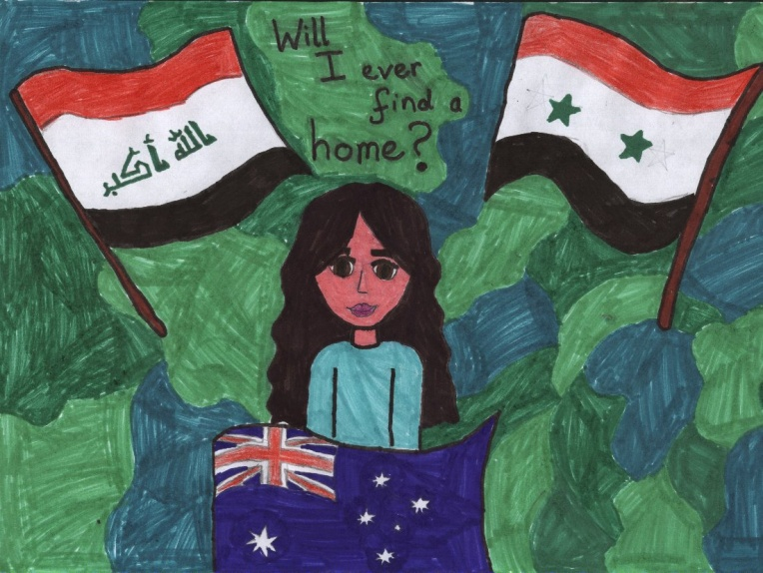

24th July 2016
Please excuse my lack of writing, a lot has happened! Okay, I will fill you in on what happened. At the start of the year I was ready to give up, until I heard of a wonderful place called Australia. The rest of the people in the apartment said they were leaving tomorrow, on a big ship, to a place outside Sydney. They said people were setting up a refugee camp there. Suddenly, I thought of finally having a happy life. I decided the only way this would happen, was I’d have to leave Syria. The next day I woke up and remembered the long journey a head of me. I dressed in my best clothes and followed the rest of the refugees out the door, saying goodbye to the horrible apartment, thet I refused to call home. We all set off on the long journey to the port, where the boat would set sail. I completely forgot how many people would want to go to Australia and suddenly I started to panic as I wondered if there would be enough room for me, as I looked at people hanging off the edge of the boat, but the others assured me there would. I tried to get comfortable, which I failed at miserably as I was so squished. I tried to go to sleep, as I prepared myself for the 11,980km journey to Australia. I hated every minute of the long journey, but I knew it would be worth it in the end. No one spoke to me and I felt all alone, without my family to protect me. I was almost always crying and I was always doubting my decisions. I got no food or drink and I think I passed out a few times from hunger and thirst and of course no one else cared. Finally after the dreadful journey, we reached the coast of Sydney and there was a quiet cheer from the refugees, even though they were so weak. I almost fell off the boat as I tried my best to leap off the edge. I should have been relieved, but after the long journey I felt dizzy and light-headed. I started to follow the other refugees to the nearby camp and, after a few hours, we reached it. I was elated when we arrived and I got my first sip of water in days.
1st December 2016
Today is my birthday and also my parents’anniversary. I woke up at the camp feeling very blue, remembered my dear parents. One of the camp’s voluntary workers, Eva noticed I was feeling sad so decided to bring me into Sydney. This wasn’t allowed under any circumstances, but I knew she thought of me as her own child and I was happy to break one little rule. She brought me to a little café and bought me some new clothes. When we were in the café Eva met one of her friend, by coincidence. Her friend asked who I was and she introduced me as her new foster child! Her friend said she was really happy for Eva as she new she had been looking for a child to foster for a while. I was so shocked that I nearly fainted. After Eva’s friend left, Eva said that she had asked her manager if she could foster me and he gladly said yes! I couldn’t believe my ears! ‘You’re coming home with me today’, Eva said, smiling! Now I am sitting on Eva’s couch with her golden retriever, Millie, also Eva is a vet! Tonight we are having shepherd’s pie, which I’m really looking forward to.
25th December 2016
Today is Christmas! We are going to the beach for Christmas dinner and I’m very excited. For Christmas Eva got me a little kitten, who I called Daisy! I also got another present which has to be the best resent ever, Eva adopted me! I can’t believe Eva is legally my mum! She says I will be starting school in two weeks and I will ever leave Australia! have new friends and teacher! I ate my burger that night on Sydney beach, knowing that I wouldn’t have to ever leave Australia.
8th January 2017
I started school today and it was wonderful, I have a wonderful teacher and lovely friends. I can’t wait to spend the next year with all my new classmates. I love all the work and I especially love the art. I drew a piucture today of all the flags of the places I’ve lived and the teacher was really interested. My classmates asked me all about living in a country with war and the refugee camps.
5th August 2017
Today Eva got married to a man called John; it was one of the best days of my life! Now I have a father to call my own! Life in Australia really is a dream come true, actually it’s even better than I thought it could ever be! My name Elena means bright-one, after the Greek Helen and finally I feel very bright!
Alexandra

